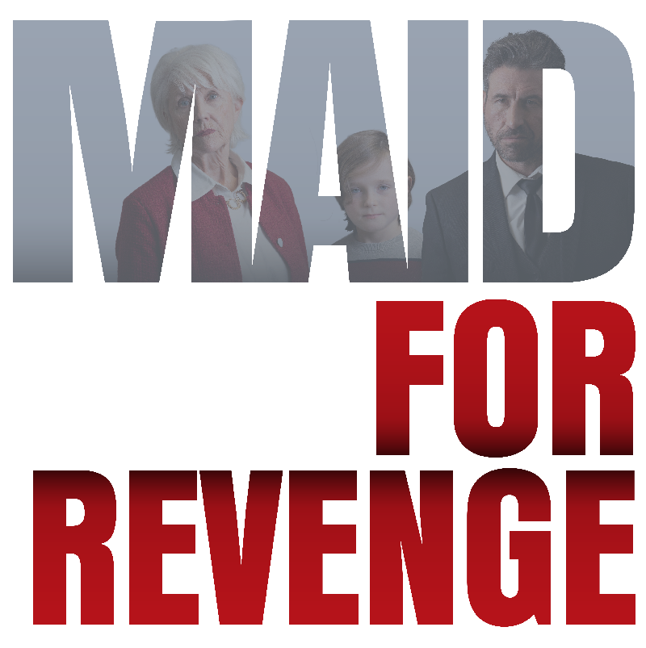

Johnson Production Group

Press Kit

One-Liner
Following the tragic death of her husband, Annie finds work as a house cleaner to make ends meet, only to wake up one day beside the body of her client, framed for murder, with no idea how she got there. On the run, the police closing in, Annie races against the clock to clear her name and discover who set her up, all the while caring for her 8 year-old son.

Synopsis
Following the death of her husband in a tragic car accident, Annie takes a job as a house cleaner to make ends meet, willing to do whatever it takes to support her 8 year-old son – only to wake up one day beside the dead body of a client with no idea how she got there, framed for murder.
With the police on the way, Annie goes on the run – unwilling to risk losing her son if she can’t prove her innocence, desperate to figure out who set her up. In her desperation to get back to her son, she attempts to steal a stranger’s truck. It turns out that Billy’s mom was also a single parent so he decides to help her out.
With Billy’s help, her search soon leads back to her own troubled past, finding clues linking what happened to the death of her husband – and the driver of the other car that night
In her desperation, Annie turns to the only family she has left: Elizabeth, her wealthy ex-mother-in-law. Although their relationship was strained during Annie’s marriage, Elizabeth had always been there for Tate after the death of his father, generous to a fault, spoiling him in his grief.
But Elizabeth isn't the friend Annie thought she was. Elizabeth drugs her, summoning the real murderers to remove Annie and kill her. But Annie escapes.
In a bizarre twist, Tate is then kidnapped by the murderers Elizabeth had hired, thinking they can ransom Tate to get even more money from her.
All alone, a wanted fugitive, betrayed by those she trusted most, Annie comes up with a dangerous plan to rescue her son. Tracking the kidnappers to their hiding spot, she overcomes the odds through the strength of a mother’s love, seeing justice in the end.

Producers
Executive Producers
TIMOTHY O. JOHNSON
OLIVER DE CAIGNY
ANDREW C. ERIN
Co-Executive Producer
JOSEPH WILKA
Producer
TARALEE GERHARD

Key Cast
CHARACTER  Annie Wilkerson  Billy  Elizabeth Hale  Hank Darrow  Maynard Barr  Marcus |  | ACTOR  KATHRYN KOHUT  MATT WELLS  BARBARA GORDON  RYAN BANNON  TERRY WJ RYAN  TIM MYLES

Key Cast Biographies

KATHRYN KOHUT
Kathryn Kohut is a Canadian actress, martial artist and model. She was born in Wetaskiwin, Alberta into a family of pipeline welders. Welding alongside her father in Fort McMurray, she was recruited by EllisDon and grew to have a successful career in the construction industry. Her career as an actress began only recently, as growing up she didn't have access to acting programs and didn't consider it a possibility until she decided to leave the construction industry and follow the pull she felt towards the arts.
Kohut began her training at the Lee Strasberg Theatre and Film Institute in New York, and has since continued her studies with a diverse number of teachers and coaches throughout Canada, USA and the UK. She hit the ground running, with her first role being a supporting lead in Spare Parts (RLJE Films, Amazon Prime) and has continued on an upward trajectory.
Apart from acting, Kohut is an avid horseback rider, and extreme sports enthusiast with a passion for dirt biking, wake boarding, skiing and Muay Thai. In 2014, she won Miss International Canada and placed second runner up out of 85 contestants in Bangkok, Thailand. In 2015, she won Miss International Canada and placed second runner up at Miss Universe Canada in 2017.
Kohut is passionate about supporting causes that are close to her heart which include the Malala Fund, the Canadian Centre to End Human Trafficking and Black Lives Matter. She is also an animal rights advocate and volunteered for animal shelters and organizations growing up.
MATT WELLS
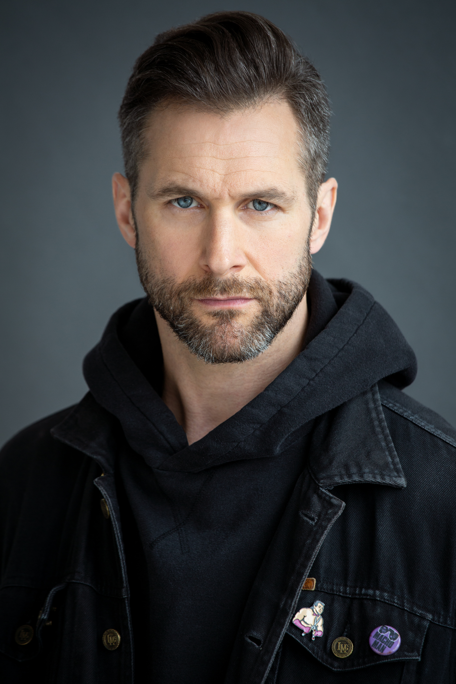
Matt Wells is a Canadian actor, writer, and musician born in St. John's, Newfoundland best known for his work in the award winning and critically acclaimed independent film "Crown and Anchor" which he created, produced and co-starred.
His path began writing songs and fronting the notorious Newfoundland punk/hardcore band Bucket Truck; releasing 4 albums, 10 self-produced music videos, and traveling the world while sharing stages with Slayer, Damage Plan, Fishbone, and Lagwagon. This journey directly led to him embarking on a career as an acclaimed music/film journalist for Much Music, The New Music, Bravo and MTV where Matt has interviewed everyone from The Police, Quentin Tarantino, Lee Daniels, and John Lydon to Lou Reed, Mariah Carey, Ben Kingsley, Zack Snyder and Lady Gaga.
As a solo musician Matt has released 2 albums and shared the stage with Sammy Hagar, Levon Helm, and Great Big Sea; as an actor he has appeared in Designated Survivor, Schitt's Creek, Murdoch Mysteries, and the multiple award winning short film "Poison in the Water" which he co-wrote with his daughter. Matt's most recent short film "The New Normal" won Best International Comedy at the 2021 Venice Film Awards and is an official selection at both The London International Film Festival and Berlin Flash Film Festival.

BARBARA GORDON
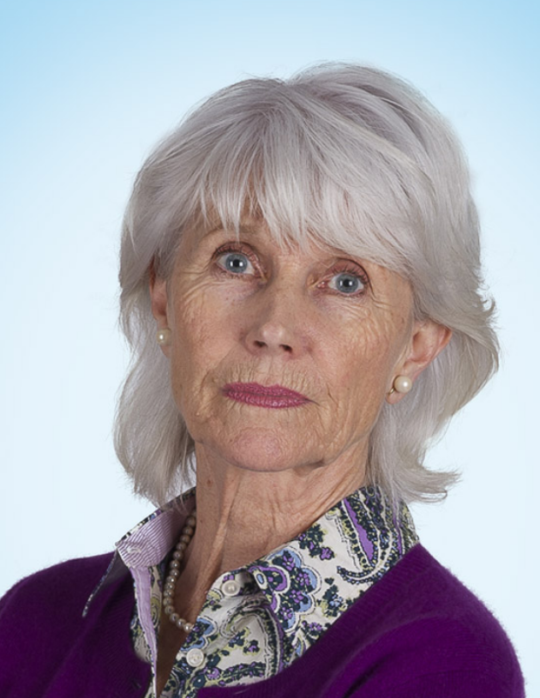
Barbara Gordon began her career on stage in Vancouver over 40 years ago and has played on most of the stages across Canada. Just a few of her stage credits include The Matchmaker for which she received a 1981 Dora nomination. She was also nominated for her performance in Diningroom in 1984, Criminals in Love in 1985 and Hamlet in 1992. More recent stage work in Toronto includes Nightwood Theatre’s The Happy Woman, Canstage’s Tout Comme Elle and Mirvish Productions’ Calendar Girls. Barbara Gordon is pictured as Muriel in a CBC publicity still for the mini-series, The Best Laid Plans.

RYAN BANNON
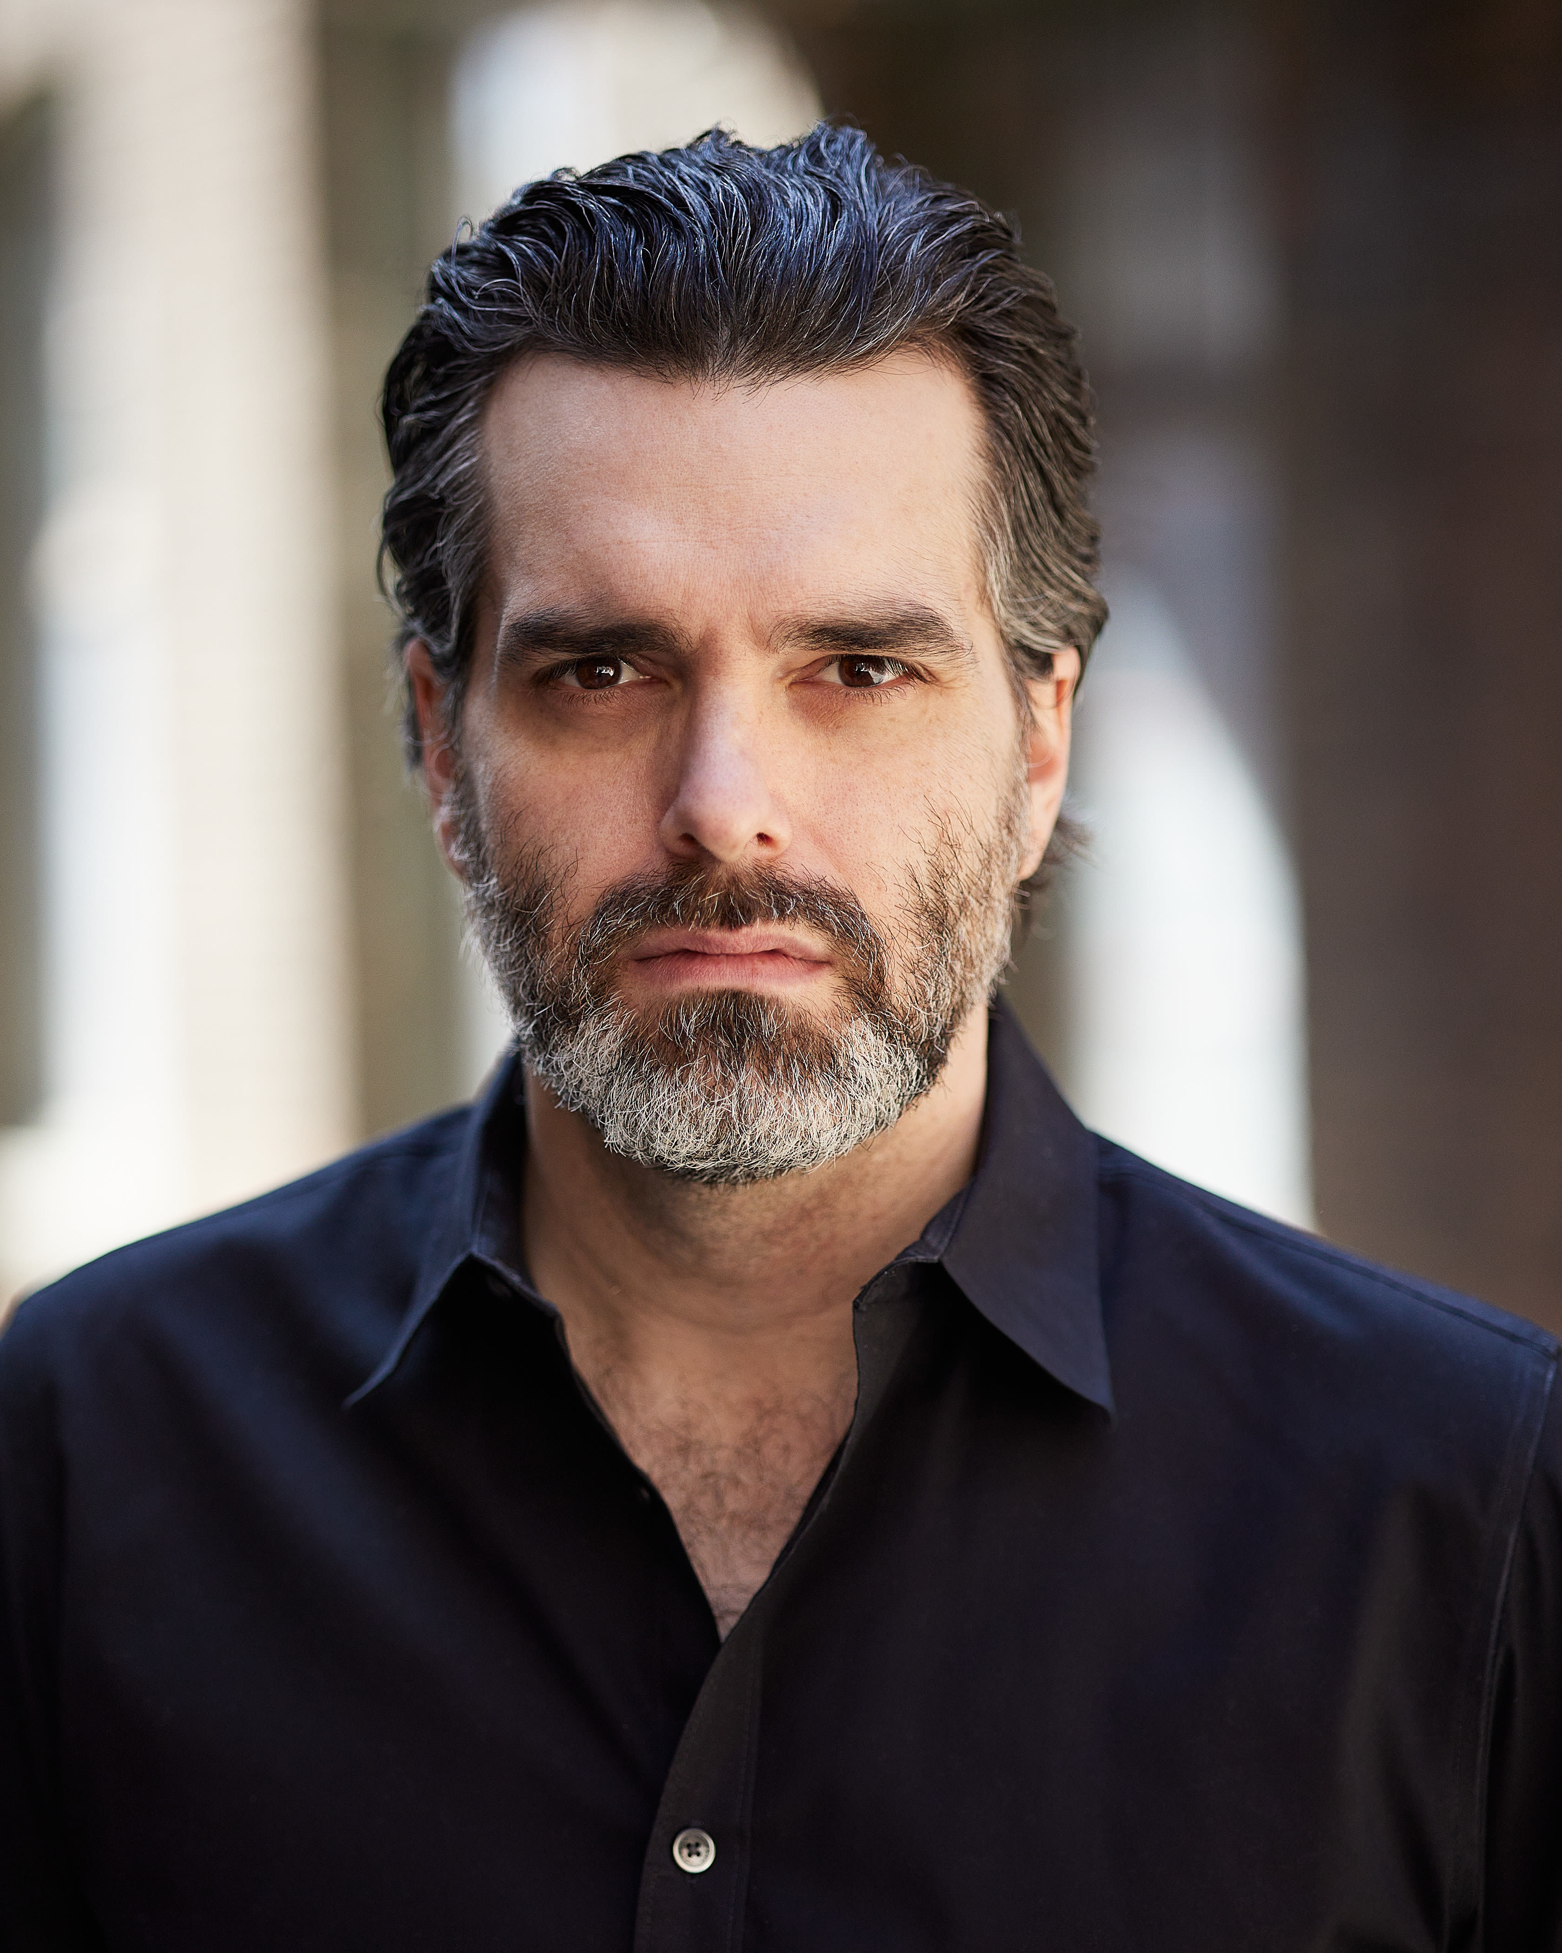
Ontario based actor, Ryan Bannon, is a classically trained guitarist and has been studying acting using the Meisner technique for several years. In addition to commercial and theatrical appearances, Ryan has had roles in several TV series, shorts and in the upcoming film Wildfire.

TERRY WJ RYAN
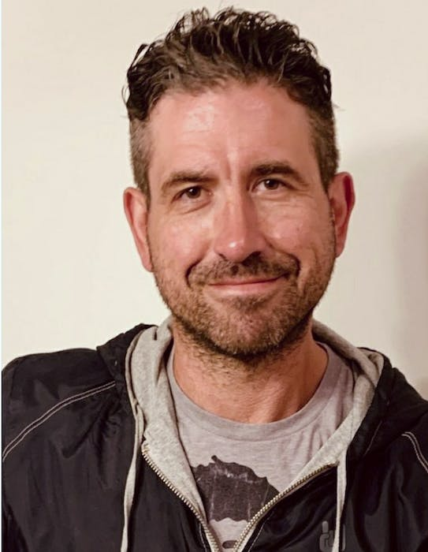
Terry Ryan, raised in Mount Pearl, Newfoundland and Labrador, was a professional hockey player for 7 years - highlighted by appearing in 8 NHL games. He retired in 2007, released a best-selling book entitled "Tales of a First Round Nothing", and began a career in the arts.
Ryan now works in the film industry and has appeared on several episodes of the hit CBC television program Republic of Doyle, playing small roles. He has also played himself in the OLN's "Road Hockey Rumble" (2008). He released his first book, "Tales of a First Round Nothing" in May 2014, and it was well received by critics.
Ryan is now also trying his hand at stand up comedy and performed his second show to good reviews opening for Gerry Dee at the General Motors Centre in Oshawa, Ontario on April 22, 2016.
In addition to playing "British Soldier #1" (Episode 1) - (the first on-screen casualty in the Netflix/Discovery Channel television series Frontier, starring Jason Momoa in the lead role), in 2017 Ryan also had small roles in Frontier Season 2, Little Dog (CBC), Caught (CBC), Schitt's Creek, and various short films. In 2018, he wrote and played the lead role in a short film called "A Stand In", played "Coyote" in Justin Oakey's A Fire In The Cold Season. In 2019, Ryan - who acted and did his own stunts - played the "Gunman" in Episode 11 of Hudson and Rex, and played hockey playing Newfoundlander "Teddy" on the hit Canadian television series Letterkenny (Season 8, Episode 1).

TIM MYLES
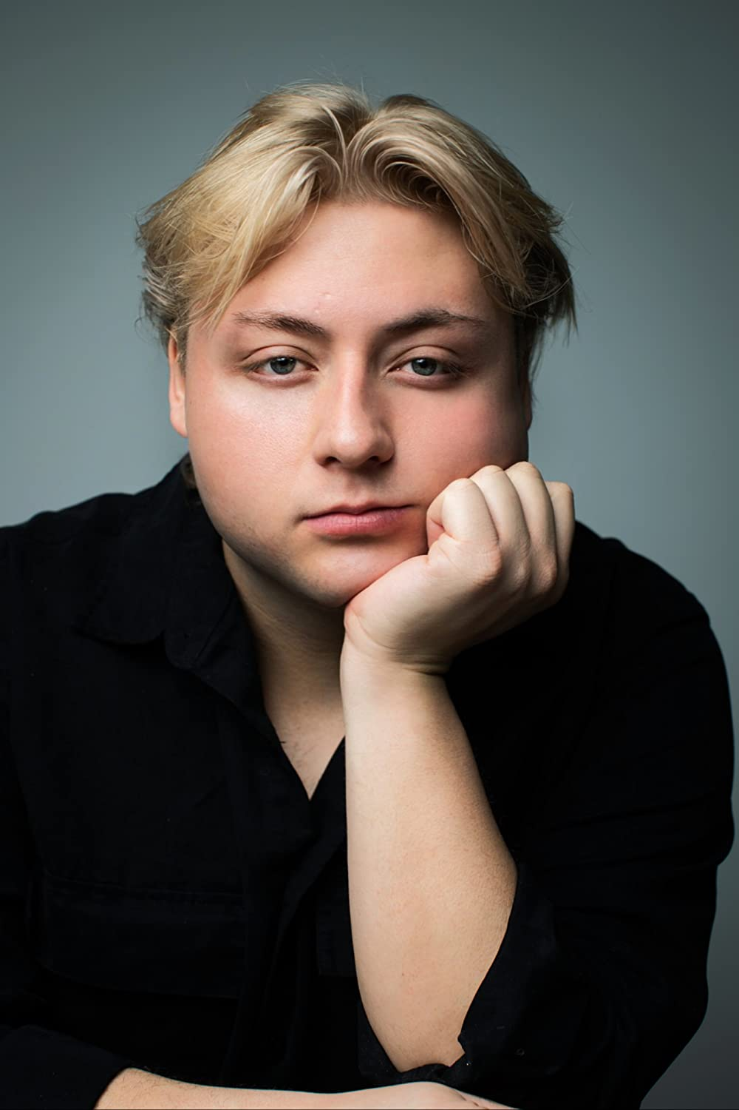
Tim Myles is a writer, director and actor. He began his career directing music videos for various labels such as Universal Music and Island Records. His debut short film, Little Bird, was made in partnership with imagineNATIVE, LIFT and Netflix Canada, and premiered at the 2021 Toronto International Film Festival. The film was nominated for an IMDBPro award for best Canadian short film at TIFF. It was named one of '10 must see Indigenous Films' during the festival, and Tim was named one of the "10 Indigenous Artists in Toronto you should know" by Blog TO in 2021.

Production Credits

Full Cast
Actors  KATHRYN KOHUT  MATT WELLS  BARBARA GORDON  TERRY WJ RYAN  TIM MYLES  RYAN BANNON  ROBERT PARSON  LINCOLN MACNEIL  ZARA MATTHEWS  BRUCE MARSHALL | Role  Annie Wilkerson  Billy  Elizabeth Hale  Maynard Barr  Marcus  Hank Darrow  Samuel Primm  Tate  Katy  Radio Announcer

Casting
RON LEACH, c.d.c.

Composer
CATALIN MARIN

Costume Designer
LAUREN SNOW

Editor
ALVIN CAMPANA

Production Designer
DAVE WHITTY

Director of Photography
MICHAEL TIEN

Written by
SHAWN RIOPELLE

Directed by
ALEXANDRE CARRIÈRE

Other Crew
TOM DUNNE |  |  | Stunt Coordinators
GLENN REDMOND
MALLORY HORSMAN |  |  | First Assistant Director
SHARA DÉSIRÉE KING
JEFF LEWIS |  |  | Second Assistant Director
MALLORY HORSMAN |  |  | Third Assistant Directors
DION EMBERLEY
DION EMBERLEY |  |  | Set Production Assistants
SUSAN KELSEY
MALLORY HORSMAN |  |  | Local & BG Casting Director
JUSTIN NURSE |  |  | Tutor
ZOË BALSOM |  |  | Production Coordinator
TIM SULLIVAN |  |  | Assistant Production Coordinator
JOSHUA LANGE |  |  | Production Accountant
VICTORIA PICKETT |  |  | Assistant Accountant
DAVE CONNORS |  |  | Producer's Assistant
DAVE WHITTY |  |  | Production Designer
STEPHEN BUTLER |  |  | Art Director
KOBE DILLON |  |  | Set Decorator
MICHAEL COLLIS |  |  | Graphic Designer
MICHAEL LAWLOR |  |  | On-Set Props
LAUREN SNOW |  |  | Costume Designer
KELSEY MAYE |  |  | Wardrobe Assistant
MICHAEL TIEN |  |  | Director of Photography
ADAM PENNEY |  |  | B Camera Operator
JOSEF GERHARDS |  |  | A Cam - First Assistant Camera
NICK EDGAR DUNNE |  |  | A Cam - Second Assistant Camera
NATHAN "JONNA" BOULIANE |  |  | B Cam - First Assistant Camera
RILEY HARNETT |  |  | B Cam - Second Assistant Camera
MATTHEW FITZGERALD |  |  | Camera Assistant & Trainee
JOSHUA CAINE |  |  | Lab Technician
SARAH HOWSE |  |  | Stills Photographer
JEREMY JESTICAN |  |  | Gaffers
TIM SULLIVAN
CHRIS ADAMS |  |  | Best Electric
ADAM THISTLE |  |  | Best / Rigging Electric
DAN GILL |  |  | Grip / Electric Swings
TIM SULLIVAN
ADAM THISTLE
ANDREW HAMOND |  |  | Key Grip
JAMES HARRIS
STEVE PIERCEY |  |  | Best Grips
TIM SULLIVAN
CHRIS MOSS |  |  | Third Grip
DAN GILL |  |  | Grips
VANESSA HARING
RUSSELL O'BRIEN
PETER WELSH
DIEGO MEDINA |  |  | Sound Mixer
ALEX TOPOLNISKI |  |  | Boom Operator
DAVE CONNORS |  |  | Script Supervisor
DANNY NOSEWORTHY |  |  | Location Manager
DONNA CORCORAN |  |  | Location Coordinator
KELSEY MAYE |  |  | Location Scout
DAVID FLEMING |  |  | Location Production Assistants
LUCAS KING
TRAVIS NOTFALL
ALEXANDER PIERCE
MEGAN GREGORY |  |  | Key Makeup Artist
SAMANTHA KOSUB |  |  | Assistant Key Makeup Artist
ZACK CLARKE |  |  | Key Hair Stylist
SAMANTHA KOSUB |  |  | Makeup & Hair Assistant
PAUL ELLIOTT |  |  | Transport Coordinator
CHRIS CHAFE |  |  | Transport Captain
JAMES WALL |  |  | Driver
KEVIN SWEENEY |  |  | Off-Set Labour
JAMES MICHAEL WOOLRIDGE
ANDREW HAMOND |  |  | Safety Officer
JULIA MORRISSEY |  |  | Set Medic
PEARL WENTZELL |  |  | Daily Medic
JENNIFER NORMAN |  |  | Food & Beverage Manager
CHERYL RYALL |  |  | Caterer First Assistant
DION EMBERLEY |  |  | Catering Assistant
AMY TOBIN |  |  | Key Craft Service
MELANIE GIBBONS |  |  | Assistant Craft Service
HOLLYWOOD SCRIPT RESEARCH |  |  | Script Clearances
 | THE NO CONFLICT CLEARANCE COMPANY
 | HALL WEBBER LLP | Legal Services
 | DANNY WEBBER
 | ABOVE THE LINE MEDIA SERVICES | Business Affairs
 | BRENDAN MCNEILL
 | ARTHUR J. GALLAGHER CANADA LTD. | Insurance
 | ALEXANDRA WARING | Post Production Supervisor
 | URBAN POST PRODUCTION | Post Production Services provided
 | JOSEPH FACCIUOLO | Dialogue & ADR Editor
 | EHREN PFEIFER | ADR Recordist
 | KIRSTY SMITH | Sound FX Editors
 | LUKA TOMA
 | TESS MOIR | Foley Artists
 | RYAN MACNEILL
 | JESSICA SEVIER | Foley Recordists
 | TESS MOIR
 | RUDY MICHAEL | Re-Recording Mixer
 | LUCAS ROVEDA | Re-Recording Assistant
 | EVAN GRAVES | VFX Artist
 | STEVE LAHEY | Colorist
 | KALI RAIGH | Online Editor
 | PETER TOKARSKY | Project Manager
 | BRUCE REES | Picture Operations Manager
 | ROBERTA BRATTI | V.P. of Operations
 | POND5/MIZAMOOK | Stock Footage
 | Special thanks to Danny Williams Jr.
 | and the Province of Newfoundland and Labrador
 | "Simplistic Soul"
 | by Nicholas John Steele and David John Vanacore
 | courtesy of Worth It's Weight In Gold Music
 | "Tombstone"
 | by Vezio Bacci, Geoffrey James Pidcock Holroy and Patrick Robert Murdoch
 | courtesy of West One Music Limited

Producer Biographies
TIM JOHNSON – Executive Producer
Tim Johnson is among the most active and reliable producers in the business thanks to top rate productions and global distribution appeal.
Johnson is also responsible for producing the international hit series, DR. QUINN, MEDICINE WOMAN for CBS for over 5 seasons. During his 100-episode tenure, he also developed and produced the original docu-drama COLD CASE for CBS network, which was the very first program to integrate television with the Internet.
Johnson has produced over 150 movies, 15 globally released series for every major US network - including ABC, Disney, CBS, NBC, Netfly, FOX and Sony.

JOHNSON PRODUCTION GROUP
The Johnson Production Group contracts globally to produce television content for international networks, studios and distributors. Based in Los Angeles and Vancouver, British Columbia, the company manages production, facilitates development and financing, procures distribution and guarantees quality and timely execution of its programs. While costs have gone up, so has the demand for quality. No longer is good enough, good enough. Johnson Production Group serves that segment when a show needs to be "A" quality, but produced efficiently enough to meet a locked budget. JPG specializes in value, protection of creative elements, and delivery of a quality finished product.
OLIVER DE CAIGNY – Supervising Producer
Oliver De Caigny is a Canadian producer originally from Belgium, his background in financing, production, and post production makes him a well-rounded producer for any type of production. His experience in financing and production agreements (film and TV series and movies-of-the week), distribution agreements (both domestic and foreign) as well as international co-productions, Canadian tax credit, Telefilm Canada and Canada Media Fund incentives provides him with a well-rounded background in development, production and distribution for motion pictures, television series and productions.
ANDREW C. ERIN – Executive Producer
Andrew Erin is a Canadian Writer/Director making a big splash in the US, and has produced, written and directed numerous commercially successful films. His directorial debut, SAM’S LAKE, was an official selection at the Tribeca Film Festival and did an excellent theatrical run in select theaters around the country; distributed by Lionsgate Films. Andrew also wrote the script for the film. Andrew’s directorial credits include, SIMPLE THINGS, produced for Screen Media Ventures and Universal Studios. Besides winning The Bob Clark Award for Best Director at the California Independent Film Festival, the film was commercially received. Andrew has worked continuously as a writer/director, building a strong library of films in the Thriller/Horror genres with: Embrace of The Vampire, The Clinic, Final Sale, Confined and Toxic Skies.

JOSEPH WILKA – Co-Executive Producer
Joseph Wilka is the Head of Production for Johnson Production Group. Los Angeles-based, Joseph had already produced and directed several feature films before serving as the senior marketing executive for Gravitas Ventures. While at Gravitas, Wilka helped pioneer new distribution models for independent films including day-and-date theatrical releases. It was also at Gravitas where Joseph first worked with Johnson Production Group to facilitate the release of their films to the worldwide Video On Demand audience. After serving as the Director of Distribution and Production for Viva Pictures, where he produced English-language versions of foreign animated titles for DirecTV, Wilka officially joined Johnson Production Group. As Head of Production, he oversees the development, production, and distribution of films from multiple production units for release on broadcast and streaming platforms.

TARALEE GERHARD– Producer
Taralee Gerhard committed to following her dream of making movies almost 20 years ago when the film industry was in its infancy in Ottawa. She spent several years with Fireside Pictures in Ottawa and truly cares about the family culture that Fireside has fostered amongst the crew, supporting each other's big sky dreams, making movies to be proud of. During the Covid-19 pandemic, the spirit of taking risks and following her heart lead Taralee to Newfoundland and she remains truly grateful to be able to continue working with Fireside Pictures as an in house Producer opening a new territory, expanding the Fireside Family and helping to foster the independent film industry in Newfoundland.

Billing Block
LIFETIME PRESENTS in association with JOHNSON PRODUCTION GROUP
MAID FOR REVENGE starring KATHRYN KOHUT MATT WELLS BARBARA GORDON RYAN BANNON TERRY WJ RYAN TIM MYLES Casting RON LEACH, c.d.c. Composer CATALIN MARIN Costume Designer LAUREN SNOW Editor ALVIN CAMPANA Production Designer DAVE WHITTY Director of Photography MICHAEL TIEN Co-Executive Producer JOSEPH WILKA Executive Producers TIMOTHY O. JOHNSON OLIVER DE CAIGNY ANDREW C. ERIN Producer TARALEE GERHARD Written by SHAWN RIOPELLE
Directed by ALEXANDRE CARRIÈRE
In Loving Memory of our dear friend and colleague
Ronald David Leach
1954 – 2023
The Canadian Film or Video Production Tax Credit
© MMXXII MTK Productions Inc. & MTK Productions (Ontario) Inc. All Rights Reserved

Meta Data
LONG (max 3000 characters) synopsis
Following the death of her husband in a tragic car accident, Annie takes a job as a house cleaner to make ends meet, willing to do whatever it takes to support her 8 year-old son – only to wake up one day beside the dead body of a client with no idea how she got there, framed for murder.
With the police on the way, Annie goes on the run – unwilling to risk losing her son if she can’t prove her innocence, desperate to figure out who set her up. In her desperation to get back to her son, she attempts to steal a stranger’s truck. It turns out that Billy’s mom was also a single parent so he decides to help her out.
With Billy’s help, her search soon leads back to her own troubled past, finding clues linking what happened to the death of her husband – and the driver of the other car that night
In her desperation, Annie turns to the only family she has left: Elizabeth, her wealthy ex-mother-in-law. Although their relationship was strained during Annie’s marriage, Elizabeth had always been there for Tate after the death of his father, generous to a fault, spoiling him in his grief.
But Elizabeth isn't the friend Annie thought she was. Elizabeth drugs her, summoning the real murderers to remove Annie and kill her. But Annie escapes.
In a bizarre twist, Tate is then kidnapped by the murderers Elizabeth had hired, thinking they can ransom Tate to get even more money from her.
All alone, a wanted fugitive, betrayed by those she trusted most, Annie comes up with a dangerous plan to rescue her son. Tracking the kidnappers to their hiding spot, she overcomes the odds through the strength of a mother’s love, seeing justice in the end. (1649)

MEDIUM (max 500) synopsis
Following the tragic death of her husband, Annie finds work as a house cleaner to make ends meet, only to wake up one day beside the body of her client, framed for murder, with no idea how she got there. On the run, the police closing in, Annie races against the clock to clear her name and discover who set her up, all the while caring for her 8 year-old son. (362)
SHORT (max 100 characters) synopsis
A recently widowed mother finds work as a house cleaner, only to find herself framed for murder. (96))
5 KEY WORDS
Murder, kidnapping, house cleaning, framed

