

INSPIRED BY A TRUE EVENT

Johnson Production Group

Press Kit

One-Liner
A teenage girl is cyberbullied but is shocked to find out that the harasser is the last person she would expect to bully her.

Synopsis
Inspired by a true event, this film follows the story of high school senior, Mia and her divorced mother, Madelyn. Soon after Mia starts dating her school’s football star, she starts to receive harassing and hurtful texts, DM’s, etc. Madelyn seemingly tries to help resolve the situation until it is revealed to the viewer that Madelyn is the cyberbully. The bullying worsens, until Mia discovers her mother is the actual harasser.

Producers
Executive Producers
TIMOTHY O. JOHNSON
STACY MANDELBERG
OLIVER DE CAIGNY
LISA RINNA
Producer
NAVID SOOFI
Supervising Producer
TIM MUDD

Key Cast
CHARACTER  Madelyn  Mia  Erik  Summer  Eliot  Detective Bolton |  | ACTOR  LISA RINNA  BRIANA SKYE  BRADLEY STRYKER  DELILAH BELLE HAMLIN JONATHAN SIMAO  KATRINA KWAN

Key Cast Biographies

LISA RINNA
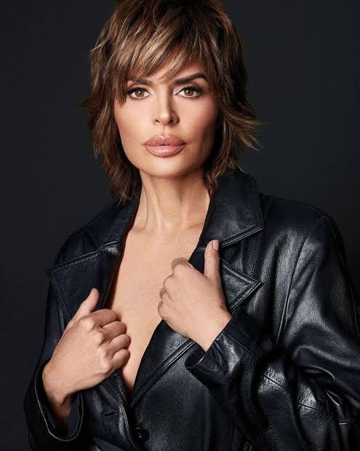
Lisa Deanna Rinna was born on July 11, 1963 in Newport Beach, California and raised in Medford, Oregon to Lois Rinna & Frank Rinna, she has an older half-sister: Nancy Rinna. As an actress, she is best known for her roles as Billie Reed on the NBC daytime soap opera, Days of Our Lives (1965) and Taylor McBride on Fox's television drama, Melrose Place (1992). Since 2014, Rinna has been a cast member on Bravo's hit reality television series, The Real Housewives of Beverly Hills (2010). Other television credits include being a contestant on NBC's The Celebrity Apprentice and ABC's Dancing with the Stars, as well as guest-starring roles on Entourage, The Middle, Veronica Mars, Community & 8 Simple Rules. Rinna made her Broadway debut in Chicago as Roxie Hart on June 2007. She was the host of Soapnet's talk show, SoapTalk (2002) for which she earned four Emmy nominations for Outstanding Talk Show Host. Rinna has also written three books: Starlit, The Big, Fun, Sexy Sex Book and The New York Times best-seller Rinnavation. Her other ventures include a fashion line for QVC named The Lisa Rinna Collection and the cosmetics collection Rinna Beauty.
Rinna is married to American actor Harry Hamlin, with whom she has two daughters, actress Delilah Belle Hamlin and model Amelia Gray Hamlin.

BRIANA SKYE
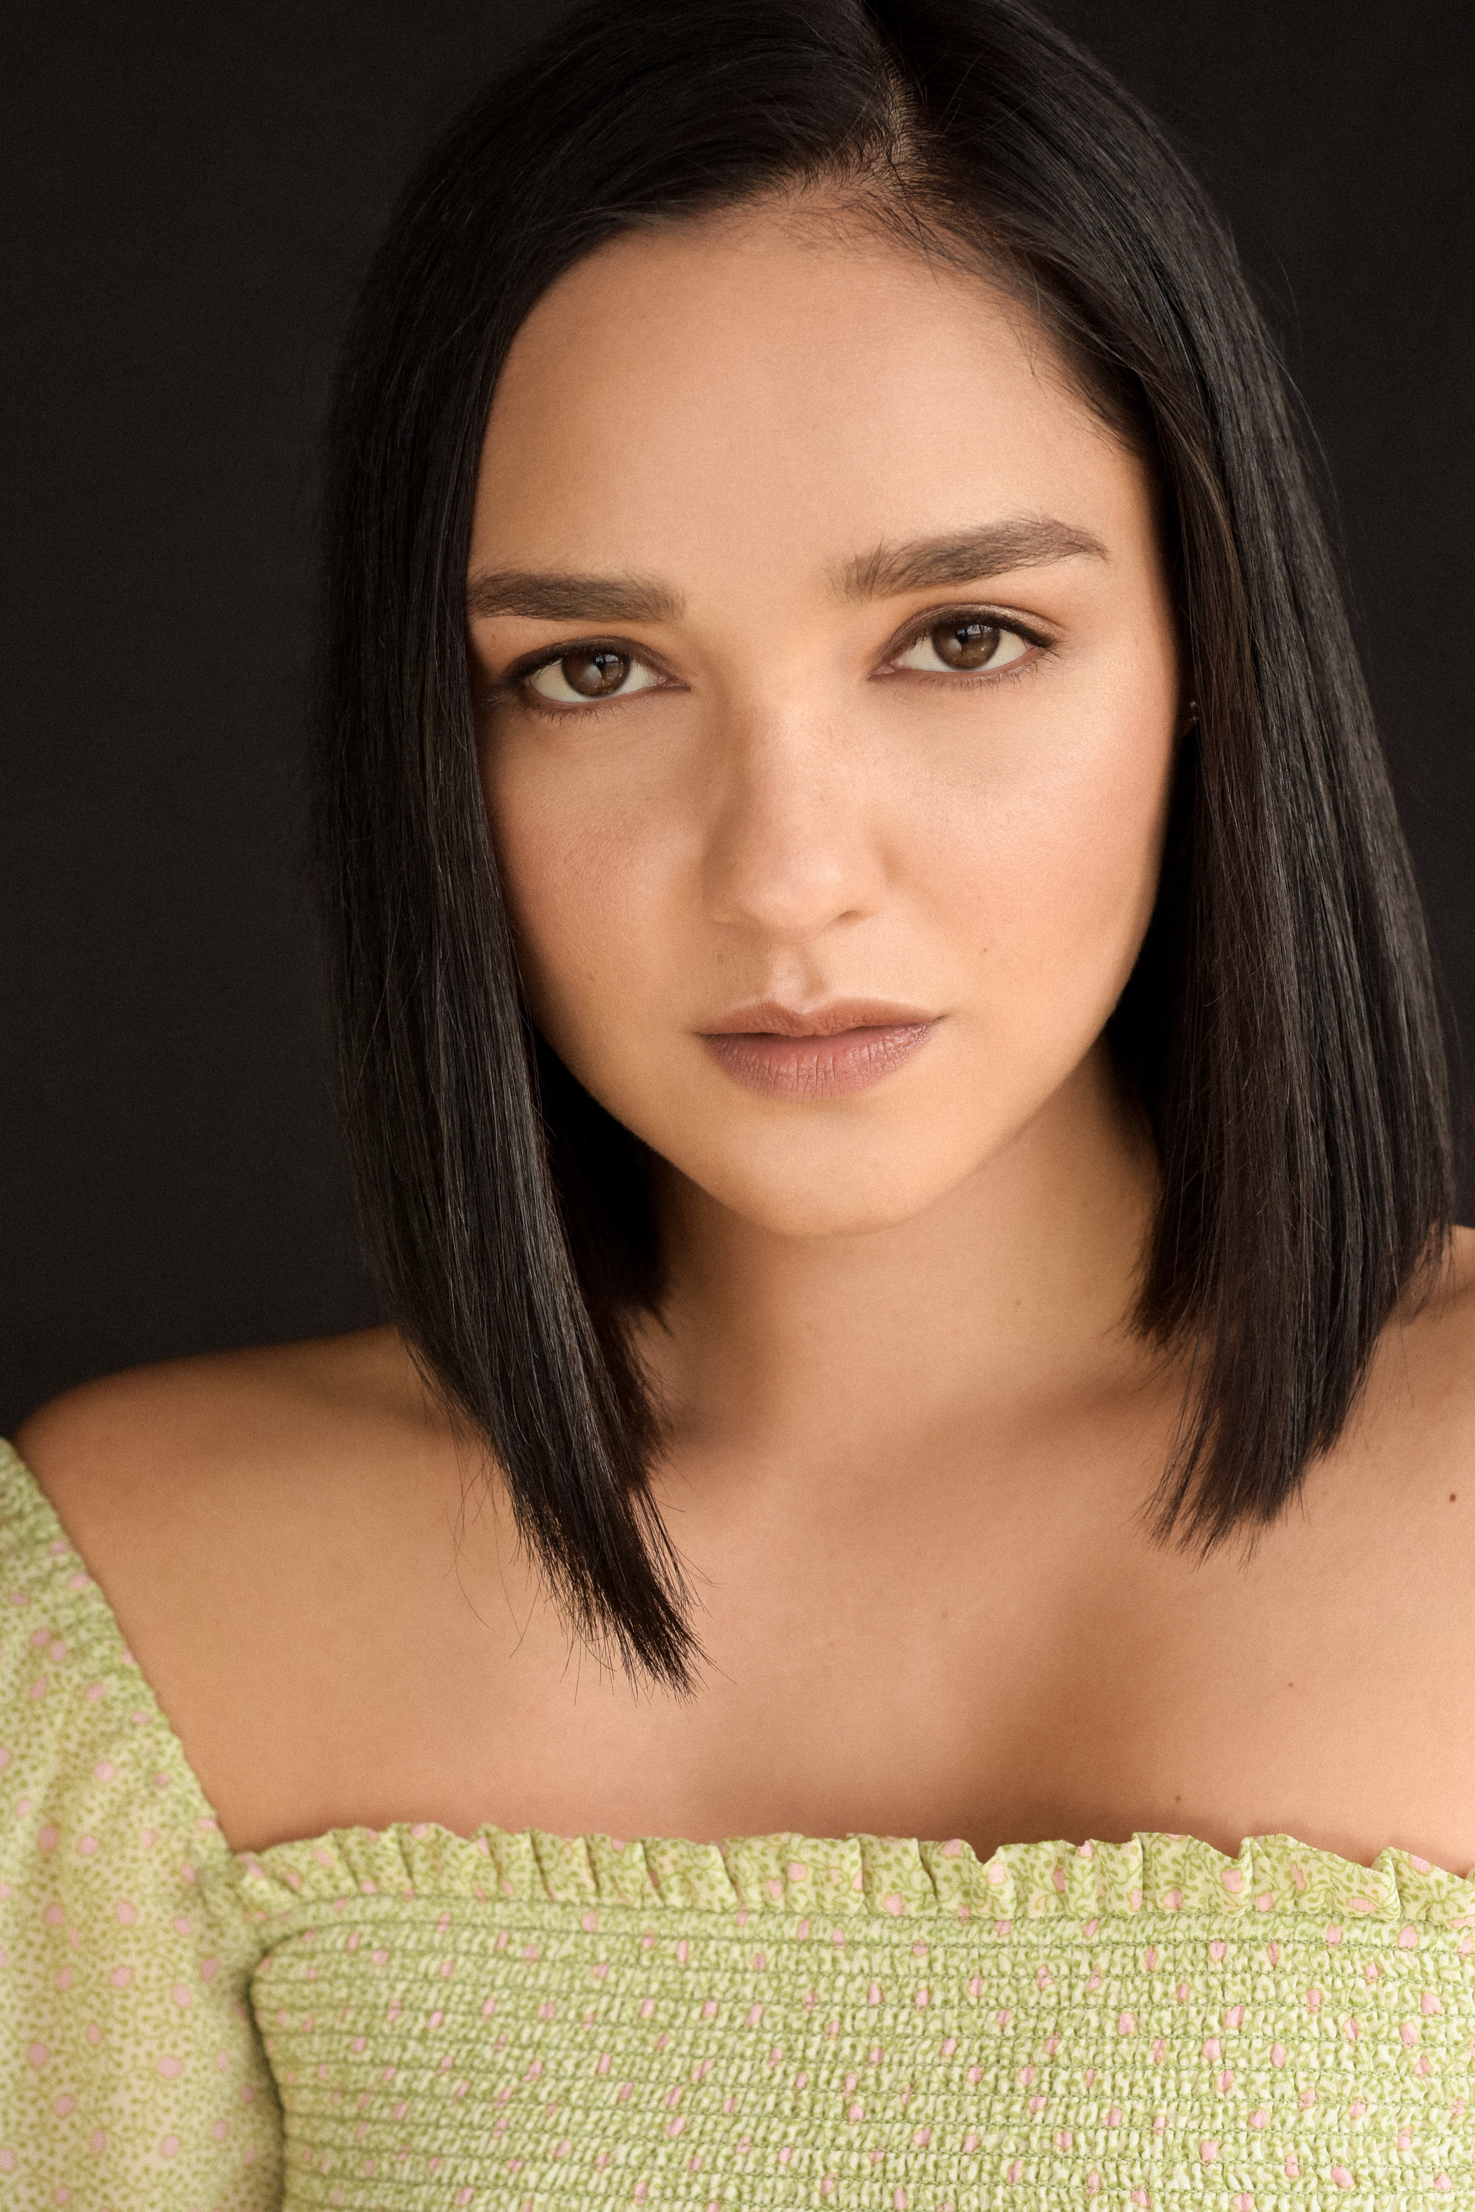
Vancouver, BC based Briana Skye is a model and actress on the rise. She is well known for her portrayal of Amanda in the first season of Batwoman, Mira in SyFy’s Van Helsing, and Silvia Hines in the fifth season of DC’s Legends of Tomorrow. Her film credits include appearances in Picture A Perfect Christmas and Dangerous Lives.

BRADLY STRYKER
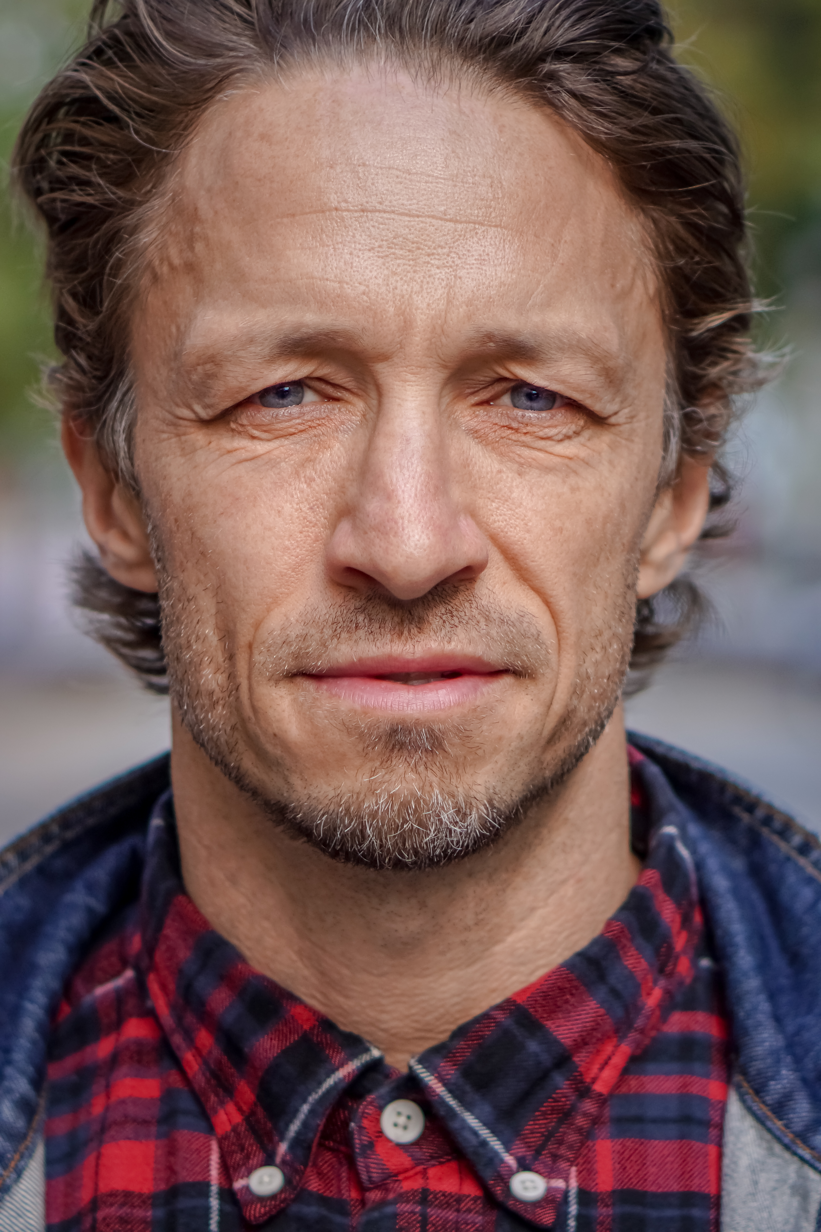
Born and raised in the Pacific Northwest, Bradley is an award-winning Actor whose debut feature film as Writer/Director, "Land of Smiles", received 35 International film festival awards as well as an additional 20 wins and 30 nominations for his other work.
Bradley has been actively studying the craft of acting for going on two decades. An intrinsic need for storytelling that has led him to a life behind the camera as well. It was when Bradley started travelling extensively in the early 2000's that he realized his impulse for exploring humanity was more vast than he had originally thought. Upon returning home from life changing trip to Southeast Asia, he began writing screenplays, directing would quickly follow, and his propensity for storytelling has been in full swing since.
Bradley's theory on life is very simple, "It's about exploration; growth; and change. Three habits of living that just so happen to directly feed the life of a storyteller."

DELILAH BELLE HAMLIN
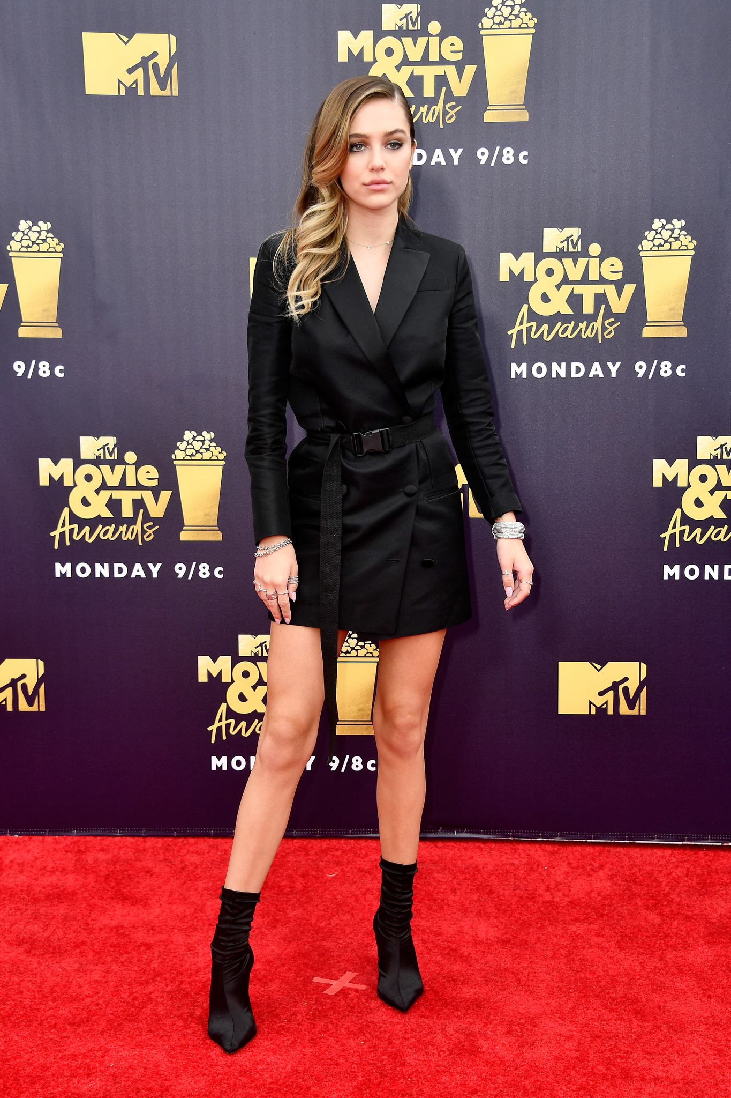
Delilah Hamlin was born on June 10, 1998 in Los Angeles, California, USA. She is an actress, known for How She Caught a Killer, Access Hollywood (1996) and The Real Housewives of Beverly Hills (2010).

JONATHAN SIMAO
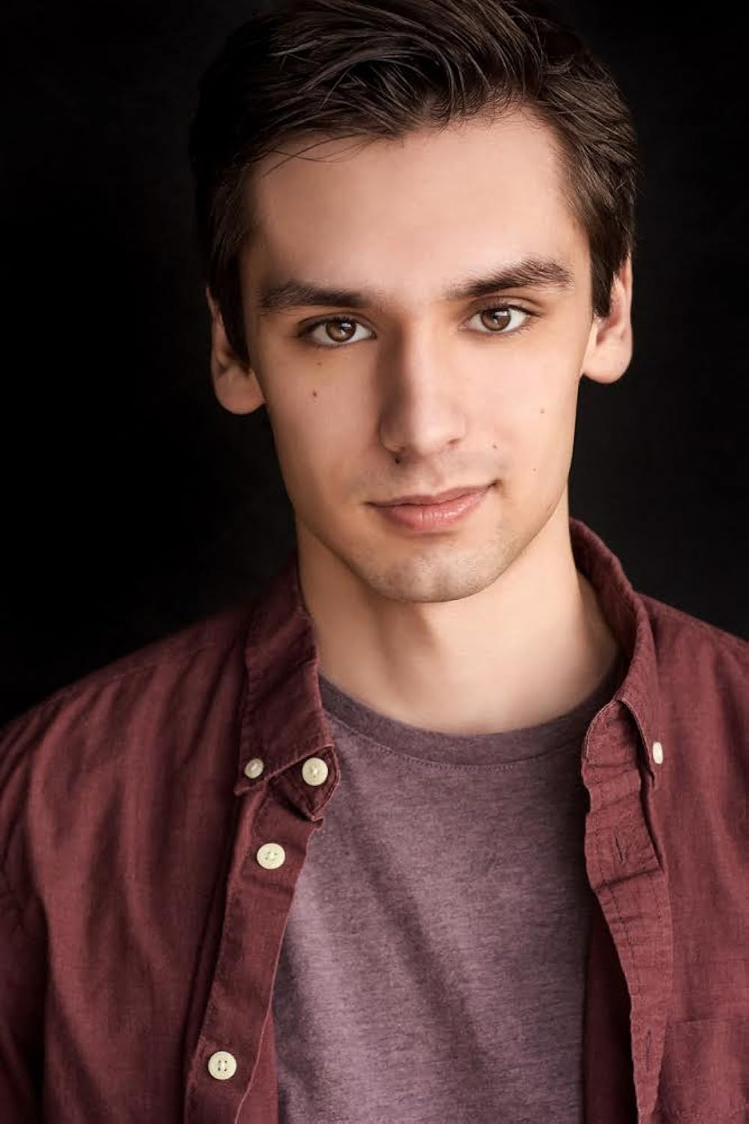
Jonthan Simao was born April 12 2000 in Burnaby BC and raised in White Rock BC. His interest in acting and storytelling came during his childhood but began being pursued and studied at the age of 12. After numerous classes and his experience with high-school theater his first booking came when he was 17 as the character Grey, a murder victim on the web-series Blue Steele. This personal success lead him to use his creative intuition of acting to make his own short films as a teenager. Which instantly sparked a fascination for the technical side of films. After studying in film school he found his creative intentions weren't being met, but felt inspired by the experience to create his first official short film "Separate Sights" (2020) with his other passionate filmmaker friends. Around the same time his career in acting suddenly picked up, when he landed the role of a non-verbal kid with autism, Kayden Peterson, in "When Time Got Louder" (2020) making this Jonathan's feature debut. He has also had a recurring role on the TV Series Turner & Hooch.
Growing up Jonathan has found himself to be confused and behave differently when socializing, he then found out at the age of 11 he was diagnosed with Asperger Syndrome, which explained the reason for some of his behaviors. This shocking news gave him the idea and confidence to use unique perspective to create characters and stories that are both different and relate-able for people to watch. Loyal and determined, has demonstrated great resilience and dedication to his work and the craft and plans to continue to keep striving till he feels an impact has made from his films.
Jonathan was nominated in 2023 for a Leo Award as Best Lead Performance by a Male for his work in When Time Got Louder
KATRINA KWAN
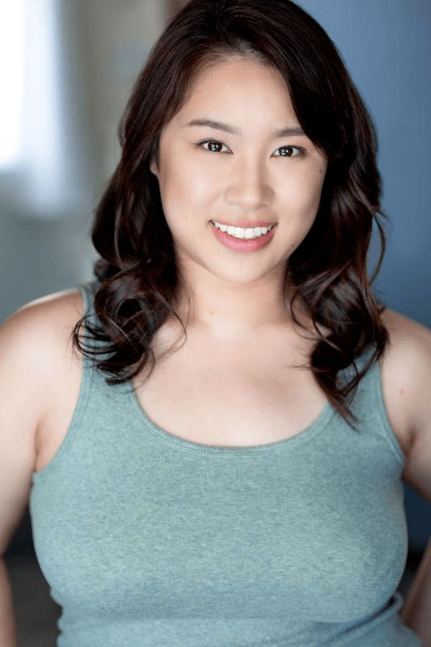
Katrina Kwan is a Canadian actress and author born January 20, 1995 in Vancouver, Canada. After graduating from Acadia University with a Bachelor of Arts in Political Science with Honors in 2017, she decided to pursue her love of acting. She is best known for her roles in Superman & Lois (2021), The Good Doctor (2017), A Million Little Things (2018), and In Loving Memory (2021).

Production Credits

Full Cast
Actors  LISA RINNA  BRIANA SKYE  JONATHAN SIMAO  BRADLEY STRYKER  KYLE CLARK  KWESI AMEYAW  JASON PAUL TREMBLAY  RAMUDHI EKANAYAKE  KELSEY LOPES  KATRINA KWAN  DELILAH BELLE HAMLIN  OLIVIA DUCAYEN  JILL MORRISON  JESSICA GARCIE  MARK PARINAS  JESSICA VAN DER VEEN  SHANNON COONEY  CHLOE KERR | Role  Madelyn  Mia  Eliot  Erik  Josh  Principal Allen  Scot  Emma  Zoey  Detective Bolton  Summer  Kira  Elizabeth  Piper  Phone Store Clerk  Barbara  French Teacher  Young Mia

Casting by
JUDY LEE

Production Designer
MOE CURTAIN

Director of Photography
MIKE KAM

Edited by
JASON NIELSEN

Music by
TAYLOR SWINDELLS
JORDAN KLASSEN

Written by
GREGG MCBRIDE

Directed by
GREG BEEMAN

Full Crew
LARISSA DIAS | Associate Producers
PARALEE COOK
TIM SPENCE
CELESTE CROWE
CELESTE CROWE | Production Manager
GRANT O’KANE | First Assistant Director
MICHAEL ALCANTARA | Second Assistant Director
RACHEL SUGDEN | Set Decorator
CHOLE BOHONOS | Assistant Set Decorators
ERIKA TING
TERRILYN BELL | Buyer
MADISON STENNER | Set Dec Buyer
ALLISHA WORSDELL | On Set Dresser
FRANTZ DE RYCKE | Set Dec Driver
MATT CARSOON | Lead Dresser
CONOR FERGUSON | Set Dressers
SEBASTIAN PAETKAU THIBAULT
ISOBEL BAKER-SMITH
KIERA CASTRO
NAOMI SOLANO
ANITA WALSH
TYE LESUEUR
DALLAN WALSH
MATTHEW HOSS BRUNT
NATHANIAL DAVIS
JAN SIKORA
ANDREW W R SIMPSON | Props Master
SHELDON MARVEL | Assistant Props Master
BABAK GOLKAR | Art Director
CASSANDRA KLEINSCHROTH | Key Hair Stylist
KEELY ANDERSON MAHON | Hair Assistant
KATHLEEN FOWLSTONE | Key Makeup Artist
ROSE MEKHAEL | 1st Makeup Assist
PAOLA ORTEGA | Makeup Artist
MICHELLE WATSON | Makeup & Hair Swing Assist
JULIA LOUISE ROSS | Costume Designer
ERICA STERRY | Assistant Costume Designer
ANNALEESE COCHRANE | Costume Dressers
ROBIN LYONS
AMÉRICA ARRIETA-PÉREZ
TEESHA HUNS
LILY QUIRIN
DUNCAN VOGEL
JARED LIM | Costume Truck Supervisor
TITOUAN FOURNIER | Camera Operator
CHARLES HADRIAN
BENJAMIN BURGIS
COENRAAD BEEN
JEN OSBORNE | Stills Photographer
SEPEHR MAHBOB | Gaffer
MOHSEN MAHBOB | Best Boy Electric
CHRISTIAN EICHMANN | Lamp Operators
ERIK MORTENSEN
EVAN MOYER
PARKER LIDIARD | Generator Operator
MITCHELL ROWLAND | Key Grip
WILLIAM S BENNETT | Best Boy Grip
DYLAN CAMPBELL | Grips
DYLAN MORIN
JORGE PREISSER ROMERO
KYLE MCKEACHIE | Dolly Grip
PETER GIBSON | Transport Coordinator
DOUGLAS HALVORSON | Transport Captain
GEORGINA CHURCH | Drivers
ROBIN LAWRENCE
GORDON MACKAY
JACK CHARLTON
CUBA WILD
BARRY HUNT | Security Coordinator
CATHY STRANBERG
SANDRA J SIGVARDSEN
JASON HUNT
PERRY PARSONS
MEGHAN RILEY
RICHARD PLUHOWY
NIGEL WILLIAMS | Location Manager
MATTHEW CAMPBELL | Location Scout
ED APPLEBY | Production Assistants
CHAD FRITSCH
ANASTASIA KONSTANTINOVA
MAHDI SELSELEH
MELISSA GOSSELIN
ALEXANDER PETROV
APRIL REES
TAD NAZAR | Production Sound Mixer
PAUL SONG | Boom Operator
SAM SUMINSUIT | Script Supervisors
JOAN HERMOSO
PARALEE COOK | Production Accountant
AMANDA PORTER | Payroll Accountant
CHRISTOPHER LOGAN | Production Accountant Assistant
SAM SUMINSUIT | Business Affairs
BROOK JAMES
KARRY CROFT | Production Coordinator
JESSICA OLSEN | Assistant Production Coordinator
SEAN MORAN | Craft Service/First Aid
KATHALEEN SMITH | Craft Service/First Aid Assistants
AALIYAH MORAN
JACOB CHILD | Third Assistant Director
PETER VAN DER GRIENT | Special Effects Coordinator
CAMERON WINTERS  JESSE GALANG  STEPHEN WIESE | Chef  Chef Assistants
LA HILTS | Extras Casting
ELFIE PAVLAKOVIC | Background Coordinator
TRACY FROESE | Stand-Ins
HAZEL ATKINS
LEA MATINA
COASTAL CLEARANCES | Script Clearances
CHANDLER FOGDEN LYMAN LAW CORPORATION | Legal Services
FRONT ROW INSURANCE BROKERS | Insurance
TIM SPENCE | Post Production Supervisor
RON PENCHALAIYA | Online Editor
HRANT AHANISYAN | Assistant Editor
SEAN TRAVERS | Colourist
MICHAEL CREBER | Choir Arrangements & Piano
MONIQUE CREBER | Singers Contracted & Conducted
JASON SAKAKI | Vocals
GRAHAM VERCHERE
MICHELLE CREBER
TAYLOR MCKEE
MAVERICK POST GROUP | Post Audio Facilities
GREGOR PHILLIPS | Supervising Sound Editor
MATT DAWSON, MPSE | Dialogue Editor
CRAIG GEORGE | SFX Editor
DEVON QUELCH | Foley Artists
ALEX MACIA
MATIAS GIBBS | Foley Editor
JEFF GROUT | ADR Mixer
GREGOR PHILLIPS | Re-Recording Mixer

Producer Biographies

TIMOTHY O. JOHNSON – Executive Producer
Timothy O. Johnson is among the most active and reliable producers in the business thanks to top rate productions and global distribution appeal. He is the managing partner of Johnson Production Group, a Canadian based operation that produces over 100 hours of dramatic television annually with hundreds of programs running internationally. The company is the leader supplier to Lifetime, Hallmark and other international outlets.
A graduate of the Marshall School of Business at the University of Southern California, he served as President of the USC Entertainment Management Association and a member of the Advisory Committee of the Center for Entrepreneurial Studies.
Johnson is also responsible for producing the international hit series, DR. QUINN, MEDICINE WOMAN for CBS for over 5 seasons. During his 100-episode tenure, he also developed and produced the original docu-drama COLD CASE for CBS network, which was the very first program to integrate television with the Internet.
Most recently, Johnson has produced the THE NOEL DIARY, being the #1 Film on Netflix’s Top 10 list in December of 2022. He was also at the helm of the successful GIRL IN THE SHED: THE KIDNAPPING OF ABBY HERNANDEZ, as well as the V.C. Andrews series of films, to date including TWILIGHT’S CHILD, MIDNIGHT WHISPERS, and DAWN, all produced for Lifetime..
Johnson has produced over 400 movies and 15 globally released series for every major US network - including Netflix, Lifetime, Hallmark, ABC, Disney, CBS, NBC, Netfly, FOX and Sony.

JOHNSON PRODUCTION GROUP
The Johnson Production Group contracts globally to produce television content for international networks, studios and distributors. Based in Los Angeles and Vancouver, British Columbia, the company manages production, facilitates development and financing, procures distribution and guarantees quality and timely execution of its programs. While costs have gone up, so has the demand for quality. No longer is good enough, good enough. Johnson Production Group serves that segment when a show needs to be "A" quality, but produced efficiently enough to meet a locked budget. JPG specializes in value, protection of creative elements, and delivery of a quality finished product.
OLIVER DE CAIGNY – Executive Producer
Oliver De Caigny is a Canadian producer originally from Belgium, his background in financing, production, and post production makes him a well-rounded producer for any type of production. His experience in financing and production agreements (film and TV series and movies-of-the week), distribution agreements (both domestic and foreign) as well as international co-productions, Canadian tax credit, Telefilm Canada and Canada Media Fund incentives provides him with a well-rounded background in development, production and distribution for motion pictures, television series and productions.

STACY MANDELBERG – Executive Producer
Stacy Mandelberg attended Stanford University’s Mass Media Institute, Northwestern University School of Speech for a BS in Radio, Television and Film, and obtained her Masters of Fine Arts, Film at New York University School of the Arts. She is now the Head of Creative at Johnson Production Group and has had an extensive career in senior executive roles at New World Television, von Zerneck Sertner Films, Wilshire Court Productions, Atmosphere Entertainment, CBS and most recently, Sony/TriStar Television where she oversaw Showtime’s “On Becoming a God in Central Florida”. Stacy is known as a producer of TV movies including Switched Before Birth, Girl Positive, and Haunting Sarah (Lifetime), The Real World Movie (MTV), Sweetwater: A True Rock Story (VH1 Network), Bad to the Bone (ABC) and Crazy Horse (TNT). Additionally she produced several series including The Dovekeepers and The Doris Duke Story (CBS), as well as Robin Cook's Invasion (NBC).
NAVID SOOFI – Producer
Navid is the primary producer for Novus Ordo Seclorum. Navid’s passion for filmmaking along with his business and engineering background plays an important role in creating a successful and transparent business model. Navid has been in the entertainment industry for more than 13 years and has produced over 50 feature films, TV shows and commercials that have been featured on national television, international theatres, and new media platforms. His credits include Over the Moon in Love, The Mistletoe Secret, Random Acts of Christmas, Love Unleashed, Identity Theft of a Cheerleader, and A Mother on the Edge.

Billing Block
LIFETIME In Association with JOHNSON PRODUCTION GROUP presents MOMMY MEANEST starring LISA RINNA BRIANA SKYE BRADLEY STRYKER DELILAH BELLE HAMLIN JONATHAN SIMAO KATRINA KWAN Casting by JUDY LEE Production Designer MOE CURTAIN Director of Photography MIKE KAM Edited by JASON NIELSEN Music by TAYLOR SWINDELLS JORDAN KLASSEN Supervising Producer TIM MUDD Executive Producers OLIVER DE CAIGNY LISA RINNA TIMOTHY O. JOHNSON STACY MANDELBERG Produced by NAVID SOOFI Written by GREGG MCBRIDE Directed by GREG BEEMAN

With the participation of the Province of British Columbia
Film Incentive BC
The Canadian Film or Video Production Tax Credit

© MMXXIV Stalking Productions Inc. All Rights Reserved




Meta Data
LONG (max 3000 characters) synopsis
Inspired by a true event, this film follows the story of high school senior Mia and her divorced mother, Madelyn. Soon after Mia starts dating her school’s football star, Mia starts to receive harassing and hurtful texts, DM’s, etc. Madelyn seemingly tries to help resolve the situation until it is revealed to the viewer that Madelyn is the cyberbully. The bullying worsens, until Mia discovers her mother is the actual harasser. (433)
MEDIUM (max 500) synopsis
Inspired by a true event, this film follows the story of high school senior Mia and her divorced mother, Madelyn. Soon after Mia starts dating her school’s football star, Mia starts to receive harassing and hurtful texts, DM’s, etc. Madelyn seemingly tries to help resolve the situation until it is revealed to the viewer that Madelyn is the cyberbully. The bullying worsens, until Mia discovers her mother is the actual harasser. (433)
SHORT (max 100 characters) synopsis
A cyberbullied teen has the support of her mother; but discovers her mother is the actual harasser. (99)
5 KEY WORDS
Cyberbully, high school, jealousy, divorce

