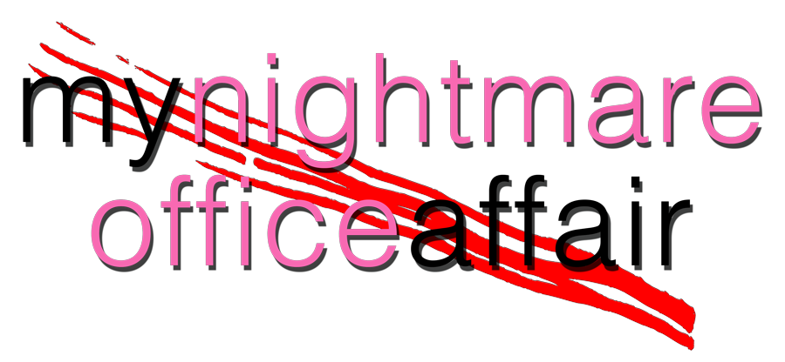

Johnson Production Group

Press Kit

One-Liner
When a successful executive tries to break off an affair with his boss, he finds himself in a dangerous game with her that threatens his job, his family and his life.

Synopsis

When Nick Sherman gets the promotion of a lifetime, it comes with an unexpected cost. As he gets closer to his boss, Lisa, he begins to realize that the extra hours he's putting in may be putting his family life in jeopardy as Lisa becomes more obsessed with him. Nick's wife Jennifer and young daughter, Julianna, suffer the consequences and try to stay out of danger's path as Lisa intertwines herself in their lives and Nick must decide between work and family.

Producers
Executive Producers
TIMOTHY O. JOHNSON
JOSEPH WILKA
Producer
A.J. KELLY
Line Producer
JACOB HORN

Key Cast
CHARACTER  Lisa  Nick Sherman  Jennifer Sherman  Bob  Cassie |  | ACTOR  LAURIE FORTIER  MARC HERRMAN  KRISTI MURDOCK  MATTHEW POHLKAMP  ELIZABETH SINGH

Key Cast Biographies

LAURIE FORTIER
Laurie has been working professionally for over 20 years and has worked with legends including Michelle Pfeiffer, James Gandolfini, James Caan, Dennis Hopper, Martin Landau, Danny Aiello and Hugh Laurie to name only a few. Laurie played real life cop Donna Kading, opposite Josh Duhamel in the USA Network series, Unsolved: a true crime story about the murder of Biggie Smalls and Tupac Shakur and was thrilled to work with Emmy award winning director, Anthony Hemmingway. She has also starred in numerous movies made for Lifetime including, "Into the Arms of Danger" alongside Cathy Moriarty, "In Bed with a Killer", "Erasing His Dark Past" and "My Mom's Darkest Secrets". With a wide breadth of success in TV & Film, Laurie was most recently seen in DC's Swamp Thing for CW. She has been in: every version of CSI (multiple times), Hawaii Five-O, Castle, Rush, Stalker, and 2 seasons of the Netflix original series Hemlock Grove opposite Dougray Scott and Famke Jansen. She starred in the Warner Brothers film The In Crowd and got her start acting in "To Gillian on Her 37th Birthday", opposite Michelle Pffiefer, Peter Gallagher and Claire Danes, where she was cast by legendary casting director Lynn Stalmaster (Tootsie, The Graduate).
Laurie is thrilled that in her career she has been offered numerous prime time roles as mothers, male (yes male) con artists, maniacs, the girl next door, high powered attorneys, cops, victims, perps, athletes and devilish villains. From "kindhearted heroines" to the "evil monster", Laurie Fortier has been blessed with the gift of true versatility.

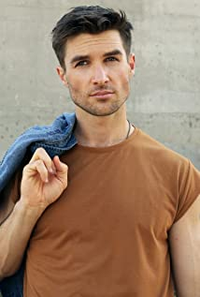
MARC HERRMAN
Marc Herrmann is an LA based actor, writer and director whose career has taken off in the last couple of years. From producing his own award nominated shorts to appearing in multiple films, Marc has been very busy. He starred in Deadly Mile High Club, Killer Cover Up, Love OnThe Reef and 5 South. He has also had roles in Ashley Jones Is Perfectly Normal, Secrets Exposed, Christmas In Pine Valley, Christmas Together, and The Wrong Cheer Captain.

KRISTI MURDOCK
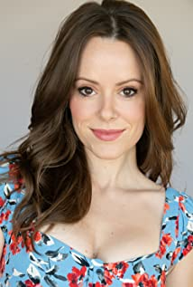
Kristi is a classically trained, diverse actress with a wide emotional range. She began her training studying the methods of Uta Hagen while at the University of North Carolina at Wilmington, where she joined the National Theatre Honor Society, Alpha Psi Omega, after tackling roles in various university & community theatrical productions. She is a member of SAG-AFTRA & the Television Academy.
She leads a busy professional life with film roles in Trust in Love, Husband, Wife & Their Lover, Spring Break Nightmare, A Furry Little Christmas, Melons, Hazardous Duty, Secrets on Sorority Row, The New HOA President, No Way to Die, Rapture Camp, Reflections and Who Stole My Daughter?

MATTHEW POHLKAMP
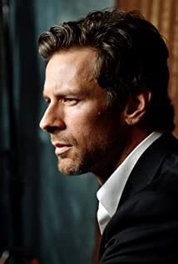
Originally from the west side of Cincinnati, OH, Matt at age 10 found passion in BMX bicycle racing and quickly climbed his way to the top of the sport turning professional at age 20. With numerous national and a world title to his credit, he still competes in the Masters Professional division at the international level. Matt found acting as a way to mentally get away from the demanding grind of professional athletics and has now become his new passion.
His many successes have included Sinister Stepsister, Student Seduction, If Walls Could Talk, The Wrong Blind Date, Dancer in Danger, Deadly Garage Sale, Dangerous Snow Day, Party from Hell, Designed for Death, Her Deadly Boyfriend, Behind Closed Doors, and Dangerous Medicine, amongst others.
ELIZABETH SINGH
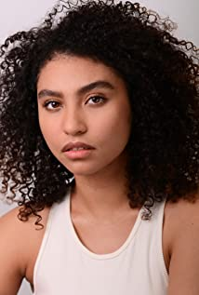
Elizabeth Singh is an American actress born in Rochester, NY and raised in Los Angeles, CA since the age of 5. Elizabeth always having a love for the performing arts, with a 7 year background in dance, Elizabeth began to expand her artistic journey in motion pictures at the age of 19. She is best known for her supporting role as Jess Franklin on Lifetime Network's drama/thriller feature film, "Sins in the Suburbs," and as Chloe Pena in "Secrets on Campus".

Production Credits

Full Cast
Actors  LAURIE FORTIER  MARC HERRMAN  KRISTI MURDOCK  MATTHEW POHLKAMP  ELIZABETH SINGH  ALANI JADE  SPRING PEÑA  KIMBERLY HILL  ALYSON HALBREICH  BOURKE FLOYD  EMILY VILLARREAL | Role  Lisa  Nick Sherman  Jennifer Sherman  Bob  Cassie  Julianna Sherman  Detective  Caseworker  Teenage Lisa  Businessman  Commercial Woman

Casting By
JEFF HARDWICK CSA

Production Designer
ROBERT WISE

Director of Photography
ZACH SALSMAN

Edited By
JAMES KONDELIK

Composer
KEVIN BLUMENFELD

Written By
JOHN HAYES

Directed By
KAILA YORK

Other Crew
SARA PEDERSEN | First Assistant Director
KAYLA MASON | Second Assistant Director
TYLER DUVAL
NOEL MAGNUSSON | Prop Master
FRED MANCHENTO | Art Director
ASHLEY BAKER
KESHIA SMITH | Make-up Artist
CORTNEY WATSON | Hair Stylist
DESHON GREY | Additional Stylist
NATHAN MEADE | Steadicam Operator
ANDRESSA COR | 1st Assistant Camera
SIERRA BOVE
GEORGE ELLETT
AMY FRYE | 2nd Assistant Camera
NOAH NELSON
FONG KUO
PETE AGUIRRE | Media Manager
KEN SAX | Stills Photographer
JEFF MARLOWE | Gaffer
DEVIN CONNER | Best Boy Electric
NATHAN ALEXANDER | Electric
PETER G HOWELL | Key Grip
SERGIO NAVA | Best Boy Grip
JOSHUA TOLON | Dolly Grip
JOAQUIN CRUZ
KINGSLEY COSTIN
CHRISTOPHER GRAJALES
MATT JONES
SUSAN DOEPNER-SENAC | Costume Designer
ADRIENNE REISHUS | Wardrobe Assistant
CORY COLLINGS
ERIC ENROTH | Production Sound Mixer
ADAM BROOKS | Boom Operator
TONI CREY | Script Supervisor
AMANDA SEARS | Production Manager
KARIM PHELPS | Safety Coordinator
MIKE ESCAMILLA | Safety Co-Cordinator
ARIES LOUIZIA | Production Assistants
BROOKE SHARLAND
KAT NOLTE
DOM PONIAC
 | Dialogue Editors
 | Sound Editors
 | Foley Recordist
 | Foley Artist
 | Foley Editor
 | Re-Recording Mixers
HOLLYWOOD SCRIPT CLEARANCE | Script Clearance
 | ADR Facilities
 | Visual Effects
ABACUS INSURANCE BROKERS, INC | Insurance
BLUELINE FINISHING | Post Production Services
 | Colorist
WELL DONE CATERING | Catering
RARE BREEDS | Cameras

Producer Biographies
TIM JOHNSON – Executive Producer
Tim Johnson is among the most active and reliable producers in the business thanks to top rate productions and global distribution appeal.
Johnson is also responsible for producing the international hit series, DR. QUINN, MEDICINE WOMAN for CBS for over 5 seasons. During his 100-episode tenure, he also developed and produced the original docu-drama COLD CASE for CBS network, which was the very first program to integrate television with the Internet.
Johnson has produced over 150 movies, 15 globally released series for every major US network - including ABC, Disney, CBS, NBC, Netfly, FOX and Sony.

JOHNSON PRODUCTION GROUP
The Johnson Production Group contracts globally to produce television content for international networks, studios and distributors. Based in Los Angeles and Vancouver, British Columbia, the company manages production, facilitates development and financing, procures distribution and guarantees quality and timely execution of its programs. While costs have gone up, so has the demand for quality. No longer is good enough, good enough. Johnson Production Group serves that segment when a show needs to be "A" quality, but produced efficiently enough to meet a locked budget. JPG specializes in value, protection of creative elements, and delivery of a quality finished product.

JOSEPH WILKA – Co-Executive Producer
Joseph Wilka is the Head of Production for Johnson Production Group. Los Angeles-based, Joseph had already produced and directed several feature films before serving as the senior marketing executive for Gravitas Ventures. While at Gravitas, Wilka helped pioneer new distribution models for independent films including day-and-date theatrical releases. It was also at Gravitas where Joseph first worked with Johnson Production Group to facilitate the release of their films to the worldwide Video On Demand audience. After serving as the Director of Distribution and Production for Viva Pictures, where he produced English-language versions of foreign animated titles for DirecTV, Wilka officially joined Johnson Production Group. As Head of Production, he oversees the development, production, and distribution of films from multiple production units for release on broadcast and streaming platforms.

A.J. KELLY – Producer
Producer and co-founder of the creative production company, Goodform, A.J. Kelly has spent the past decade creating film, television, documentary, experiential and branded content. His work has won awards at top festivals including Cannes & SXSW, aired on premium networks and received multi-cultural acclaim.
Based in Los Angeles, A.J. believes in elevating content from diverse creative voices and providing an outlet for filmmakers to bring their stories to life.

Billing Block
Johnson Production Group in association with Lifetime presents “MY NIGHTMARE OFFICCE AFFAIR” starring LAURIE FORTIER MARC HERRMAN KRISTI MURDOCK MATTHEW POHLKAMP AND ELIZABETH SINGH Casting By JEFF HARDWICK CSA Production Designer
ROBERT WISE Director of Photography ZACH SALSMAN Edited By JAMES KONDELIK Composer KEVIN BLUMENFELD Line Producer JACOB HORN Executive Producers JOSEPH WILKA TIMOTHY O. JOHNSON Produced By A.J. KELLY
Written By JOHN HAYES Directed By KAILA YORK
© MMXX Johnson Production Group Inc. All Rights Reserved
Meta Data
LONG (max 3000 characters) synopsis
When Nick Sherman gets the promotion of a lifetime, it comes with an unexpected cost. As he gets closer to his boss, Lisa, he begins to realize that the extra hours he's putting in may be putting his family life in jeopardy as Lisa becomes more obsessed with him. Nick's wife Jennifer and young daughter, Julianna, suffer the consequences and try to stay out of danger's path as Lisa intertwines herself in their lives and Nick must decide between work and family. (464)
MEDIUM (max 500) synopsis
Nick is a successful executive with a picture-perfect family, loving wife and adorable daughter. It looks like he has it all to his boss, Lisa, who desperately wants a child of her own. Lisa seduces Nick in his moment of weakness, hoping to remove his wife from the picture so she can fill her role as wife and mother. When Nick tries to break things off with Lisa, he finds himself in a dangerous game with her that threatens his job, his family and his life. (460)
SHORT (max 100 characters) synopsis
Nick’s job, family and life are threatened in a dangerous game when he ends an affair with his boss. (100)
5 KEY WORDS
Executive, boss, wife, affair, threats

