Johnson Production Group

Press Kit

One-Liner
When pursuing her dreams leads to a fractured relationship with her mother, a young student angrily leaves home, but soon finds herself the hostage of a deranged criminal who forces her to drive him across the country. Inspired by a True Story.

Synopsis
After accidentally killing his father, the handsome and charming Rick flees the scene of the crime. To avoid getting caught by the police, he asks the innocent Emma, a young student who recently left home after a disagreement with her mom, to drive him to the airport. What started out as a simple request for a ride, quickly turns into an active hostage situation, as Rick does everything he can to avoid getting caught by the authorities.

Producers
Executive Producers
TIMOTHY O. JOHNSON
JOSEPH WILKA
Producer
A.J. KELLY
Co-Producer
JACOB HORN
Line Producer
AMANDA SEARS

Key Cast
CHARACTER  Emma Simpson  Rick Hoover  Hillary Simpson  Detective Ramirez |  | ACTOR  VERONICA RAMIREZ  LUKAS CHARLES STAFFORD  CHALA SAVINO  GABRIELLA BIZIOU

Key Cast Biographies

VERONICA RAMIREZ
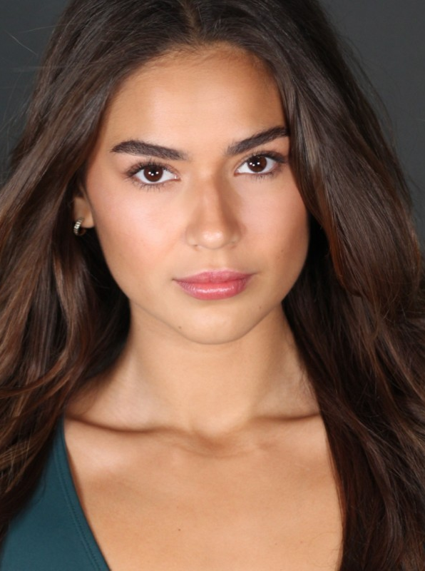
Actress Veronica Ramirez is originally from Toronto, Canada and now living in Los Angeles pursuing her career. She attended the New York Film Academy and has a Bachelor of Fine Arts In Acting for Film. Veronica has studied in various styles and techniques; trained in fighting and stunts; and is also professionally trained in multiple dance styles such as jazz, hip hop, tap and ballet

LUKAS CHARLES STAFFORD
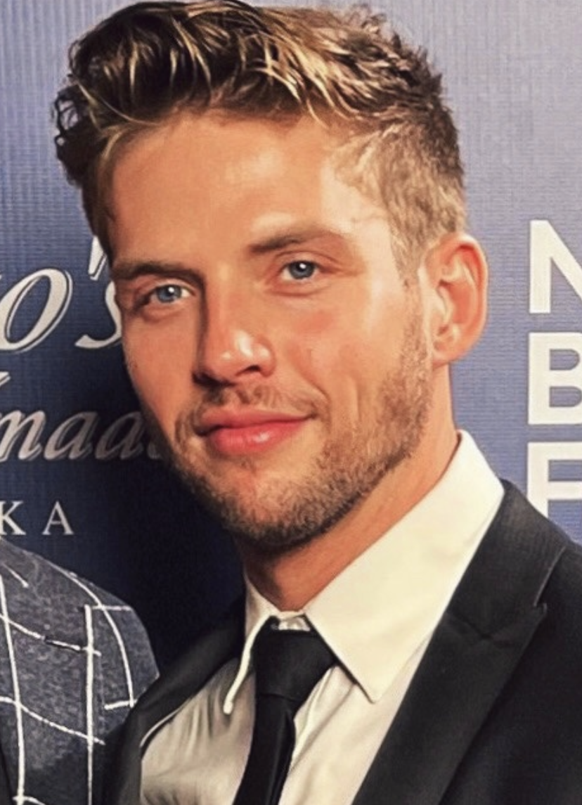
Lukas Charles Stafford is an American actor, singer, and songwriter best known for his work on multiple Lifetime Films, his portrayal as Tom Hawkins in East of Middle West (SAG-feature), acting for Carrie Underwood, his popular single, "Still Missin You", and for performing in Broadway's production of "Home for the Holidays".
Born and raised in small-town Anderson, Indiana, Luke began a passionate life in the Midwest working summer labor jobs, playing sports, serving at homeless shelters, and learning music at an early age. Luke is the son of two middle-class parents, Robert Sheldon Stafford Jr., a manufacturing plant manager, and Cathy Elaine Stafford (Putcho), a cafeteria worker and substitute teacher. A small town kid with humble, hard-working roots and big dreams; his deep love for film, music, and entertainment pushed him to move quickly.
At the age of 11, Luke picked up the saxophone and started learning musical theatre. At 18 years old, he graduated high school and began degrees in music, business, and theatre. During his college career, Stafford took every opportunity available outside of the classroom to grow his talents.
At 19, Luke began singing gospel music, playing the piano, and music directing for Celebration Church at Arrow Heights in his hometown. At 21, he took his first lead live-performance role in Cedar Point's, "Luminosity", Cedar Fair's highest-grossing pop show, located in Sandusky, Ohio and produced by Pepsi. At 22, Luke took his first role on screen, joining Carrie Underwood in her 2016 hit music video, "Dirty Laundry". Starting at the top of the following year, he began his first domestic tour with Sheldon Reynolds of Earth, Wind, and Fire, hosted by Kalimba: The Spirit of EWF. Dreams destined for something greater, Luke finished his college degrees and moved to Los Angeles where his career expanded quickly.
In late 2017, he moved to New York City for his Broadway debut in "Home for the Holidays" playing saxophone and singing back-up for (American Idol winner) Candice Glover, (America's Got Talent champion) Bianca Ryan, (The Voice champion) Josh Kauffman, and (YouTube sensations) Peter and Evynne Hollens. He returned to LA in 2018, where later that year he starred in "By & By", a film directed by Brian Lucke Anderson.
In fall of 2019, Luke made his feature film debut as Tom Hawkins in "East of Middle West" (SAG-feature), produced by Stained Glass Productions in Los Angeles, and filmed in Iowa City, Iowa.
Recently, in late 2022, he released his first original song, "Still Missin You", making it's way quickly to thousands of fresh ears.
This fall, Luke will be seen playing the leading man in the Lifetime thriller, "The Student", directed by Brian Skiba.
Still a simple soul from the Midwest, Luke dreams of sowing back into society with his work supporting homelessness communities and sex-trafficking prevention across the states. His free-time hobbies include playing piano, leading worship music for his local communities, and riding his 2007 Harley Sportster, "Roxanne," across-country. He enjoys writing, reading, football, and smoking his pipe (paired with a fine scotch) whenever there's something worth celebrating.

CHALA SAVINO
Actress Chala Savino obtained her Bachelor’s degree in Theater from Wichita State University, attended School For Film and Television and The Second City Conservatory and Music Conservatory, where she honed her skills in Improv, Sketch and Musical Sketch. While she has an extensive live theater career and has been the lead in several short films, she has had several film roles including A Miracle Before Christmas, Honey Boy (w/Shia LeBouef), Barbershop The Final Cut and Soy Nero (w/Johnny Ortiz). She has been a guest star for 10 episodes on Saturday Night Live, had recurring roles on Young and the Restless, Days of Our Lives and All My Children. She has also had roles in Truth Be Told, All American and The Eleventh.

GABRIELLA BIZIOU
Gabriella Biziou is an American born actress from Austin, TX. Her first agent found her after being impressed by her performance in an acting class in Austin and she and began acting professionally in Texas before moving to Los Angeles, CA. She won the "Best of Indi" Actor Award in 2016 and her past film work have claimed 9 awards from independent film festivals and counting.

Production Credits

Full Cast
Actors  VERONICA RAMIREZ  LUKAS CHARLES STAFFORD  CHALA SAVINO  GABRIELLA BIZIOU  CHRISTOPHER SKY  CIRCUS-SZALEWSKI  JENNIFER CASTILLO  LISA LONG  NICOLE ANDREWS | Role  Emma Simpson  Rick Hoover  Hillary Simpson  Detective Ramirez  Detective Graves  Charles Hoover  Katy  Motel Clerk  Linda

Casting By
JEFF HARDWICK CSA

Production Designer
MATT WALKER

Director of Photography
ANDRESSA CORDEIRO

Edited By
QUINN ELSE

Music By
RYAN GARRISON

Written By
JOHN HAYES

Directed By
KAILA YORK

Other Crew
ANDREW JUKES | First Assistant Director
NATHAN DE LORIMIER | Second Assistant Director
NATALIE BRADY | Second Second Assistant Director
ABIGAIL PEREZ | Art Directors
BLOSSOM CHIDDICK
JARON FLYNN | Set Dresser
EMILY MEFFORD | Key Make-up Artist
SARAH KRASNIANSKI | Key Hair Stylist
CATHERINE BESLER | Additional Stylists
KELLY TORRES
TYSON GALLAND | Second Camera Op
RYAN MAGRISH | 1st Assistant Camera
RUOYU ZHANG | 2nd Assistant Camera
MORGAN MILLER
PEDRO AGUIRRE | Media Manager
KEN SAX | Stills Photographers
ABE ATRI
TOM LEDUC | Gaffers
JEFF MARLOWE
TAYLOR HUDDLESTON | Additional Gaffer
AARON ROMO | Best Boy Electric
DEVIN CONNOR | Additional BBEs
NATHAN ALEXANDER
MAILE EDWARDS
DUSHENE FOSTER | Key Grips
PETER G HOWELL
CHENG XU | Best Boy Grip
JOSHUA TOLON | Additional BBG
CHAD MARSHALL | Dolly Grip/Swing
JESSICA MAURICIO | Costume Designer
SOHN GUESSFORD | Wardrobe Assistant
JASON BODILY | Production Sound Mixer
MARIA-CAREY WALTON | Script Supervisor
TRAVIS PILAT | Production Manager
KARIM PHELPS | Safety Coordinator
ARIES LOUIZIA | Production Assistants
BROOKE SHARLAND
BRANDON HILL
GABAR CHOLI
ANDREW SILAGY | Supervising Sound Editor
LUIS MURGUIA | Sound Designer
ARTEM SEMENOV | Re-Recording Mixer
MATÍAS BELTRANDO | Dialogue Editor
PATRICK EVANS | Post Production Supervisor
CHANGING FRAMES | Post Production Services
JEFF SPOTT | Colorist
ANTHONY CAMPAGNA | Finishing Artist
HOLLYWOOD SCRIPT CLEARANCE | Script Clearance
PRIVATE ISLAND AUDIO | ADR Facilities
RISING TIDE EFFECTS | Visual Effects
TARANTULA
GOODFORM
ABACUS INSURANCE BROKERS, INC | Insurance
BOYS IN THE KITCHEN | Catering
TOO TASTY CATERING
LORI’S KITCHEN
RARE BREEDS | Cameras
SIMMI SINGH | Special Thanks
JOHN AUGUSTINI

Producer Biographies

TIM JOHNSON – Executive Producer
Tim Johnson is among the most active and reliable producers in the business thanks to top rate productions and global distribution appeal.
Johnson is also responsible for producing the international hit series, DR. QUINN, MEDICINE WOMAN for CBS for over 5 seasons. During his 100-episode tenure, he also developed and produced the original docu-drama COLD CASE for CBS network, which was the very first program to integrate television with the Internet.
Johnson has produced over 150 movies, 15 globally released series for every major US network - including ABC, Disney, CBS, NBC, Netfly, FOX and Sony.

JOHNSON PRODUCTION GROUP
The Johnson Production Group contracts globally to produce television content for international networks, studios and distributors. Based in Los Angeles and Vancouver, British Columbia, the company manages production, facilitates development and financing, procures distribution and guarantees quality and timely execution of its programs. While costs have gone up, so has the demand for quality. No longer is good enough, good enough. Johnson Production Group serves that segment when a show needs to be "A" quality, but produced efficiently enough to meet a locked budget. JPG specializes in value, protection of creative elements, and delivery of a quality finished product.

JOSEPH WILKA – Executive Producer
Joseph Wilka is the Head of Production for Johnson Production Group. Los Angeles-based, Joseph had already produced and directed several feature films before serving as the senior marketing executive for Gravitas Ventures. While at Gravitas, Wilka helped pioneer new distribution models for independent films including day-and-date theatrical releases. It was also at Gravitas where Joseph first worked with Johnson Production Group to facilitate the release of their films to the worldwide Video On Demand audience. After serving as the Director of Distribution and Production for Viva Pictures, where he produced English-language versions of foreign animated titles for DirecTV, Wilka officially joined Johnson Production Group. As Head of Production, he oversees the development, production, and distribution of films from multiple production units for release on broadcast and streaming platforms.

A.J. KELLY – Producer
Producer and co-founder of the creative production company, Goodform, A.J. Kelly has spent the past decade creating film, television, documentary, experiential and branded content. His work has won awards at top festivals including Cannes & SXSW, aired on premium networks and received multi-cultural acclaim.
Based in Los Angeles, A.J. believes in elevating content from diverse creative voices and providing an outlet for filmmakers to bring their stories to life.

JACOB HORN – Co-Producer
Jacob Horn began his career in the entertainment industry by working his way up through Elijah Wood’s production company, Spectrevision. With them, he was able to gain producing experience with directors such as Nacho Vigalondo and Josh Waller. After leaving Spectrevision, Jacob went out on his own to produce and direct his own content including several short films, a Christmas feature for Hallmark , and also becoming the Stunt Dept Manager on Once Upon A Time In Hollywood. At present, Jacob is the Head of Production for GoodFlix, a feature film production company where he oversees an annual slate of films.

AMANDA SEARS – Line Producer
Born in Denmark, Amanda has been interested in movies since she was a young kid. At age 15 she joined a 3-year film program, where she worked on multiple internationally award-winning short films, before eventually making her way to Los Angeles to pursue her dreams as a producer. She has been working as a coordinator with GoodFlix since the winter of 2021 before getting the chance to Line Produce her first feature film in the fall of 2022.
In her free time, she enjoys skydiving and martial arts.

Billing Block
Lifetime Presents In Association with Johnson Production Group ROAD TRIP HOSTAGE
starring VERONICA RAMIREZ LUKAS CHARLES STAFFORD CHALA SAVINO GABRIELLA BIZIOU Casting By JEFF HARDWICK CSA Production Designer MATT WALKER Director of Photography ANDRESSA CORDEIRO Edited By QUINN ELSE Music By RYAN GARRISON Line Producer AMANDA SEARS
Co-Producer JACOB HORN Executive Producers JOSEPH WILKA TIMOTHY O. JOHNSON
Produced By A.J. KELLY Written By JOHN HAYES Directed By KAILA YORK

© MMXXIII Johnson Production Group Inc. All Rights Reserved

Meta Data
LONG (max 3000 characters) synopsis
After accidentally killing his father, the handsome and charming Rick flees the scene of the crime. To avoid getting caught by the police, he asks the innocent Emma to drive him to the airport. Emma is a young student who had angrily left home when pursuing her dreams led to a fractured relationship with her mother. What started out as a simple request for a ride, quickly turns into an active hostage situation, as Rick does everything he can to avoid getting caught by the authorities. (491)
MEDIUM (max 500) synopsis
After accidentally killing his father, the handsome and charming Rick flees the scene of the crime. To avoid getting caught by the police, he asks the innocent Emma to drive him to the airport. Emma is a young student who had angrily left home when pursuing her dreams led to a fractured relationship with her mother. What started out as a simple request for a ride, quickly turns into an active hostage situation, as Rick does everything he can to avoid getting caught by the authorities. (491)
SHORT (max 100 characters) synopsis
A rebellious girl becomes hostage to a deranged criminal and has to drive him across the country. (98)
5 KEY WORDS
Dancer, dreams, mother, criminal, car

