Johnson Production Group

Press Kit

One-Liner
An escalating series of unfortunate events keeps delaying a young woman’s journey to her sister’s wedding – a journey she is forced to take with the guy who was her biggest rival in high school.

Synopsis
Megan loves her sister Blair, who’s getting married in three days. As the maid of honor, Megan needs to be there for the bachelorette party, the rehearsal dinner and the big event. But her trip from Denver to Wichita hits a disastrous parade of bumps: a baggage handlers’ striker closes the Denver airport, the car she rents to drive to Kansas is stolen, the replacement car ends up in a ditch, and it’s hauled for repair to an off-the-beaten-track town which is holding its annual Renaissance Fair and temporarily off-the-grid. She misses the party, the dinner – and she’s in real danger of missing the wedding.
Traveling with her is Alden, who was a constant thorn in her side in high school, where they competed in everything (debate club, pep squad, etc.). He needs to get to Wichita for his dad’s retirement celebration. Joined at the hip for three days, all the annoyances and grudges of the past are front and center – until they’re not. Forced to really be together, they slowly realize how much they have in common and how that high school rivalry masked a strong mutual attraction.
Meanwhile, in Wichita Blair goes through the steps of preparing for marriage without her sister there to act as maid of honor. Her bestie, Della, steps in as a marker – and increasingly falls in love with the idea of being maid of honor for real.
Will Megan and Alden make it to Wichita in time? Will Della be willing to step aside? Come on the journey with us and find out.

Producers
Executive Producers
TIMOTHY O. JOHNSON
ANDREW C. ERIN
THOMAS STANFORD
STEVE N. WHITE
Co-Executive Producer
JOSEPH WILKA
Producer
HAYDEN BAPTISTE
Supervising Producer
OLIVER DE CAIGNY

Key Cast
CHARACTER  Margo Miller  Alden Brown  Blair Miller  Della Simmons  Edie Miller  Charlie  Zadie  Leanne O'Riley |  | ACTOR  NATALIE HALL  COREY SEVIER  JULIA BORSELLINO  ELANA DUNKELMAN  WENDY GERMAN  TIM PROGOSH  DANIELLE BOURGON  TRACY RANKIN

Key Cast Biographies

NATALIE HALL
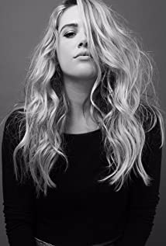
Natalie Hall is a talented and versatile actor and singer. Most recently Natalie starred in a in the Blumhouse anthology series INTO THE DARK for Hulu, as well as opposite Carla Gugino as in Sebastian Gutierrez Cinemax series JETT. She is well known to television audiences for playing the feisty stripper/mogul “Candi Coco” on the critically acclaimed comedy series UNREAL and for her memorable arcs on HBO’s TRUE BLOOD, USA’s ROYAL PAINS and the CW series CHARMED. In addition, Natalie was one of the leads of STAR-CROSSED for the CW and of the UNT. MARC CHERRY PILOT for ABC and has appeared on hit shows like NCIS: NEW ORLEANS, LAW AND ORDER: SVU, THE GOOD WIFE, CSI and PRETTY LITTLE LIARS. Also a very talented vocalist, Natalie has performed on stage in CRUEL INTENTIONS: THE MUSICAL and A CHORUS LINE, for which she received an Ovation Nomination for Best Supporting Actress in the latter. On the feature side, Natalie played opposite Miles Teller in the Sony/Lionsgate feature ONLY THE BRAVE and starred in the independent films SUMMER OF 8, THE BOY DOWNSTAIRS, THE CURSE OF SLEEPING BEAUTY, PLUS ONE, STILL LIFE, and RISING STARS. She has also been the lead of the highly rated Hallmark MOWs YOU’RE BACON ME CRAZY, A WINTER PRINCESS, FIT FOR A PRINCE, SEVEN YEAR HITCH and LOVE’S CHRISTMAS JOURNEY.

COREY SEVIER
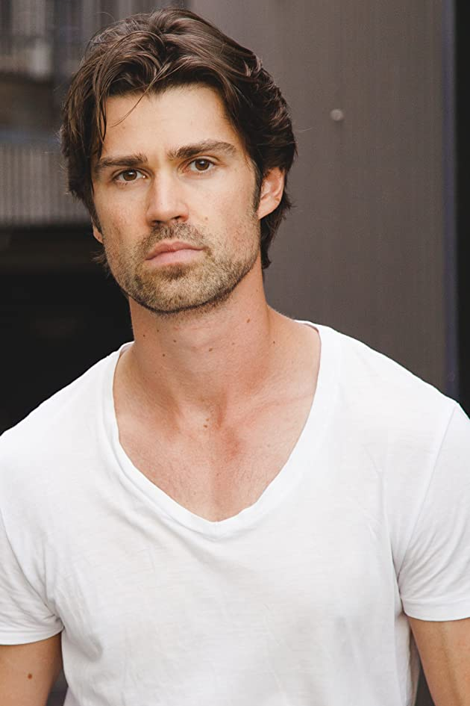
Corey Sevier is a Canadian actor whose career began at the age of seven. He landed the role of "Timmy" in the 90's version of the prolific series LASSIE then starred in PAX's period drama LITTLE MEN, the WB's martial art series BLACK SASH and FOX's steamy drama NORTH SHORE. Sevier has also guest-starred in numerous well-known series, among them PSYCH, CSI MIAMI, SMALLVILLE, SUPERNATURAL and MURDOCH MYSTERIES. Recently, he had recurring roles as "Seth Gunderson" in the Hallmark Channel series CEDAR COVE and as "David Hudson" in ABC’s MISTRESSES. He's also become a fixture in MOWs through his work on Hallmark’s NORTHERN LIGHTS OF CHRISTMAS, Lifetime’s GROUNDED FOR CHRISTMAS, LOVE IN TRANSLATION, LOVE IN WHITBROOKE, MEET ME IN NEW YORK, IT TAKES A CHRISTMAS VILLAGE (which he also directed) and the upcoming THE SECRET SAUCE and GET ME TO THE WEDDING ON TIME. Feature film work includes his role as "Apollo" in Tarsem Singh's epic IMMORTALS, THE NORTHLANDER, DECOYS and THE CORRUPTION OF DIVINE PROVIDENCE.

JULIA BORSELLINO
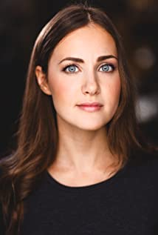
Canadian actress and producer, Julia Borsellino, is known for her roles in the TV movies On the Basis of Sex, Next-Door Nightmare, The Perfect Wedding and You May Kiss the Bridesmaid. She has also had a recurring role in the Podcast series Real Legitimate Anthology as well as the TV Series Bad Roommate.

ELANA DUNKELMAN
Quebec born Elana Dunkelman is a Canadian based actress and voiceover artist. She stars as the title role, Fenyx, in Ubisoft's latest action adventure video game Immortals Fenyx Rising. She was recently nominated for a Canadian Game Award in Best Performance for her work as Fenyx.
Elana makes Toronto her home but jets back to her hometown of Montreal to work both on camera and in the voice booth, and of course, to eat bagels. She obtained a performing degree from Dawson College and continues her studies with Matthew Harrison of the Actor’s Foundry.
Elana is known for principal roles in The Bold Type, Transplan, Rule of 3, Good Sam and Murdoch Mysteries, along with Assassin's Creed: Odyssey (2018).

WENDY GERMAN
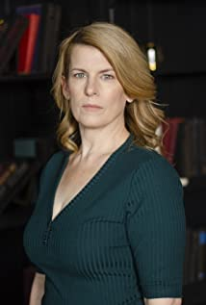
Wendy German is a Canadian film & theatre actress and director. After getting her acting start at Windsor Light Music Theatre, Wendy began performing in live shows with Cardinal Productions and Migration Hall, including Bye Bye Birdie, The King and I, Legally Blonde, and Beauty & The Beast. A talented theatre professional both on- and off-stage, Wendy's passion for acting and arts management led her to take her talents on-screen in 2016, landing her roles in several television shows including Haunted Case Files, Web of Lies, Paranormal 911, and Paranormal Nightshift. Wendy has also appeared in several short films, including The Acrylic, In Her City, and Sweet Revenge, a film which went on to be honoured at Kevin Hart's Just For Laughs Film Festival in 2018. In that same year, Wendy starred in Clash, a Nigerian-Canadian film that reached the #1 position on Netflix Nigeria and is making waves around the world after being released on Netflix platforms worldwide in July 2021. Wendy is also set to appear in upcoming episodes of Paranormal Hotline and Time to Kill and has recently directed and acted in Finding Orleen, a short documentary film that is due to be released later this year.

TIM PROGOSH
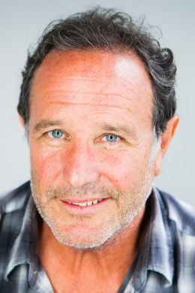
Tim Progosh is a Canadian actor and the creator and original producer of the Canadian Comedy Awards, an annual awards presentation that celebrates Canadian comedy in a variety of media (TV, radio, film, the Internet, etc.) inaugurated in 2000.
His most notable roles include Principal Bill Kremeza in the 2015 award-winning film Spotlight, which won the Academy Award for Best Picture with Best Original Screenplay at the 88th Academy Awards, and the ensemble cast character Firouz in the TV series The Adventures of Sinbad.
Since that time he has appeared as a regular in the TV series Crawford, as well as in many outher well loved series such as Ki’m Convenience, Schitt’s Creek, 1-800-Missing and American Gods. Recently he has had roles in TV movies such as Christmas Scavenger Hunt, Love at Look Lodge, A Christmas Village Romance, A Chance for Christmas and A Christmas Stray.
Tim graduated with a Double Honors degree in Political Science and Drama from the University of Western Ontario. His first job was as a lobbyist for the Canadian Federal Government, but switched permanently to acting and stand-up comedy in 1981. He studied screenwriting at Algonquin College in Ottawa and improvisational acting at The Second City in Toronto.

DANIELLE BOURGON
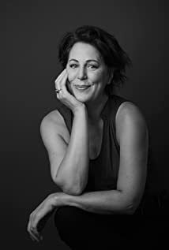
Danielle Bourgon is an actress and writer, known for A Simple Favour, Regression and The Christmas Chronicles. From 2013-2018 she appeared as Dr. Louise Helvi in all 39 episodes of the TV Series Hard Rock Medical.Her first feature screenplay ME & BOO, won "Audience Choice" at The Female Eye Film Festival.

TRACY RANKIN
Tracy Rankin has been an actor in both stage and film for several decades. Adept at multiple UK and North American accents, she obtained her Arts Specialist Degree as a Drama Major at the University of Toronto and Guildford School of Acting Surrey UK
Recently she appeared in two student films- The Country Inn and Pick A Politician as well as the series Private Eyes. She also embarked on learning something new last year- writing a solo play. Semi autobiographical, her short play " Buried in Comfort" proved to be incredibly rewarding and challenging. Last summer she toured it to Hamilton and received glowing reviews. By writing, producing and performing her own work, she’s experienced a new level of vulnerability, which has served her work and improved her acting skills. She is also known for Vicious Fun, Boom, Headshot! and The Cries of Lorena.

Production Credits

Full Cast
Actors  NATALIE HALL  COREY SEVIER  JULIA BORSELLINO  ELANA DUNKELMAN  WENDY GERMAN  TIM PROGOSH  DANIELLE BOURGON  GEORGE KRISSA  COLTON ROYCE  DERICK AGYEMANG  TRACY RANKIN  JESSE REYNOLDS  KATE MACLELLAN | Role  Margo Miller  Alden Brown  Blair Miller  Della Simmons  Edie Miller  Charlie  Zadie  Franklyn  Jack Evans  Will  Leanne O'Riley  Receptionist  Stella

Casting
RON LEACH, c.d.c

Composer
CATALIN MARIN

Costume Designer
SARAH A. CARROLL

Editor
CASEY TOURANGEAU

Production Designer
GREG WILSON

Director of Photography
MICHAEL TIEN

Story by
J.B. WHITE
STEVE N. WHITE

Screenplay by
J.B. WHITE

Directed by
SAMANTHA WAN

Full Crew
JOHNNY ROSS | First Assistant Director
BEN HRKACH | Second Assistant Director
KELSEY MAYE | Third Assistant Director
AIDAN MAZEROLLE | Cast Wranglers
CEDRIC BELISLE
CAROLINE MCLOUGHLIN | Cast Assistant
AMTI | Extras Casting
ANGIE SAKLA-SEYMOUR
HAYDEN BAPTISTE | Line Producer
JACKIE MASSAR | Production Coordinator
VAL HARTRY | Assistant Production Coordinator
JOSIE FITZGERALD | Office Manager
LOGAN A. WAGNER | Production Accountant
JOSHUA LANGE | Assistant Production Accountant
GREG WILSON | Production Designer
JESSA MILLAR | Art Director
TOMAS CHOVANEC | Set Dressers
JODY HAUCKE
GORAN POBRIĆ
ANTHONY RANKIN
NATHALIE GREGOIRE | Property Master
SARAH A. CARROLL | Costume Designer
ELLA JAMES-BESWICK | Assistant Costume Designers
AMANDA COLLIE
ERIN MORRISON | Costume Dresser
ANDY TAIT | Costume Daily
MICHAEL TIEN | Director of Photography
KEEGAN YANG | Camera Operator
JACOB CONLEY | First Assistant Camera
NATHAN JONNA BOULIANE
ADAM TESTA
RACHEL VRECIC
MATT CROSSE | Second Assistant Camera
NIKKI TUBONGBANUA
YOUSIF HASSAN
LINDSEY BELANGER
TRINH KIEN | Camera Trainees
JULIE MONTREUIL
TONY GULOY | Camera Technician
JEFF BRAY | Digital Imaging Technician
MARTIN DESCHAMBAULT | Drone Operator
PETR MAUR | Stills Photographer
NICHOLAS CROSSE | Gaffer
YAN SCHNELL | Best Electric
NICHOLAS HOTTE | Electric
NICHOLAS HERMIER | Key Grip
RJ NADON | Best Grip
ALEXANDRA ADAMS | Swings
ALANNA BROERE
JOHN HOLMES
SONIC LIGHTNING ENTERTAINMENT INC. | Sound
ANDREW SUTHERLAND | Production Sound Mixers
CHARLES PAQUIN
PETER MONET | Boom Operator
ANGIE MILLS | Script Supervisor
PATRICK GARDEN | Location Manager
SAGINE CAVÉ | Assistant Location Manager
DEEDEE BUTTERS | Location Scout
KEENE IMBLEAU | Location Production Assistants
SAM KITTS
BENNY LI
RYAN MYLES
NATHAN OSBORNE
KELSEY DAUPHINEE | Key Makeup Artist
CHANCELLE MULELA | Assistant Makeup Artist
SAMNANG TEP | Key Hair Stylists
DARCY RYAN LANGILLE
STEFANE GREGOIRE | Transport Coordinator
GREG LEWIS | Transport Captain
ZACK ALLEN | Drivers
JESSICA LAIGHT
DAVE ROSE
STEVE CHAPESKI | Transport Production Assistants
STEVE MONETTE
PERRY MCCONNELL
CRAIG WRIGHT
NICHOLAS BOUSQUET | Move Crew
KEITH STEFFENSEN
CORNELIA VILLENEUVE
DAN VILLENEUVE
ERIC VILLENEUVE
SEAN VILLENEUVE
ACTION SET MEDICS INC. | Health & Safety
BIAGIO'S | Catering
JODI JENNINGS
CAMERON MATHESON | Craft Laborer
HALL WEBER LLP | Script Clearances
HALL WEBER LLP | Legal Services
ABOVE THE LINE MEDIA SERVICES | Business Affairs
BRENDAN MCNEILL
ARTHUR J. GALLAGHER CANADA LTD. | Insurance
ALEXANDRA WARING | Post Production Supervisor
URBAN POST PRODUCTION | Post Production Services provided
STEVE MOORE | Re-Recording Mixers
LUCAS ROVEDA
CALVIN TRAN | Re-Recording Assistant
URBAN POST PRODUCTION | Sound Edit provided by
EHREN PFEIFER | ADR Recordist
MATT THIBIDEAU | Foley
DAVE MERCEL
WARREN CHINN | Colorist
KYLE CAMPBELL | Online Editor
IKE MURPHY | Project Manager
BRUCE REES | Picture Operations Manager
ROBERTA BRATTI | V.P. of Operations
BLACKBOXGUILD/POND5.COM | Stock Footage
ORCLICK/POND5.COM
SMALLTOWN63/POND5.COM
THEVIDSOURCE/POND5.COM
ZENSTRATUS/POND5.COM

Music
My Dear Friend
by Andrew Bojanic, Elizabeth Hooper and Ivy Levan
courtesy of Extreme Production Music
Familial Business
by Geoff Siegel and Nik Frost
courtesy of Gramoscope Music
Uh Oh
by Adam Skinner, Dan Skinner and Dave James
courtesy of Audio Network Limited

Producer Biographies

TIM JOHNSON – Executive Producer
Tim Johnson is among the most active and reliable producers in the business thanks to top rate productions and global distribution appeal.
Johnson is also responsible for producing the international hit series, DR. QUINN, MEDICINE WOMAN for CBS for over 5 seasons. During his 100-episode tenure, he also developed and produced the original docu-drama COLD CASE for CBS network, which was the very first program to integrate television with the Internet.
Johnson has produced over 150 movies, 15 globally released series for every major US network - including ABC, Disney, CBS, NBC, Netfly, FOX and Sony.

JOHNSON PRODUCTION GROUP
The Johnson Production Group contracts globally to produce television content for international networks, studios and distributors. Based in Los Angeles and Vancouver, British Columbia, the company manages production, facilitates development and financing, procures distribution and guarantees quality and timely execution of its programs. While costs have gone up, so has the demand for quality. No longer is good enough, good enough. Johnson Production Group serves that segment when a show needs to be "A" quality, but produced efficiently enough to meet a locked budget. JPG specializes in value, protection of creative elements, and delivery of a quality finished product.
ANDREW C. ERIN – Executive Producer
Andrew Erin is a Canadian Writer/Director making a big splash in the US, and has produced, written and directed numerous commercially successful films. His directorial debut, SAM’S LAKE, was an official selection at the Tribeca Film Festival and did an excellent theatrical run in select theaters around the country; distributed by Lionsgate Films. Andrew also wrote the script for the film. Andrew’s directorial credits include, SIMPLE THINGS, produced for Screen Media Ventures and Universal Studios. Besides winning The Bob Clark Award for Best Director at the California Independent Film Festival, the film was commercially received. Andrew has worked continuously as a writer/director, building a strong library of films in the Thriller/Horror genres with: Embrace of The Vampire, The Clinic, Final Sale, Confined and Toxic Skies.
THOMAS STANFORD – Executive Producer
Tom Stanford has worked in various production and business affairs capacities for over 3 years on multiple movies and television productions, including Chasing Waterfalls, Butlers in Love, Adventures in Christmasing and numerous others He is a graduate of the University of British Columbia with a degree in Physics.

STEVE N. WHITE – Executive Producer
Steve White started his career as a literary agent, and then was a founder and partner of Warden, White & Associates. His clients included the screenwriters of "Batman 1&2," "Sleepless in Seattle," "Enemy of the State," "Wild Things," and "Deja Vu." He left his agency after twenty years to focus on producing.

JOSEPH WILKA – Co-Executive Producer
Joseph Wilka is the Head of Production for Johnson Production Group. Los Angeles-based, Joseph had already produced and directed several feature films before serving as the senior marketing executive for Gravitas Ventures. While at Gravitas, Wilka helped pioneer new distribution models for independent films including day-and-date theatrical releases. It was also at Gravitas where Joseph first worked with Johnson Production Group to facilitate the release of their films to the worldwide Video On Demand audience. After serving as the Director of Distribution and Production for Viva Pictures, where he produced English-language versions of foreign animated titles for DirecTV, Wilka officially joined Johnson Production Group. As Head of Production, he oversees the development, production, and distribution of films from multiple production units for release on broadcast and streaming platforms.
HAYDEN BAPTISTE – Producer
Hayden Baptiste is a Producer and Development Executive with The Mob Entertainment, an LA Based production company with a Canadian office in Ontario. After spending nearly 15 years working as an Associate Producer for The Johnson Production Group and working as an Independent Producer in Toronto and Vancouver, Hayden has evolved into a well rounded producer who understands all aspects of production from development to delivery. Hayden has produced films for various networks including CBC, Bravo, The Hallmark Network, UP TV and Lifetime Network. His films have been selected for film festivals around the world including the Montreal World Film Festival, Atlantic Film Festival, Screamfest, Catalina Film Festival, National Screen Institute and Chicago International. In addition to his extensive production experience, Hayden is a screenwriter and composer. Hayden has studied at the Canadian Screen Training Centre, and completed the summer intensive screenwriting program at UBC.

OLIVER DE CAIGNY – Supervising Producer
Oliver De Caigny is a Canadian producer originally from Belgium, his background in financing, production, and post production makes him a well-rounded producer for any type of production. His experience in financing and production agreements (film and TV series and movies-of-the week), distribution agreements (both domestic and foreign) as well as international co-productions, Canadian tax credit, Telefilm Canada and Canada Media Fund incentives provides him with a well-rounded background in development, production and distribution for motion pictures, television series and productions.

Billing Block

Johnson Production Group Presents “ROAD TRIP ROMANCE”
Starring NATALIE HALL COREY SEVIER JULIA BORSELLINO ELANA DUNKELMAN WENDY GERMAN TIM PROGOSH DANIELLE BOURGON TRACY RANKIN Casting RON LEACH, c.d.c Composer CATALIN MARIN Costume Designer SARAH A. CARROLL Editor CASEY TOURANGEAU Production Designer GREG WILSON Director of Photography MICHAEL TIEN Co-Executive Producer JOSEPH WILKA Supervising Producer OLIVER DE CAIGNY Executive Producers THOMAS STANFORD ANDREW C. ERIN TIMOTHY O. JOHNSON STEVE N. WHITE Produced by HAYDEN BAPTISTE Story by J.B. WHITE STEVE N. WHITE Screenplay by J.B. WHITE Directed by SAMANTHA WAN

With the participation of the Province of British Columbia
Film Incentive BC
The Canadian Film or Video Production Tax Credit
© MMXXI WW 2021 Films Inc All Rights Reserved

Meta Data

LONG (max 3000 characters) synopsis

Synopsis
Megan loves her sister Blair, who’s getting married in three days. As the maid of honor, Megan needs to be there for the bachelorette party, the rehearsal dinner and the big event. But her trip from Denver to Wichita hits a disastrous parade of bumps: a baggage handlers’ striker closes the Denver airport, the car she rents to drive to Kansas is stolen, the replacement car ends up in a ditch, and it’s hauled for repair to an off-the-beaten-track town which is holding its annual Renaissance Fair and temporarily off-the-grid. She misses the party, the dinner – and she’s in real danger of missing the wedding.
Traveling with her is Alden, who was a constant thorn in her side in high school, where they competed in everything (debate club, pep squad, etc.). He needs to get to Wichita for his dad’s retirement celebration. Joined at the hip for three days, all the annoyances and grudges of the past are front and center – until they’re not. Forced to really be together, they slowly realize how much they have in common and how that high school rivalry masked a strong mutual attraction.
Meanwhile, in Wichita Blair goes through the steps of preparing for marriage without her sister there to act as maid of honor. Her bestie Della steps in as a marker – and increasingly falls in love with the idea of being maid of honor for real.
Will Megan and Alden make it to Wichita in time? Will Della be willing to step aside? Come on the journey with us and find out.
(1457)

MEDIUM (max 500) synopsis
An escalating series of unfortunate events keeps delaying a young woman’s journey to her sister’s wedding – a journey she is forced to take with the guy who was her biggest rival in high school.
(194)
SHORT (max 100 characters) synopsis
Megan is stuck with her rival when the trip to her sister’s wedding hits some disastrous bumps.
(95)

5 KEY WORDS
Romance, business, rival, travel, wedding

