

Johnson Production Group

Press Kit

# One-Liner

Will Kyra’s new romantic interest, dog lover Trevor, find out she entered a non-existent dog into an agility dog show?

# Synopsis

When Kyra meets the new store manager of Merlin's Grocery, she immediately finds Trevor charming and reliable - a perfect match for her set-in-stone love plans! But Trevor might have more in common with their colleague Lara, including a love of dogs. Kyra's best friend Mark, wanting to help her out, lies and says Kyra has a dog too. Not wanting to get Mark in trouble, Kyra goes along with it but then she's suddenly roped into entering her non-existent dog into an agility dog show! She better get a dog, and quick!

# Producers

Executive Producer

TIMOTHY O. JOHNSON

### Co-Executive Producer

JOSEPH WILKA

Producer

NAVID SOOFI

Supervising Producer

OLIVER DE CAIGNY

Key Cast

|  |  |  |
| --- | --- | --- |
| CHARACTER  Kyra  Kevin  Trevor  Mark  Heather |  | ACTOR  ANDREA BROOKS  MARCUS ROSNER  NATHAN WITTE  BENJAMIN CHARLES WATSON  LUCIE GUEST |

# Key Cast Biographies

# ANDREA BROOKS

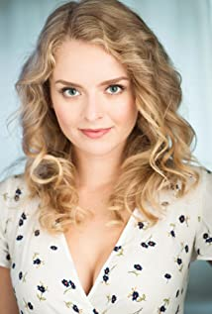Andrea Brooks is a Canadian actress who began her acting career at age fifteen after being spotted at an open casting call for figure skaters for the Disney film Ice Princess (2005). Some of Andrea's television credits include roles on Supernatural (2005), iZombie (2015), UnREAL (2015), and Supergirl (2015), where she plays Eve Teschmacher, as originally portrayed by Valerie Perrine in Superman (1978) and Superman II (1980). She can also be seen in feature films, such as What Goes Up (2009), No Men Beyond This Point (2015), The Company You Keep (2012), and 50/50 (2011). Andrea plays the role of Faith Carter on the Hallmark Channel Original series, When Calls the Heart (2014). Growing up, Andrea trained in figure skating, dance, music, and theatre. Andrea holds a Bachelor's, and Master's of Arts degree from The University of British Columbia.

# MARCUS ROSNER

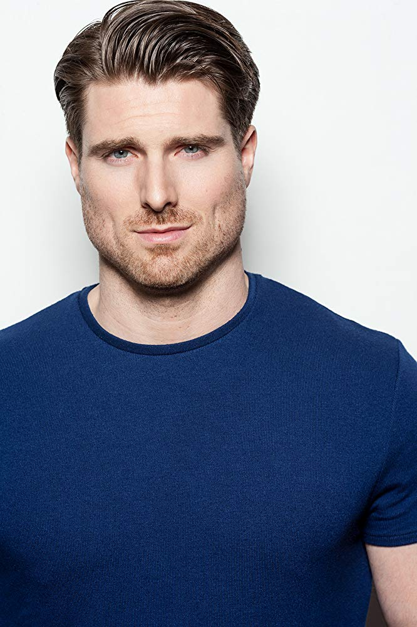Marcus Rosner is a Canadian actor born on the west coast of British Columbia but raised on the prairies of Sherwood Park, Alberta. He started acting in 2012 and some of his more notable roles include appearances in the TV Shows UnREAL, Arrow, Supernatural, and Once Upon a Time to name just a few.

# NATHAN WITTE

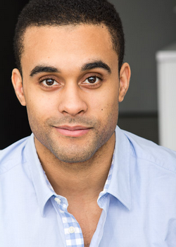Nathan Witte, originally from Calgary, Alberta began his career in entertainment as a young boy in family home videos and hasn't looked back since. He has always enjoyed making people around him laugh so it came as no surprise to those who knew him that he would make a career of being in front of the camera. At 17, Nathan started working in whatever capacity he could in the industry, which like most, led him to background parts and stand-in work for local TV shows and films. Being a part of professional sets and watching A-list stars work was a great source of inspiration for him. In 2007 his talents and aspirations brought him to Vancouver where he immediately found success booking roles on films Finder of Lost Children (2009) and Gutterballs (2008), and a prominent Guest Star role on the TV show The Assistants (2009). Since then Nathan has continued to work regularly appearing on episodes of Smallville (2001), Supernatural (2005), Hellcats (2010), Arctic Air (2012), Arrow (2012), Rogue (2013), and Motive (2013). 2016 has brought more momentum and challenges with bookings on Meet Cute (2016) (produced for Crazy 8s Film Festival), Wayward Pines (2015), Van Helsing (2016), and the feature film Ms. Matched (2016). Nathan and his business partner Chad Rook of CheckMate Films are in post production of their highly anticipated first feature film The Perfect Pickup (2020). Nathan will be playing the lead role of Corey in this comedy, as well as serving as a producer on the project. The film foresaw a summer release in 2016.

# BENJAMIN CHARLES WATSON

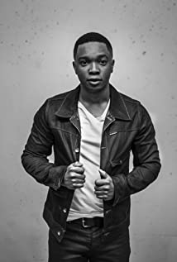Born in Jamaica, Watson moved to Toronto with his family when he was 10 years old. He loved storytelling from an early age, and was drawn to the performers he saw in movies and on television.

Unlike a handful actors who get into the business when they are children, Watson chose to pursue an education before getting his feet wet in the acting world. He decided after high school to attend Humber College in Toronto, and he started to attend scene study and voice and improvisation classes. In 2006 he decided to immerse himself in his craft, and did every independent film, short, and project that came his way.

In 2007, he landed a lead role in "The Limits", which did well in the festival circuit. He then went on to book various roles in television from 2009 through 2010. In 2011, Watson landed the role that would put him on the map not only in Canada but in the United States as well, playing "Tariq" in "The L.A. Complex." The show follows the exploits of six attractive, young hopefuls in search of stardom in Hollywood.

Since then, Watson has had a successful career in both TV and film, including roles in Designated Survivior, Snowpiercer and I Am Syd Stone.

# LUCIE GUEST

Lucie Guest is an actor, director, and writer who was named one of the Top Ten Filmmakers to Watch in 2017 by Independent Magazine. She is a powerhouse talent both in front of and behind the camera and in 2020 her dynamic talent as a storyteller will be on full display. Up first she can be seen in a recurring role in part 3 of the hit series "The Chilling Adventures of Sabrina," premiering January 24, 2020, on Netflix. Lucie has had an affinity for the arts for as long as she can remember. Early in her career she studied improv and trained with the acclaimed Upright Citizen's Brigade and The Groundlings in LA and is a graduate of The Second City Conservatory Program. Lucie has had roles in countless projects for film and television, including The CW's "Supernatural" and "iZombie", NBC's "Timeless", ABC's "Dead of Summer" and "Beyond" as well as BBC America's "Orphan Black." As a filmmaker, Lucie has directed and written films that have screened internationally and won a handful of awards including Best of Fest at the Women in Comedy Boston Film Festival, Best International Film at the Malibu Film Festival and was selected for Kevin Hart's Top 20 films for JFLs 2017. Her most recent credits include directing a feature-length romance which she co-wrote called LOVE AT FIRST FLIGHT and a rom-com entitled FOR YOU, WITH LOVE. Past credits include writing and directing the short film NEVER BETTER - A CLOSURE COMEDY as well as an off-beat comedic short film entitled BE RIGHT BACK. Lucie also created and directed CHARLIE AND YONI #LIFE AFTER 30 which was optioned by CBC's Comedy Coup.

# Production Credits

### Full Cast

|  |  |
| --- | --- |
| [**Actors**](http://www.imdb.com/name/nm7589451/?ref_=ttfc_fc_cl_t1)  ANDREA BROOKS  MARCUS ROSNER  BENJAMIN CHARLES WATSON  ASHLEY ROSS  NATHAN WITTE  LUCIE GUEST  MELANIE REES  SARAH SURH  ROBIN T. ROSE  DEVIN MACKENZIE  KAMANTHA NAIDOO  NOVA | **Role**  Kyra  Kevin  Mark  Laura  Trevor  Heather  Diane  Vet  Trainer #1  Trainer #2  Trainer #3  Sam the dog |

### Casting by

JUDY LEE

### Production Designer

HEATHER COUTTS

### Director of Photography

SEAN COX

### Edited by

JASON NIELSEN

### Music by

MARIO VAIRA

### Supervising Producer

OLIVER DE CAIGNY

### Co-Executive Producer

JOSEPH WILKA

### Executive Producer

TIMOTHY O. JOHNSON

### Produced By

NAVID SOOFI

### Written By

BARBARA KYMLICKA

### Directed by

HEATHER HAWTHORN-DOYLE

### Full Crew

|  |  |
| --- | --- |
| STEPHANIE STANTOR-LINDER | Dog Wranglers |
| DYLAN WOODLEY |  |
| DREW THOMPSON |  |
| MACAYLA WOODLEY |  |
| CRYSTAL VAN MEER |  |
| LALE AKSU |  |
| CARLEY SWANN |  |
| THOMAS STANFORD | Associate Producer |
| NAVID SOOFI | Production Managers |
| DARREN ROBSON |  |
| GRANT O’KANE | First Assistant Director |
| CLAUDE PAVEL | Second Assistant Directors |
| NAOMI POLK |  |
| RUSTY ROSS | Set Decorator |
| CLARA SALAMEH | On Set Dresser |
| CIMRAN JASSAL | Dressers |
| MITCHELL RAUSCH |  |
| AARON WILSON |  |
| MORGAN GREENWELL |  |
| MADISON FRIESEN |  |
| GELLERT HORVATH |  |
| RAINE LEMAY |  |
| LEWIS CORDONI | Carpenter |
| KSENIIA LIEONTIEVA | Props Master |
| LETICIA LOUREIRO BRANDAO | Props |
| TIAGO CAVALCANTI D’OLIVEIRA |  |
| SELENA TAYLOR | Hair Stylist |
| KATHLEEN FOWLSTONE | Make-up |
| BRYANA KOENNING | Swing |
| SOPHIA NIEWERTH | Costume Designer |
| SOPHIA KOUMBIS | Assistant Costume Designer |
| MATTHEW PASSARELLI | Set Supervisor |
| JODY SCHILBE | Truck Costumer |
| JENNA FUOCO | Camera Operators |
| SUNG YOUNG PARK |  |
| RYAN PETEY |  |
| BAURZHAN DOSMAGAMBETOV | First Assistants Camera |
| THOMAS WANG |  |
| KAMA SOOD | Second Assistants Camera |
| BENJAMIN STENNER |  |
| PIERRE CRUZ | Gaffer |
| SEPEHR MAHBOB | Best Boy Gaffers |
| ERIK MORTENSEN |  |
| EVAN MOYER | Electrics |
| CHRISTOPHER HALL |  |
| CORY TYMOSCHUK | Key Grips |
| TRISTAN MATHARU |  |
| DENNIS CHAPPELL | Best Boy Grips |
| SAMANTHA GAUTHIER |  |
| CHRISTOPHER JENKINS | Dolly Grips |
| NILS KIMMEL |  |
| RON OKINAWA |  |
| JOSEPH HUNT | Grips |
| SAHAR KHALADJI |  |
| GERALDO MEDINA |  |
| PETER GIBSON | Transport Coordinator |
| BARRY HUNT | Transport Captain |
| ONKAR NAGRA | Drivers |
| BRUCE SPURRELL |  |
| RANDY DAY |  |
| JOHN SINGH |  |
| SEAN WATSON |  |
| BARRY HUNT | Security Coordinator |
| LINDA LARSON | Security |
| PARRY PARSONS |  |
| JASON HUNT |  |
| MEGHAN RILEY |  |
| BRANDON RYAN |  |
| DAVID BECKER |  |
| CATHY STRANBERG |  |
| CELESTE CROWE | Location Manager |
| ANA NUNES | Assistant Location Manager |
| CARTER VILLEMAGNE-GAMACHE | Key Location Assistants |
| LIANA BABIN |  |
| JACK MEEHAN |  |
| JANA QUADRELLI | Location Assistants |
| JUSTINE BRUEHLER |  |
| ERIKKA GRIGGITHS-KEAM |  |
| ERICA KARAMESINIS |  |
| SEAN REA |  |
| EMILIA SAINZ SOLER | Production Sound Mixer |
| ELSY DAGDUG CHAMELIS | Boom Operator |
| CHRISTOPHER DOERKSEN | Script Supervisor |
| PARALEE COOK | Production Accountant |
| ROBERT JAY DEACHMAN | Production Accountant Assistant |
| THOMAS STANFORD | Business Affairs |
| JEFF DESMARAIS | Production Coordinator |
| KARRY CROFT | Production Assistant |
| MICHAEL HOLSTEIN | Craft Service/First Aid |
| JULIA ANDERSON | Craft Service/First Aid Assistants |
| MELANIE MUNOZ |  |
| TAYLER MORAN |  |
| KAYLA BROWN | COVID Specialist |
| JENNIFER ROBERTS | COVID Assistants |
| TARRA LOMAS |  |
| CHRIS BILLON | Third Assistant Director |
| ADAM RUMPEL | Background Coordinator |
| WAY LEE CHOO | Catering |
| CAMERON WINTERS |  |
| MAIA MICHAELS | Casting Assistant |
| LA HILTS | Extras Casting |
| CLAUDIA MOON | Extras Casting Assistant |
| KATRINA NEUHAUS | Stand-In |
| COASTAL CLEARANCES | Script Clearances by |
| CHANDLER FOGDEN ALDOUS LAW CORPORATION | Legal Services by |
| FRONT ROW INSURANCE BROKERS | Insurance by |
| LEAH MYERS | Post Production Supervisor |
| TIM SPENCE | Post Production Coordinator |
| RON PENCHALAIYA | Assistant Editor |
| SO YOUNG PARK | Second Assistant Editor |
| MARCEL VANDERWEKKEN | Visual Effects |
| SEÁN TRAVERS | Colourist |
| MAVERICK POST GROUP | Sound Facilities Provided by |
| GREGOR PHILLIPS | Supervising Sound Editor |
| GREGOR PHILLIPS | Re-Recording Mixer |
| ELAN GABRIEL | Dialogue Editor |
| CRAIG GEORGE | SFX Editor |
| ALEX MACIA | Foley Artists |
| DEVON QUELCH |  |
| JEFF GROUT | ADR Recordist |

# Producer Biographies

TIM JOHNSON – Executive Producer

Tim Johnson is among the most active and reliable producers in the business thanks to top rate productions and global distribution appeal.

Johnson is also responsible for producing the international hit series, DR. QUINN, MEDICINE WOMAN for CBS for over 5 seasons. During his 100-episode tenure, he also developed and produced the original docu-drama COLD CASE for CBS network, which was the very first program to integrate television with the Internet.

Johnson has produced over 150 movies, 15 globally released series for every major US network - including ABC, Disney, CBS, NBC, Netfly, FOX and Sony.

## JOHNSON PRODUCTION GROUP

The Johnson Production Group contracts globally to produce television content for international networks, studios and distributors. Based in Los Angeles and Vancouver, British Columbia, the company manages production, facilitates development and financing, procures distribution and guarantees quality and timely execution of its programs. While costs have gone up, so has the demand for quality. No longer is good enough, good enough. Johnson Production Group serves that segment when a show needs to be "A" quality, but produced efficiently enough to meet a locked budget. JPG specializes in value, protection of creative elements, and delivery of a quality finished product.

JOSEPH WILKA – Co-Executive Producer  
Joseph Wilka is the Head of Production for Johnson Production Group. Los Angeles-based, Joseph had already produced and directed several feature films before serving as the senior marketing executive for Gravitas Ventures. While at Gravitas, Wilka helped pioneer new distribution models for independent films including day-and-date theatrical releases. It was also at Gravitas where Joseph first worked with Johnson Production Group to facilitate the release of their films to the worldwide Video On Demand audience. After serving as the Director of Distribution and Production for Viva Pictures, where he produced English-language versions of foreign animated titles for DirecTV, Wilka officially joined Johnson Production Group. As Head of Production, he oversees the development, production, and distribution of films from multiple production units for release on broadcast and streaming platforms.

OLIVER DE CAIGNY – Supervising Producer  
Oliver De Caigny is a Canadian producer originally from Belgium, his background in financing, production, and post production makes him a well-rounded producer for any type of production. His experience in financing and production agreements (film and TV series and movies-of-the week), distribution agreements (both domestic and foreign) as well as international co-productions, Canadian tax credit, Telefilm Canada and Canada Media Fund incentives provides him with a well-rounded background in development, production and distribution for motion pictures, television series and productions.

NAVID SOOFI – ProducerNavid is the primary producer for Novus Ordo Seclorum. Navid’s passion for filmmaking along with his business and engineering background plays an important role in creating a successful and transparent business model. Navid has been in the entertainment industry for more than 13 years and has produced over 50 feature films, TV shows and commercials that have been featured on national television, international theatres, and new media platforms. His credits include Over the Moon in Love, The Mistletoe Secret, Random Acts of Christmas, Love Unleashed, Identity Theft of a Cheerleader, and A Mother on the Edge.

## Billing Block

Johnson Production Group Presents “ROMANCE TO THE RESCUE”  
starring ANDREA BROOKS MARCUS ROSNER NATHAN WITTE BENJAMIN CHARLES WATSON and LUCIE GUEST Casting by JUDY LEE Production Designer HEATHER COUTTS Director of Photography SEAN COX Edited by JASON NIELSEN Music by MARIO VAIRA Supervising Producer OLIVER DE CAIGNY Co-Executive Producer JOSEPH WILKA Executive Producer TIMOTHY O. JOHNSON Produced By NAVID SOOFI Written By BARBARA KYMLICKA Directed by HEATHER HAWTHORN-DOYLE

 

With the participation of the Province of British Columbia   
Film Incentive BC

The Canadian Film or Video Production Tax Credit  


© MMXXI Antarctica Productions Inc. All Rights Reserved  


Meta Data

LONG (max 3000 characters) synopsis

When Kyra meets the new manager of Merlin's Grocery, she immediately finds Trevor charming and reliable - a perfect match for her love plans! But Trevor might have more in common with their colleague Lara, including a love of dogs. Wanting to help, Kyra's best friend Mark, lies and says Kyra has a dog too. Not wanting to get Mark in trouble, Kyra goes along with it but then she's suddenly roped into entering her non-existent dog into an agility dog show! She better get a dog, and quick! (492)

MEDIUM (max 500) synopsis

When Kyra meets the new manager of Merlin's Grocery, she immediately finds Trevor charming and reliable - a perfect match for her love plans! But Trevor might have more in common with their colleague Lara, including a love of dogs. Wanting to help, Kyra's best friend Mark, lies and says Kyra has a dog too. Not wanting to get Mark in trouble, Kyra goes along with it but then she's suddenly roped into entering her non-existent dog into an agility dog show! She better get a dog, and quick! (492)

SHORT (max 100 characters) synopsis

Kyra has to quickly get a dog to enter into an agility show so she can impress the charming Trevor (98)

5 KEY WORDS

Dog, agility show, lies, romance