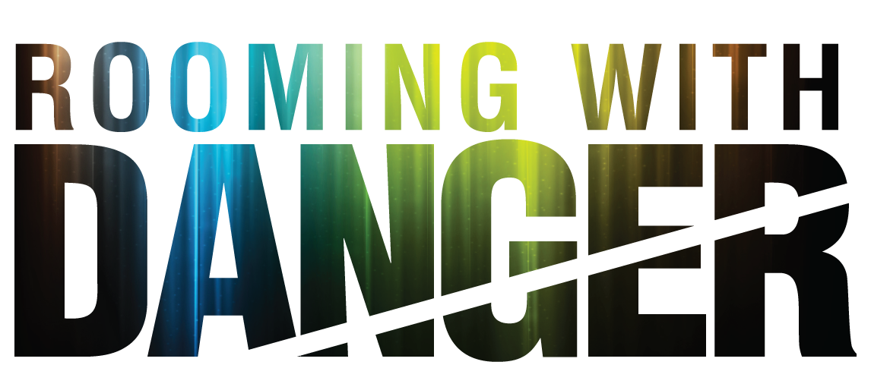

Johnson Production Group

Press Kit

One-Liner
Fresh off a bad break-up, a young professional moves in with the seemingly perfect roommate, but finds herself the object of a deadly obsession.

Synopsis

After leaving a dysfunctional relationship with her boyfriend Marco, Angelina finds what she thinks will be the perfect living situation with a new roommate named Bianca. But when Bianca begins to obsessively take over her life, Angelina realizes her new roomie isn't what she thought. Still battling her obsessive ex, and now with an obsessive roommate, Angelina must find the inner strength she didn't know she had just to survive.

Producers
Executive Producers
TIMOTHY O. JOHNSON
JOSEPH WILKA
Producer
A.J. KELLY
Line Producer
JACOB HORN

Key Cast
CHARACTER  Angelina  Bianca  Diego  Gaby |  | ACTOR  CAMILA SENNA  DANIELA RIVERA  CHRISTOPHER MILLAN  EMILY VILLARREAL

Key Cast Biographies

CAMILA SENNA
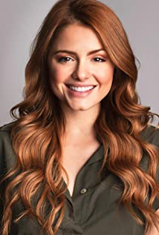
Brazilian born model and actress, Camila Senna, moved to LA after appearing for two seasons in a stage play and realizing that acting was the career for her. Once in LA she attended the New York Film Academy and has since appeared in The Bribe, The Helianthus and With Myself, and recently landed role a role in Under The Influence. Camila also hosts a show at the Hollywire Brazilian channel for Samsun TV.

DANIELA RIVERA
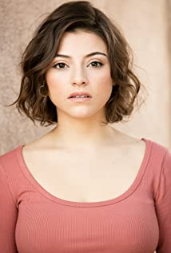
Actress Daniela Rivera recently starred in the delightful teen comedy, Banging Lanie. She also appeared in two episodes of the TV Series Dirty John, as well as the films The Meat Puppet and Another Dumb Boy Girl Not Love Story.

CHRISTOPHER MILLAN
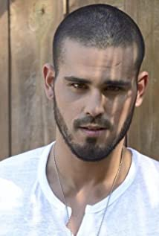
Actor Christopher Millan took drama in high school but was focused more on sports. Sports were year-round with football, soccer and volleyball. After graduating he enrolled in acting classes at The Miami Acting Studio and was there for about two years before he realized he needed to further his studies and was admitted into the New York Conservatory for Dramatic Arts and with several scholarships and eventually graduated top of his class. The project that catapulted his career throughout Latin America and continues to make its way around the world was Mariposa De Barrio, based on the legendary singer Jenni Rivera and he played “Fernie” the great love of her life. From there it was another tv-series with Telemundo called “Al Otro Lado Del Muro” as one of their leads. Following that he has appeared in several TV Series including Comeback Kid, Decisions: Some Win and Other Lose and The Flowers. Recent movies have included Miami Bici, 73 Minutes and 9 Windows.

EMILY VILLARREAL
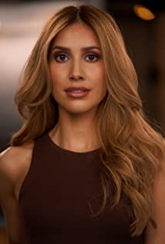
Emily Roslyn Villarreal is a Latina actress born and raised in Dallas, Texas. At an early age Emily's dream of becoming a singer, actor and dancer was realized. She started her professional career as an NBA dancer for the Dallas Mavericks. Not long after making the big move to Los Angeles she has gained momentum in Hollywood at an accelerated rate. She is best known for her roles on Euphoria on HBO Max and the film Bromates co-starring alongside Josh Brener.

Production Credits

Full Cast
Actors  CAMILLA SENNA  DANIELA RIVERA  CHRISTOPHER MILLAN  EMILY VILLARREAL  ADRIAN QUINONEZ  STEPH MARTINEZ  SAM PARKER  SALLY MAERSK  TALI SHERMAN  MAAYANTRAVOLSKI  SAVYONTRAVOLSKI  JACOB HORN  ADAM BROOKS | Role  Angelina  Bianca  Diego  Gaby  Marco  Sophie  Dylan  Inmate  Mother  Kid #1  Kid #2  Valet #1  Valet #2

Casting By
JEFF HARDWICK CSA

Production Designer
ROBERT WISE

Director of Photography
NICK ALBERT

Edited By
JEREMY BRUNSON

Music By
ANDREW SKRABUTENAS

Line Producer
JACOB HORN

Written By
JOHN HAYES

Directed By
CHRISTINE CONRADT

Full Crew
SARA VICTORIA PEDERSEN | 1st Assistant Director
KAYLA MASON | 2nd Assistant Director
ANGIE HARTLEY | Prop Master
CHRIS HERNANDEZ | Art Assistant
NATE BUCAR | Art Assistant
ADRIENNE SHIANG | Art Assistant
KESHIA SMITH | Make-Up Artist
CORTNEY WATSON | Hair Stylist
DESHON GRAY | Additional Hair Stylist
EZRA BASSIN-HILL | B CAM Operator
NATHAN MEADE | B CAM Operator
JACK SCHURMAN | Additional Second Camera Operator
ROGELIO MOSQUEDA | 1st Assistant Camera
SIERRA BOVE | Additional 1st Assistant Camera
SELENA WEBB | Additional 1st Assistant Camera
CAMERA CARLO TONDA | Additional 1st Assistant
FONG KUO | Additional 1st Assistant Camera
AMY FRYE | 2nd Assistant Camera
GEORGE ELLETT | BCAM 1st Assistant Camera
ADAM ROENKER | BCAM 1st Assistant Camera
PETE AGUIRRE | Media Manager
KEN SAX | Stills Photographer
JEFF MARLOWE | Gaffer
DAN PROSTAK | Best Boy Electric
DEVIN CONNER | Additional Best Boy Electric
EDWIN CUDE | Additional Best Boy Electric
SERGIO NAVA | Key Grip
PETER G HOWELL | Additional Key Grip
NATHAN ALEXANDER | Best Boy Grip
BRANDON CABRAL | Additional Best Boy Grip
RAYMOND SANCHEZ | Additional Best Boy Grip
JOSHUA RANESESTOLON | Dolly Grip
JUSTIN HARTSAW | Additional Dolly Grip
MIKE GONZALES | Additional Dolly Grip
SHANE HEFFERNAN | Costume Designer
CHRISTA COLLINS | Wardrobe Assistant
ERIC ENROTH | Production Sound Mixer
MARILYN MILLER | Script Supervisor
AMANDA SEARS | Production Coordinator
DAN BURAN | COVID Compliance Officer
MIKE ESCAMILLA | Safety Coordinator
GREG SABA | Production Assistant
ADAM BROOKS | Production Assistant
KAT NOLTE | Production Assistant
BROOKE SHARLAND | Production Assistant
HOLLYWOOD SCRIPT RESEARCH | Script Clearance
ABACUS INSURANCE BROKERS | Insurance
JAKOB UNTERREINER | Sound Editor / Re-Recording Mixer
MARC MELLENS | Foley Recordist
PRIVATE ISLAND AUDIO | ADR Facilities
BLUELINE FINISHING | Post Production Services
ALEX ROTHAUSER | Colorist
BOYZ IN THE KITCHEN | Caterer
RARE BREEDS | Cameras

Producer Biographies

TIM JOHNSON – Executive Producer
Tim Johnson is among the most active and reliable producers in the business thanks to top rate productions and global distribution appeal.
Johnson is also responsible for producing the international hit series, DR. QUINN, MEDICINE WOMAN for CBS for over 5 seasons. During his 100-episode tenure, he also developed and produced the original docu-drama COLD CASE for CBS network, which was the very first program to integrate television with the Internet.
Johnson has produced over 150 movies, 15 globally released series for every major US network - including ABC, Disney, CBS, NBC, Netfly, FOX and Sony.

JOHNSON PRODUCTION GROUP
The Johnson Production Group contracts globally to produce television content for international networks, studios and distributors. Based in Los Angeles and Vancouver, British Columbia, the company manages production, facilitates development and financing, procures distribution and guarantees quality and timely execution of its programs. While costs have gone up, so has the demand for quality. No longer is good enough, good enough. Johnson Production Group serves that segment when a show needs to be "A" quality, but produced efficiently enough to meet a locked budget. JPG specializes in value, protection of creative elements, and delivery of a quality finished product.

JOSEPH WILKA – Executive Producer
Joseph Wilka is the Head of Production for Johnson Production Group. Los Angeles-based, Joseph had already produced and directed several feature films before serving as the senior marketing executive for Gravitas Ventures. While at Gravitas, Wilka helped pioneer new distribution models for independent films including day-and-date theatrical releases. It was also at Gravitas where Joseph first worked with Johnson Production Group to facilitate the release of their films to the worldwide Video On Demand audience. After serving as the Director of Distribution and Production for Viva Pictures, where he produced English-language versions of foreign animated titles for DirecTV, Wilka officially joined Johnson Production Group. As Head of Production, he oversees the development, production, and distribution of films from multiple production units for release on broadcast and streaming platforms.

A.J. KELLY – Producer
Producer and co-founder of the creative production company, Goodform, A.J. Kelly has spent the past decade creating film, television, documentary, experiential and branded content. His work has won awards at top festivals including Cannes & SXSW, aired on premium networks and received multi-cultural acclaim.
Based in Los Angeles, A.J. believes in elevating content from diverse creative voices and providing an outlet for filmmakers to bring their stories to life.

Billing Block
Johnson Production Group Presents A Lifetime Movie “ROOMING WITH DANGER” starring CAMILA SENNA DANIELA RIVERA CHRISTOPHER MILLAN EMILY VILLARREAL Casting By JEFF HARDWICK CSA Production Designer ROBERT WISE Director of Photography NICK ALBERT Edited By JEREMY BRUNSON Music By ANDREW SKRABUTENAS Line Producer JACOB HORN Executive Producers JOSEPH WILKA TIMOTHY O. JOHNSON Produced By A.J. KELLY Written By JOHN HAYES Directed By CHRISTINE CONRADT

© MMXX Johnson Production Group Inc. All Rights Reserved

Meta Data

LONG (max 3000 characters) synopsis

After leaving a dysfunctional relationship with her boyfriend Marco, Angelina finds what she thinks will be the perfect living situation with a new roommate named Bianca. But when Bianca begins to obsessively take over her life, Angelina realizes her new roomie isn't what she thought. Still battling her obsessive ex, and now with an obsessive roommate, Angelina must find the inner strength she didn't know she had just to survive.
(429)
MEDIUM (max 500) synopsis

After leaving a dysfunctional relationship with her boyfriend Marco, Angelina finds what she thinks will be the perfect living situation with a new roommate named Bianca. But when Bianca begins to obsessively take over her life, Angelina realizes her new roomie isn't what she thought. Still battling her obsessive ex, and now with an obsessive roommate, Angelina must find the inner strength she didn't know she had just to survive.
(429)
SHORT (max 100 characters) synopsis
A woman finds the seemingly perfect roommate, but finds herself the object of a deadly obsession.
(97)
5 KEY WORDS
Obsession, abuse, relationship, roommate, ex-boyfriend

