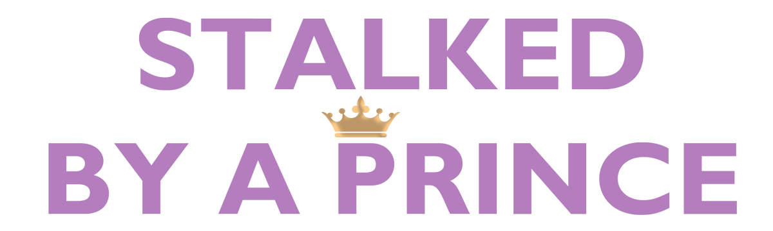

Johnson Production Group

Press Kit

One-Liner
A newly single woman thinks that she has woken up in a fairy tale when she sparks a relationship with a handsome Prince, but her dream quickly turns to a nightmare when the volatile royal refuses to let her go.

Synopsis

Publicist Alyssa Banks thinks she’s woken up in a fairy tale when she meets Jack, a handsome Prince. At first, everything seems to be going great – Jack wines and dines Alyssa, taking her to extravagant meals, on romantic carriage rides through the city, and whisking her away to Europe on a private jet. But Alyssa’s dream quickly turns into a nightmare when the volatile Prince refuses to let Alyssa leave his family’s luxurious estate in the English countryside. As Alyssa desperately tries to escape, she soon finds a way to turn the tables on her not-so-perfect Prince.

Producers
Executive Producer
TIMOTHY O. JOHNSON
ANDREW C. ERIN
Co-Executive Producer
JOSEPH WILKA
Producer
HAYDEN BAPTISTE
Supervising Producer
OLIVER DE CAIGNY
Key Cast
CHARACTER  Alyssa Banks  Jack  Taffer  Rachel  Timothy  Susan |  | ACTOR  NATALIE HALL  JONATHAN KELTZ  MICHAEL SWATTON  KONSTANTINA MANTELOS  ALEXANDER CROWTHER  MÉLANIE ST-PIERRE

Key Cast Biographies

NATALIE HALL
Natalie Hall is a talented and versatile actor and singer. Most recently Natalie starred in a in the Blumhouse anthology series INTO THE DARK for Hulu, as well as opposite Carla Gugino as in Sebastian Gutierrez Cinemax series JETT. She is well known to television audiences for playing the feisty stripper/mogul Candi Coco on the critically acclaimed comedy series UNREAL and for her memorable arcs on HBO’s True Blood, Usa’s Royal Pains and the CW series Charmed. In addition, Natalie was one of the leads of Star-Crossed for the CW and of the Unt. Marc Cherry Pilot for ABC and has appeared on hit shows like Ncis: New Orleans, Law And Order: Svu, The Good Wife, Csi and Pretty Little Liars. Also a very talented vocalist, Natalie has performed on stage in Cruel Intentions: The Musical and A Chorus Line, for which she received an Ovation Nomination for Best Supporting Actress in the latter. On the feature side, Natalie played opposite Miles Teller in the Sony/Lionsgate feature Only The Brave and starred in the independent films Summer Of 8, The Boy Downstairs, The Curse Of Sleeping Beauty, Plus One, Still Life, and Rising Stars. She has also been the lead of the highly rated Hallmark MOWs You’re Bacon Me Crazy, A Winter Princess, Fit For A Prince, Seven Year Hitch And Love’s Christmas Journey.

JONATHAN KELTZ

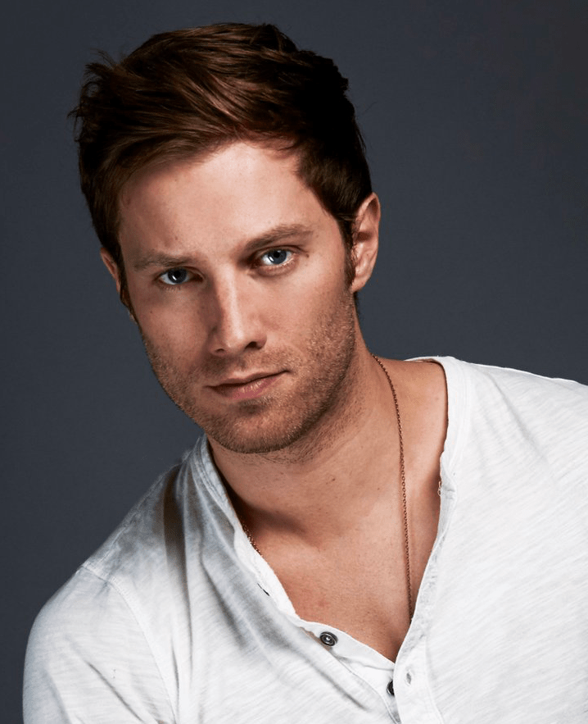
Jonathan Keltz starred on the CW’s Reign playing Leith, a kitchen boy turned war hero who is the loyal protector of Francis II, King of France. Keltz recently produced and starred in Acquainted, an independent film about the unpredictability of modern relationships. Additionally, Keltz recurred heavily on HBO’s Entourage, starred in Cardinal: Blackfly for CTV/Hulu, and starred in the popular Hallmark movies Fit For A Prince,Once Upon A Prince and Love at Look Lodge. Keltz also recently produced the limited series Nine Films About Technology for FX.

MICHAEL SWATTON
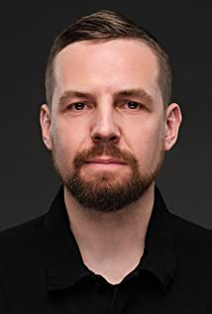
Dual British and Canadian citizen, Michael Swatton, obtained his degree from The Oxford School of Drama and has extensive experience in both film and stage. He is known for February, Ash & Dust, Two Deaths of Henry Baker, The Handmaid’s Tale, The Age of the Living Dead, The Nights Befor Christmas and Butchers.

KONSTANTINA MANTELOS
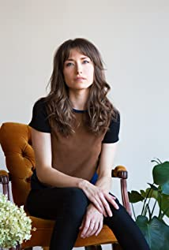
Konstantina Mantelos is a Greek-Canadian actress, screenwriter and producer. She starred as Shannon Becker in the indie horror hit Anything for Jackson (2020), and can also be seen in the romantic comedy Christmas Crush (2019) among other notable roles in film and television. She has extensive training including a BFA in Acting from Ryerson University and has also trained at the American Academy of Dramatic Arts in NYC.
Shortly after beginning her career as an actress, she recognized that she had a distinct vision for the stories that she wanted to tell. She began writing, acting in, and producing her own films in 2016, alongside her partner, director Douglas Gibbens. Her debut short, Lakesong, premiered at the 2017 LA Film Festival as part of the curated Danny Elfman Project. Through her work she uses elements of genre filmmaking to mine the dark corners and emotional depths of women on-screen.

ALEXANDER CROWTHER
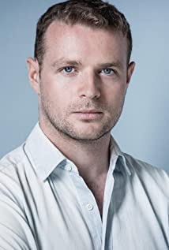
Alex Crowther is a Canadian actor. He is most noted for his performance as Aaron Warner in the 2020 film Flowers of the Field, for which he received a Vancouver Film Critics Circle Award nomination for Best Actor in a Canadian Film at the Vancouver Film Critics Circle Awards 2020. He has also had a recurring role in the TV Series Pure and appeared in the films Geogetown and American Hangman.

MÉLANIE ST-PIERRE
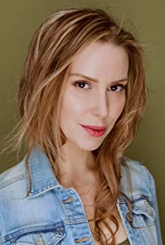
Mélanie St-Pierre was born on April 5, 1985 in Toronto, Ontario, Canada. She has extensive TV Movie experience and is known for her work on Transplant, Romance In The Wilds, Love by Accident, The Art of Falling In Love, Heroes Reborn and Garm Wars: The Last Druid.

Production Credits

Full Cast
Actors  NATALIE HALL  JONATHAN KELTZ  MICHAEL SWATTON  KONSTANTINA MANTELOS  ALEXANDER CROWTHER  MÉLANIE ST-PIERRE  VIGGO HANVELT  RODERICK MCNEIL  LISA KOVACK  DOMINIQUE DESMARAIS  CONNOR MCHANON  MAISSA HOURI | Role  Alyssa Banks  Jack  Taffer  Rachel  Timothy  Susan  Little Timmy  Chuck  Pub Owner  Model  Paparazzi #1  Paparazzi #2

Casting
RON LEACH, C.D.C

Composer
CHRISTOPHER GUGLICK

Costume Designer
SARAH A. CARROLL

Editor
RICHARD MANDIN

Production Designer
GREG WILSON

Director of Photography
WILLIAM SMITH

Written by
JOHN HAYES
SHAWN RIOPELLE

Directed by
MAXWELL MCGUIRE

Full Crew
LAYTON MORRISON | Stunt Coordinator
MATHEW MOREAU | First Assistant Director
AIDAN MAZEROLLE | Second Assistant Director
CEDRIC BELISLE | Third Assistant Director
AMTI | Extras Casting
ANGIE SAKLA-SEYMOUR
HAYDEN BAPTISTE | Line Producer
JACKIE MASSAR | Production Coordinator
VAL HARTRY | Assistant Production Coordinator
JOSIE FITZGERALD | Office Manager
LOGAN A. WAGNER | Production Accountant
JOSHUA LANGE | Assistant Production Accountant
GREG WILSON | Production Designer
JESSA MILLAR | Art Director
TOMAS CHOVANEC | Set Dressers
GORAN POBRIC
RACHEL VRECIC
NATHALIE GREGOIRE | Property Master
SARAH A. CARROLL | Costume Designer
ELLA JAMES-BESWICK | Costume Set Supervisor
AMANDA COLLIE | Costume Dressers
WILLIAM SMITH | Director of Photography
NATHAN JONNA BOULIANE | Camera Operators
ADAM TESTA
CHRISTOPHER BERTI | First Assistant Camera
KEEGAN YANG
MATT CROSSE | Second Assistant Camera
NIKKI TUBONGBANUA
TONY GULOY | Camera Technician
JEFF BRAY | Digital Imaging Technician
PETR MAUR | Stills Photographer
NICHOLAS CROSSE | Gaffer
NICHOLAS HERMIER | Best Electric
YAN SCHNELL | Electric
SHAWN TONARY | Swing
HUNTER BREEN | Key Grip
RJ NADON | Best Grip
NICHOLAS HOTTE | Grip
NICK LYNCH | Swings
MATT GARRITY
SONIC LIGHTNING ENTERTAINMENT INC. | Sound
ANDREW SUTHERLAND | Production Sound Mixer
KEITH CAMERON | Boom Operator
LORI HAREUTHER | Script Supervisor
PATRICK GARDEN | Location Manager
SAGINE CAVE | Assistant Location Manager
DEEDEE BUTTERS | Location Scout
KEENE IMBLEAU | Location Production Assistants
SAM KITTS
BENNY LI
BRENDAN MCLOUGHLIN
RYAN MYLES
NATHAN OSBORNE
KELSEY DAUPHINEE | Key Makeup Artist
CHANCELLE MULELA | Assistant Makeup Artist
ELIZAH MURRAY | Key Hair Stylists
NATASHA GABRIELA TREPANIER
SAMANTHA TREMBLAY | Daily Hair Stylist
STEFANE GREGOIRE | Transport Coordinator
GREG LEWIS | Basecamp Operator
ZACK ALLEN | Drivers
JESSICA LAIGHT
DAVE ROSE
STEVE CHAPESKI | Transport Production Assistants
STEVE MONETTE
ROBERT STRONACH
CRAIG WRIGHT
KEITH STEFFENSEN | Move Crew
ALEXANDRE VALERY
CORNELIA VILLENEUVE
DAN VILLENEUVE
ERIC VILLENEUVE
SEAN VILLENEUVE
ACTION SET MEDICS INC. | Health & Safety
BIAGIO'S | Catering
JODI JENNINGS
CAMERON MATHESON | Craft Laborer
HALL WEBER LLP | Script Clearances
HALL WEBER LLP | Legal Services
ABOVE THE LINE MEDIA SERVICES | Business Affairs
BRENDAN MCNEILL
ARTHUR J. GALLAGHER CANADA LTD. | Insurance
ALEXANDRA WARING | Post Production Supervisor
URBAN POST PRODUCTION | Post Production Services
STEVE MOORE | Re-Recording Mixers
LUCAS ROVEDA
CALVIN TRAN | Re-Recording Assistant
URBAN POST | Sound Edit
EHREN PFEIFER | ADR Recordist
BIG FOOT FOLEY | Foley
WARREN CHINN | Colorist
RICHARD DOMAN | Online Editor
IKE MURPHY | Project Manager
BRUCE REES | Picture Operations Manager
ROBERTA BRATTI | V.P. of Operations
ARTGRID | Stock Footage
21 AERIALS
CHRISTIAN BAITG SCHREIWEIS
VIA FILMS

Producer Biographies

TIM JOHNSON – Executive Producer
Tim Johnson is among the most active and reliable producers in the business thanks to top rate productions and global distribution appeal.
Johnson is also responsible for producing the international hit series, DR. QUINN, MEDICINE WOMAN for CBS for over 5 seasons. During his 100-episode tenure, he also developed and produced the original docu-drama COLD CASE for CBS network, which was the very first program to integrate television with the Internet.
Johnson has produced over 150 movies, 15 globally released series for every major US network - including ABC, Disney, CBS, NBC, Netfly, FOX and Sony.

JOHNSON PRODUCTION GROUP
The Johnson Production Group contracts globally to produce television content for international networks, studios and distributors. Based in Los Angeles and Vancouver, British Columbia, the company manages production, facilitates development and financing, procures distribution and guarantees quality and timely execution of its programs. While costs have gone up, so has the demand for quality. No longer is good enough, good enough. Johnson Production Group serves that segment when a show needs to be "A" quality, but produced efficiently enough to meet a locked budget. JPG specializes in value, protection of creative elements, and delivery of a quality finished product.
ANDREW C. ERIN – Executive Producer
Andrew Erin is a Canadian Writer/Director making a big splash in the US, and has produced, written and directed numerous commercially successful films. His directorial debut, SAM’S LAKE, was an official selection at the Tribeca Film Festival and did an excellent theatrical run in select theaters around the country; distributed by Lionsgate Films. Andrew also wrote the script for the film. Andrew’s directorial credits include, SIMPLE THINGS, produced for Screen Media Ventures and Universal Studios. Besides winning The Bob Clark Award for Best Director at the California Independent Film Festival, the film was commercially received. Andrew has worked continuously as a writer/director, building a strong library of films in the Thriller/Horror genres with: Embrace of The Vampire, The Clinic, Final Sale, Confined and Toxic Skies.

JOSEPH WILKA – Co-Executive Producer
Joseph Wilka is the Head of Production for Johnson Production Group. Los Angeles-based, Joseph had already produced and directed several feature films before serving as the senior marketing executive for Gravitas Ventures. While at Gravitas, Wilka helped pioneer new distribution models for independent films including day-and-date theatrical releases. It was also at Gravitas where Joseph first worked with Johnson Production Group to facilitate the release of their films to the worldwide Video On Demand audience. After serving as the Director of Distribution and Production for Viva Pictures, where he produced English-language versions of foreign animated titles for DirecTV, Wilka officially joined Johnson Production Group. As Head of Production, he oversees the development, production, and distribution of films from multiple production units for release on broadcast and streaming platforms.

HAYDEN BAPTISTE – Producer
Hayden Baptiste is a Producer and Development Executive with The Mob Entertainment, an LA Based production company with a Canadian office in Ontario. After spending nearly 15 years working as an Associate Producer for The Johnson Production Group and working as an Independent Producer in Toronto and Vancouver, Hayden has evolved into a well rounded producer who understands all aspects of production from development to delivery. Hayden has produced films for various networks including CBC, Bravo, The Hallmark Network, UP TV and Lifetime Network. His films have been selected for film festivals around the world including the Montreal World Film Festival, Atlantic Film Festival, Screamfest, Catalina Film Festival, National Screen Institute and Chicago International. In addition to his extensive production experience, Hayden is a screenwriter and composer. Hayden has studied at the Canadian Screen Training Centre, and completed the summer intensive screenwriting program at UBC.

OLIVER DE CAIGNY – Supervising Producer
Oliver De Caigny is a Canadian producer originally from Belgium, his background in financing, production, and post production makes him a well-rounded producer for any type of production. His experience in financing and production agreements (film and TV series and movies-of-the week), distribution agreements (both domestic and foreign) as well as international co-productions, Canadian tax credit, Telefilm Canada and Canada Media Fund incentives provides him with a well-rounded background in development, production and distribution for motion pictures, television series and productions.

Billing Block
Johnson Production Group with Lifetime Networks Presents “STALKED BY A PRINCE”
NATALIE HALL JONATHAN KELTZ MICHAEL SWATTON KONSTANTINA MANTELOS ALEXANDER CROWTHER MÉLANIE ST-PIERRE Casting by RON LEACH, c.d.c Composer CHRISTOPHER GUGLICK Costume Designer SARAH A. CARROLL Editor RICHARD MANDIN Production Designer GREG WILSON Director of Photography WILLIAM SMITH Co-Executive Producer JOSEPH WILKA Supervising Producer OLIVER DE CAIGNY Executive Producers ANDREW C. ERIN TIMOTHY O. JOHNSON Produced by HAYDEN BAPTISTE Written by JOHN HAYES SHAWN RIOPELLE Directed by MAXWELL MCGUIRE
The Canadian Film or Video Production Tax Credit
© MMXXI SBAP 2021 Productions Inc. All Rights Reserved
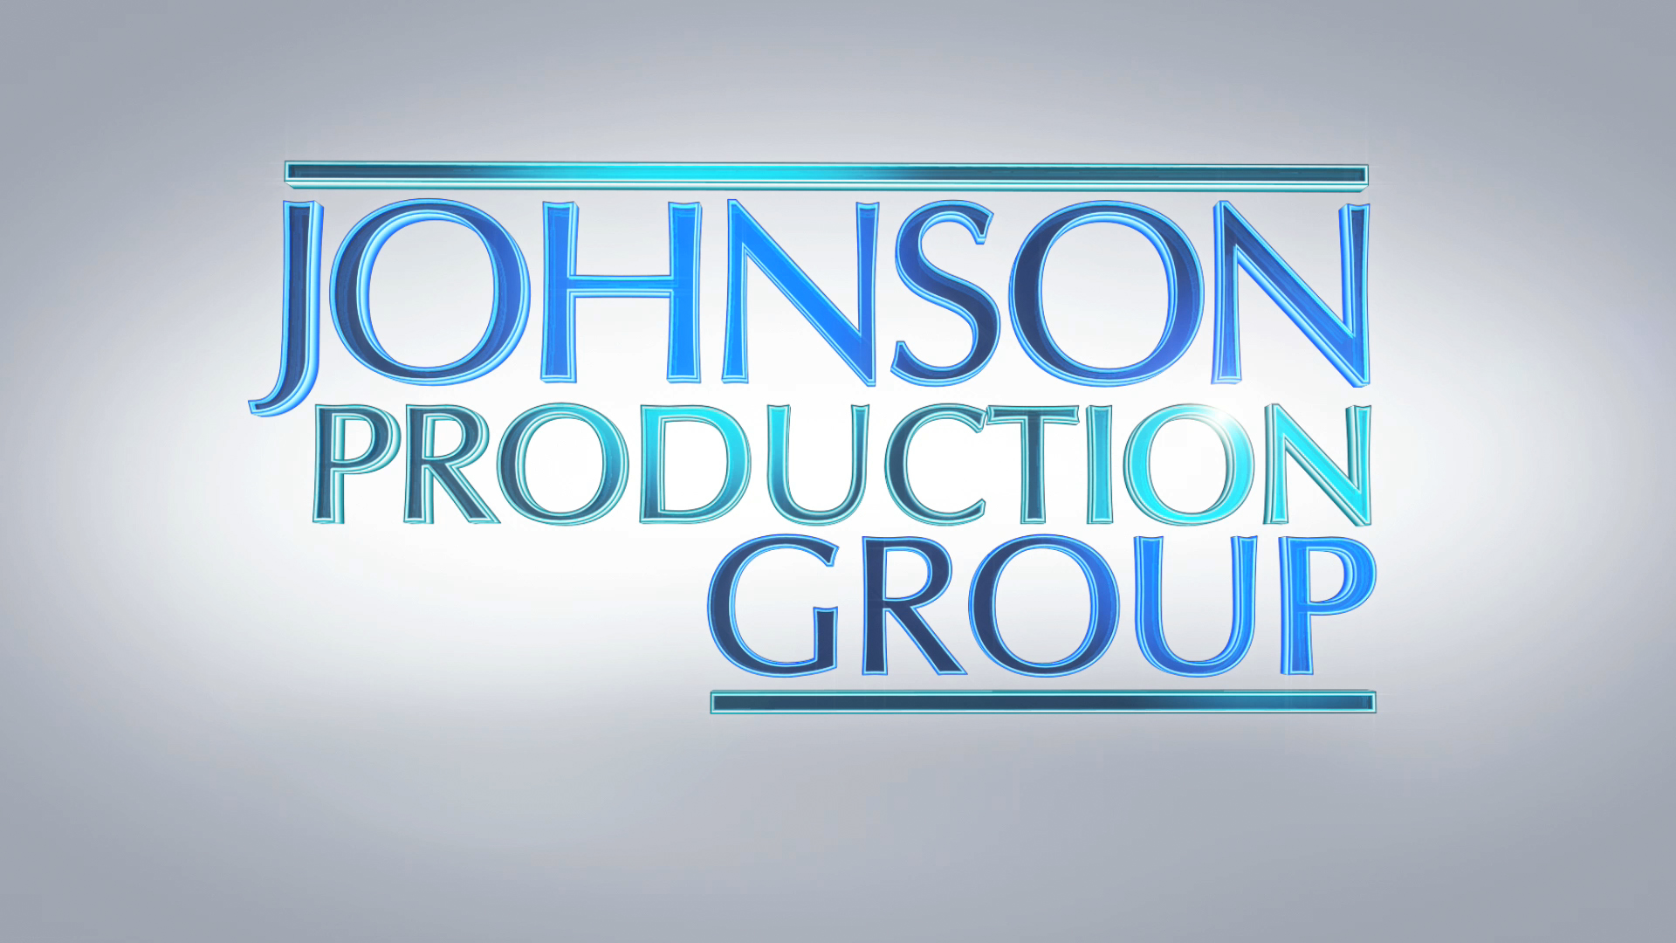

Meta Data
LONG (max 3000 characters) synopsis
Stalked by a Prince tells the Cinderella-story turned Grimm’s Fairy Tale of Alyssa Banks, a talented young publicist making her way up the corporate ranks who finds her life turned upside down when she’s introduced at a work event to the famous Prince Jack, noted philanthropist and renowned playboy, fourteenth in line to the throne.
At first, it’s a fantasy romance. A real-life Prince Charming, Jack is the picture of chivalry as he takes Alyssa on a series of epic dates, culminating in a surprise invite to a weekend getaway at his private estate deep in the countryside.
There, Alyssa learns that beneath Prince Jack’s suave exterior lurks a troubled past – a violent madness sparked when he fears affections might go unreturned. Trapped behind a façade of royalty and opulence, hunted by the man she thought her dream match, Alyssa must find a way to reveal the prince’s dark secret to the world before she becomes his latest victim.
(940)
MEDIUM (max 500) synopsis
Alyssa Banks finds her life turned upside down when she meets the famous Prince Jack, fourteenth in line to the throne. When he invites her to a weekend getaway at his private estate deep in the countryside, Alyssa learns that beneath his suave exterior lurks a troubled past. Trapped behind a façade of royalty and opulence, hunted by the man she thought her dream match, Alyssa must find a way to reveal the prince’s dark secret to the world before she becomes his latest victim.
(481)
SHORT (max 100 characters) synopsis
Hunted by the Prince she thought her dream match, Alyssa must find a way to reveal his dark secret.(99)

5 KEY WORDS
Royalty, Throne, Romance, Sinister, Charming

