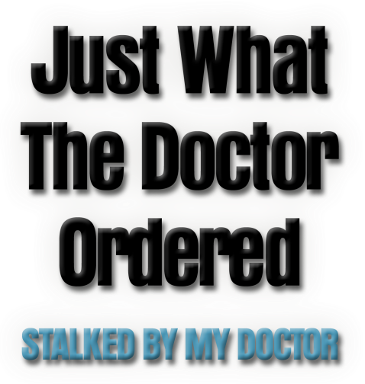

Johnson Production Group

Press Kit

One-Liner
Dr. Beck is back! Having escaped from the psychiatric prison, Dr. Albert Beck hides out in an empty house – until its new owners unexpectedly arrive to move in! Forced into the attic to evade recently the widowed mother, Beck watches from above – undeniably attracted to her 18 year old daughter.

Synopsis
Dr. Beck is back! Having escaped from the psychiatric prison where we last saw him, a “cured” Dr. Albert Beck hides out in an empty house – until its new owners unexpectedly arrive to move in! Forced into the attic to evade recently widowed Maggie Newell, Beck watches from above – undeniably attracted to Maggie’s 18 year old daughter, Alex.
When Alex collapses from the same heart condition that claimed her father, Beck comes to her anonymous rescue – and soon creates a scenario where he poses as the girl’s in-home nurse, there to ensure Alex’s safety and survival. To save her, Beck will need to locate a suitable donor heart for the young girl – a surgery he is perfectly capable of performing, proving his love to the new object of his affection. Meanwhile, Maggie searches for the identity of the mysterious “good Samaritan” who saved her daughter’s life, setting the two on a deadly collision course…

Producers
Executive Producer
TIMOTHY O. JOHNSON
Co-Executive Producers
SHERI REEVES
JOSEPH WILKA
Co-Producers
SARA SOMETTI MICHAELS
JOHN J. TIERNEY
Producer
KEN SANDERS

Key Cast
CHARACTER  Dr. Albert Beck / Laid Back Beck  Alexa Newell  Maggie Newell  Scott  Gail Matthews |  | ACTOR  ERIC ROBERTS  GRACE PATTERSON  CARRIE SHROEDER  BRANDON TYLER MOORE  ADRIAN EPPLEY

Key Cast Biographies

ERIC ROBERTS
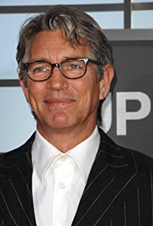
Roberts is an Academy Award nominee for his role in Runaway Train, and a three-time Golden Globe nominee for Runaway Train, Star 80, and King of the Gypsies.
In addition, Roberts received acclaim at the Sundance Film Festival for his role in A Guide to Recognizing Your Saints and It's My Party. He also starred in La Cucaracha, which won Best Film at the Austin Film Festival, and for which Roberts won Best Actor at the New York Independent Film Festival that same year. Other notable performances include his roles in The Dark Knight, Final Analysis, and Paul Thoman Anderson's Inherent Vice for Warner Bros., Millennium Films' Lovelace and The Expendables for Lionsgate.
On television, Roberts' memorable recurring roles include USA's Suits, CSI and Code Black for CBS, NBC's Heroes, and Crash for Starz. He has appeared in guest star roles on ABC's Grey's Anatomy, NBC's Will & Grace, Fox's Brooklyn Nine-Nine, CBS' Hawaii Five-O, HBO's Entourage, and so much more.
Upcoming, Roberts plays Matt Dillon's doctor in Head Full of Honey, a Warner Bros. Germany production that is directed by Til Schweiger. Emily Mortimer and Nick Nolte also star. He also has a supporting role in the independent Hard Luck Love Song directed by Justin Corsbie. Roberts will play "Skip," a grizzled doorman who offers advice to characters played by Michael Dorman and Sophia Bush. The film also stars Dermott Mulroney, and American rapper, RZA. Finally, Roberts is set to recur as DEA boss "Erick Sheldon" in La Reina del Sur for Telemundo Global Studio and Netflix.
Roberts was born in Biloxi, Mississippi, and grew up in and around the Atlanta area. He began his career in theatre in New York City where he won the Theatre World Award for his role on Broadway in Burn This.
He resides in Los Angeles with his wife of 26 years and brood of felines.

GRACE PATTERSON
Grace caught the acting bug at 9 years old after being cast in a school theater production. She subsequently trained with the Children's Theater of Dallas appearing in several stage productions before developing what would later become a passion for on-screen acting. In 2010, Grace was cast in the UTA production, unloved, in which she played an emotionally-challenged foster child. Grace is committed to her development as an actor and has trained with Cathryn Hartt, Del Shores, Sharron Garrison, and now studies with Ice Mrozek. Grace is also an accomplished dancer (including jazz, ballet, and hip hop) making her a double threat.

CARRIE SHROEDER
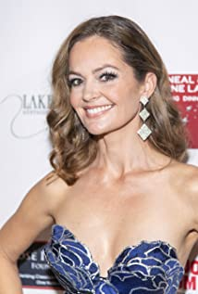
Carrie Schroeder was born and raised in the small country town of Shepparton Australia. When she wasn't riding a horse, waterskiing, or camping up the Murray River, Carrie was at a piano lesson, dance class or recital. Carrie attended Charles Sturt University in NSW Victoria and received her Bachelor of Arts in Acting for the Stage and Screen. During her time at University she starred as Hero in "Much Ado About Nothing," Jessica in "Dead White Males" and Shelby in "Steel Magnolias." During her senior year, Carrie was one of 11 students to be selected to perform in the Sydney Theatre Company's highly acclaimed production of "The White Devil" lead by Hugo Weaving and Angie Milliken as part of Sydney's Olympic Arts Festival.
Immediately following her graduation, Carrie toured in a production of "And Then They Came for Me" by American author James Still, starring in the role of Eva Schloss. To this day, one of Carrie's most humbling experiences was meeting Holocaust survivor Eva Schloss during the run of the play. Dance was still a huge part of Carrie's life until an onstage injury during a touring production in Singapore ended her dancing. Her professional focus then shifted to the screen, and she was cast in the television miniseries adaptation of Bryce Courtney's novel "Jessica." Following this, she went on to guest star in popular Australian television programs including "H2O: Just Add Water" and "Neighbours."
Carrie relocated to Los Angeles in 2012, and continues to add to her resume in film, television and webisodes. Her notable L.A. theatre credits include playing Alison in John Osborne's "Look Back in Anger" with the Los Angeles New Court Theatre and as Sophie in Joanne Mosconi's new work for the Fringe Theatre Company "You Love That I'm NOT Your Wife!" In addition to her acting career, Carrie is also an accomplished mezzo-soprano and performs regularly. She sang with Jason Alexander and the Boston Pops at Symphony Hall in 2013, and then again at Tanglewood in 2014. Carrie has sung with vocalist Robyn Spangler several times, including at The Metropolitan Room in New York City and appeared in her music video for the song, "Second Wind." She has also performed for two years as a back-up singer for the Alzheimer's Benefit - "A Night at Sardi's" at The Beverly Hilton.

BRANDON TYLER MOORE
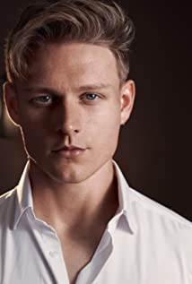
Brandon Moore is an actor, known for Dead Silent (2016), Back to the Goode Life (2019) and Brides, Grooms and Emergency Rooms (2019).

ADRIAN EPPLEY
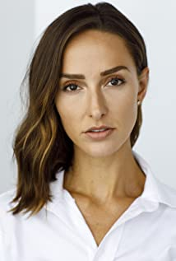
Adrian Eppley is an actress, known for Delilah (2021), Who Is Killing the Cheerleaders? (2020) and Old Blue Eyes (2020).

Production Credits

Full Cast
Actors  ERIC ROBERTS  GRACE PATTERSON  CARRIE SHROEDER  BRANDON TYLER MOORE  ADRIAN EPPLEY  MICHAEL RUBINO  ELIZA ROBERTS | Role  Dr. Albert Beck / Laid Back Beck  Alexa Newell  Maggie Newell  Scott  Gail Matthews  Dr. Patrick Carlyle  Nurse Christine McCoy

Casting by
JEFF HARDWICK, CSA

Music by
SANDRO MORALES SANTORO

Edited by
ANDREW HARWOOD

Director of Photography
FERGUSON SAUVÉ-ROGAN

Co-Producers
SARA SOMETTI MICHAELS
JOHN J. TIERNEY

Co-Executive Producers
SHERI REEVES
JOSEPH WILKA

Executive Producer
TIMOTHY O. JOHNSON

Produced by
KEN SANDERS

Story by
KEN SANDERS
DANIEL WEST

Based on Characters Created by
DOUG CAMPBELL

Screenplay by
DANIEL WEST

Directed by
JEFF HARE

Producer Biographies

TIM JOHNSON – Executive Producer
Tim Johnson is among the most active and reliable producers in the business thanks to top rate productions and global distribution appeal.
Johnson is also responsible for producing the international hit series, DR. QUINN, MEDICINE WOMAN for CBS for over 5 seasons. During his 100-episode tenure, he also developed and produced the original docu-drama COLD CASE for CBS network, which was the very first program to integrate television with the Internet.
Johnson has produced over 150 movies, 15 globally released series for every major US network - including ABC, Disney, CBS, NBC, Netfly, FOX and Sony.

JOHNSON PRODUCTION GROUP
The Johnson Production Group contracts globally to produce television content for international networks, studios and distributors. Based in Los Angeles and Vancouver, British Columbia, the company manages production, facilitates development and financing, procures distribution and guarantees quality and timely execution of its programs. While costs have gone up, so has the demand for quality. No longer is good enough, good enough. Johnson Production Group serves that segment when a show needs to be "A" quality, but produced efficiently enough to meet a locked budget. JPG specializes in value, protection of creative elements, and delivery of a quality finished product.
JOSEPH WILKA – Co-Executive Producer
Joseph Wilka is the Head of Production for Johnson Production Group. Los Angeles-based, Joseph had already produced and directed several feature films before serving as the senior marketing executive for Gravitas Ventures. While at Gravitas, Wilka helped pioneer new distribution models for independent films including day-and-date theatrical releases. It was also at Gravitas where Joseph first worked with Johnson Production Group to facilitate the release of their films to the worldwide Video On Demand audience. After serving as the Director of Distribution and Production for Viva Pictures, where he produced English-language versions of foreign animated titles for DirecTV, Wilka officially joined Johnson Production Group. As Head of Production, he oversees the development, production, and distribution of films from multiple production units for release on broadcast and streaming platforms.
SHERI REEVES – Co-Producer
Sheri Reeves is known for her work on Vitals, Family Vanished and Save the Date
KEN SANDERS – Producer
Over the past 15 years, Ken Sanders has written and/or produced over forty feature-length motion pictures. In 2009 he started the production company Shadowland, LLC with partner Robert Ballo. Together they produced THE CHEATING PACT, MISSING AT 17, THE PERFECT BOYFRIEND, DIRTY TEACHER, THE SURROGATE, STALKED AT 17, TEENAGE BANK HEIST, WALKING THE HALLS, BETRAYED AT 17, HOME INVASION, MATERNAL OBSESSION, and ACCUSED AT 17, all of which were ratings hits when they premiered on Lifetime Television. Sanders is now the primary producer for Stonecrest Entertainment where he continues to produce feature films for TV and streaming audiences. In addition to his film and television work, Sanders has served as an adjunct professor at Biola University, where he taught classes on producing and screenwriting. He is also a frequent guest lecturer at Los Angeles Valley College and the Los Angeles Film School, where he speaks on topics ranging from the business of film to post-production to pitching and script development. Sanders received his degree in Filmic Writing from the University of Southern California, School of Cinematic Arts.
JEFF HARE – Director
Jeff Hare is an American director and writer, known for Bitter/Sweet (2009), A Perfect Little Man (1999) and Checking Out (2005). Jeff has been writing and directing movies, television, television commercials and documentaries for over twenty five years. His work is extremely diverse, and has been seen on movie screens worldwide, and on TV networks like Fox, American Movie Classics, Lifetime, Lifetime Movie Network, My Network, Discovery, Speed-TV, Cartoon Network and BET, to name just a few.

Billing Block

Johnson Production Group Presents In Association with Juniper Lane Productions “STALKED BY MY DOCTOR: JUST WHAT THE DOCTOR ORDERED ”
starring ERIC ROBERTS GRACE PATTERSON CARRIE SHROEDER BRANDON TYLER MOORE and ADRIAN EPPLEY Casting by JEFF HARDWICK, CSA Music by SANDRO MORALES SANTORO Edited by ANDREW HARWOOD Director of Photography FERGUSON SAUVÉ-ROGAN Co-Producers SARA SOMETTI MICHAELS JOHN J. TIERNEY Co-Executive Producers SHERI REEVES JOSEPH WILKA
Executive Producer TIMOTHY O. JOHNSON Produced by KEN SANDERS
Story by KEN SANDERS DANIEL WEST Based on Characters Created by DOUG CAMPBELL Screenplay by DANIEL WEST Directed by JEFF HARE

With the participation of the Province of British Columbia
Film Incentive BC
The Canadian Film or Video Production Tax Credit
© MMXX Johnson Production Group Inc. All Rights Reserved

Meta Data
LONG (max 3000 characters) synopsis
Dr. Beck is back! Having escaped from the psychiatric prison where we last saw him, a “cured” Dr. Albert Beck hides out in an empty house – until its new owners unexpectedly arrive to move in! Forced into the attic to evade recently widowed Maggie Newell, Beck watches from above – undeniably attracted to Maggie’s 18 year old daughter, Alex.
When Alex collapses from the same heart condition that claimed her father, Beck comes to her anonymous rescue – and soon creates a scenario where he poses as the girl’s in-home nurse, there to ensure Alex’s safety and survival. To save her, Beck will need to locate a suitable donor heart for the young girl – a surgery he is perfectly capable of performing, proving his love to the new object of his affection. Meanwhile, Maggie searches for the identity of the mysterious “good Samaritan” who saved her daughter’s life, setting the two on a deadly collision course… (912)
MEDIUM (max 500) synopsis
Dr. Beck is back! Having escaped from the psychiatric prison, Dr. Albert Beck hides out in an empty house – until its new owners unexpectedly arrive to move in! Forced into the attic to evade recently the widowed mother, Beck watches from above – undeniably attracted to her 18 year old daughter. (297)
SHORT (max 100 characters) synopsis
Dr. Beck is hiding in the attic of a house, watching...undeniably attracted to the teen daughter. (97)
5 KEY WORDS
Beck, surgery, psychiatric prison, donor

