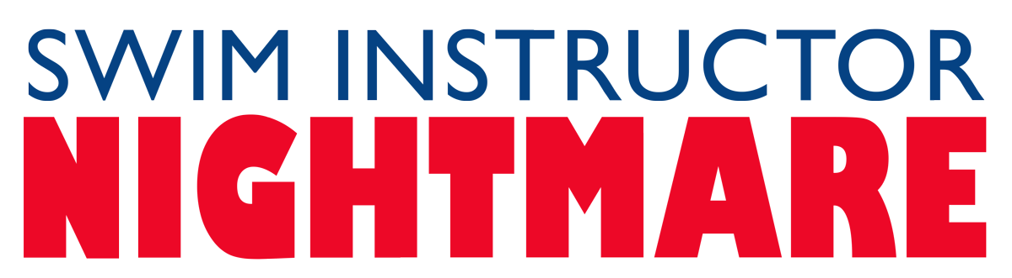

Johnson Production Group

Press Kit

One-Liner
A swim instructor forms an unsinkable obsession for her student’s father.

Synopsis
When his ten-year-old daughter refuses to go swimming due to fear, Parker hires swim instructor Sabrina. Unbeknownst to all, Sabrina forms an unsinkable obsession for Parker and plans to drown everyone in her wake.

Producers
Executive Producer
TIMOTHY O. JOHNSON
Co-Producer
JOSEPH WILKA
Producer
ROBERT BALLO
Line Producer
ROBIN CONLY
Key Cast
CHARACTER  Sabrina Jameson  Ellen Scott  Parker Scott  Ashley Scott  Coach Sharky |  | ACTOR  SYDNEY HAMM  SHELLIE STERLING  C.J. HAMMOND  KIARRA GABRIELLE BEASLEY ELIJHA MAHAR

Key Cast Biographies

SYDNEY HAMM

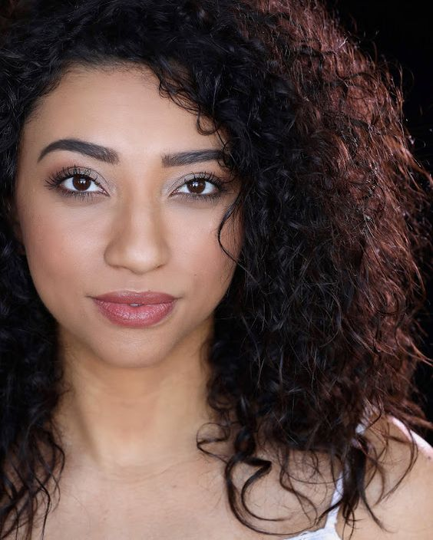
As a represented, SAG-Eligible actor and model, Sydney Hamm has been working in this industry for the better part of 7 years. Though she earned her Bachelor's Degree in Human Development from CSULB, performance art and creative expression are her true passions; and she absolutely lovse coming together with new friends and colleagues to create something beautiful. Throughout her time in the business, she has had the pleasure of working on a wide variety of different sets and projects—work which includes runway, commercial, editorial, television, and print. “With every new experience comes new knowledge, and I can't wait to grow with and learn from you!”

SHELLIE STERLING
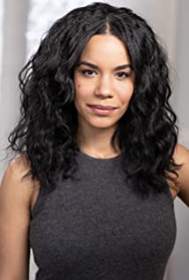
Shellie Sterling is a Los Angeles based actress currently starring as Kayla in the Lifetime series Keeping Up with the Joneses. She has also appeared in the TV Movies A Party Gone Wrong, Meteor Moon, Christmas Together and The Wrong Cheer Captain, amongst others.

C.J. HAMMOND
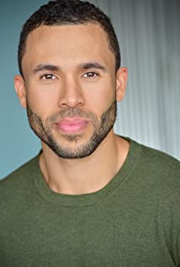
CJ Hammond is originally from Denver, Colorado and has been in the pursuit of his dream in LA for the past five years. He began his career modeling in Colorado with Wilhelmina Models, but soon realized if he wanted to make this a career he would need to move to LA. Since moving to LA he is now signed to CESD and Brand Models working on various print ads and campaigns. In addition to this CJ found a love for acting, which lead him to sign with Luciano Reeves Talent and has since been in numerous commercials and several TV movies. He is currently working towards becoming a face you see on the Big Screen in the movie theaters or small screen on your local TV on behalf Ignite Management. Through this relationship he already starred in a musical theatrical performance allowing to utilize his acting and vocal talents as well as appearing in TV movies Deadly Daughter and Barely Professional.. Lastly CJ has created, written, and starred in his own pilot TV show that garnered success at several different film festivals including Holly Shorts, Studio City International Film Festival, & Indie Night Film Festival.

KIARRA GABRIELLE BEASLEY
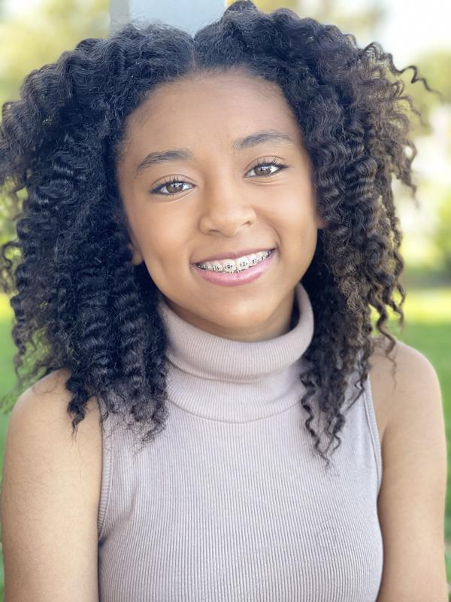
Kiarra Gabrielle Beasly is a busy young actress of African and Lation descent. She has appeared in Battle Stations, A Halloween Wish, Reborn, In The Company of Assasins, TikTok and Mom Sues Ex. When she’s not acting she keeps buys swimming, soccer, karate, basketball and bike riding.

ELIJHA MAHAR
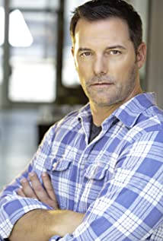
Elijah Mahar is an American actor who has appeared in multiple TV Series such as The X-Files, Shapetown USA, NCIS, Extreme Measures and Rebel. He has a Bachelor of Fine Arts from the Southern Methodist University in Dallas, Texas

Production Credits

Full Cast
Actors  SYDNEY HAMM  SHELLIE STERLING  C. J. HAMMOND  KIARRA GABRIELLE BEASLEY  ELIJHA MAHAR  MACKENZIE POSSAGE  ALISON ROBERTSON  MORRIS JUDE MARTINEZ  JANET CARTER  FREDDIE MEDINA  JEFFREY FIELDS  DEMETRIUS L. JONES  KRISTEN LEEPER  LUIS MALDONADO MANCILLA  ALLEN EISENBERG  EDGAR NUNLEY | Role  Sabrina Jameson  Ellen Scott  Parker Scott  Ashley Scott  Coach Sharky  Donna Dean  Khloe Jameson  Jerry  Vicky  Michael  Police Officer 1  Police Officer 2  Rehab Patient 1  Rehab Patient 2  Rehab Patient 3  Mr. Jameson (image)

Casting by
Robin De Lano
Nicole Dionne

Makeup by
Shannon Marie Trigger

Sound Design by
Andres Boulton

Edited by
Josh Muscatine

Costume Designer
Lena Lollis

Production Designer
Christell Holmes

Director of Photography
David Dolnik

Screenplay by
David Chester
Doug Campbell

Directed by
Doug Campbell

Full Crew
KATE LUGTU | First Assistant Director
NICOLE DIONNE | Casting Director
ROBIN DE LANO
CHRISTOPHER JORDAN | B Camera Operator
JENNY BAUMERT | Underwater Camera Operator
JUSTIN CROWE | First Assistant Camera
ALEX TETZNER
REID COLLINS | Second Assistant Camera
CHRISTELL HOLMES | Production Designer
JEWEL HAMRICK IV | Art Director
OLIVIA DOSKEY-MULVANEY | Art PA
JUSTIN THATCHER | Chief Lighting Technician
DANIEL CASTILLO | Key Grip
EDGAR NUNLEY | Grip & Electric Swing
SHANNON MARIE TRIGGER | Makeup Dept. Head
BRENDA LOPEZ | Makeup Artist
JORDAN HURST
MEGAN LONGMEYER
RAMONA COLLAZO | Hair Stylist
JASON MORAN | Production Sound Mixer
NATHAN GROOTHUIS | Key Production Assistant
SAMUEL WILDSTEIN | Production Assistants
KENT EIGENGRAU
PROVIDED BY GOODWILL MEDIA | Studio Teacher
TODD PLISS | Studio Teacher
DOERTE LINDER | Accountant
WRAPBOOK | Payroll
LORI’S KITCHEN | Catering
LORI GRIGG
REMI NATIONS | Covid Safety Supervisors
ROBIN CONLY
SAMUEL WILDSTEIN
BOOKED TALENT | Background Casting
BREAKDOWN SERVICES | Casting Support Services
ROBIN CONLY | Post Supervisor
SOUND AS ART | Post Sound
ANDRES BOULTON
JONATHAN MORGAN | Foley Editor
BLUELINE FINISHING | Conform and Delivery
RANDY COONFIELD | Color Grading
GOAL PRODUCTIONS, INC. | Stock Footage
CLEARANCE UNLIMITED | Script Clearance
SUZY VAUGHAN
BLACKSTONE ENTERTAINMENT | Grip And Lighting Equipment
GOAL PRODUCTIONS, INC. | Camera Equipment
ALL CAPS | Production Managers

Producer Biographies

TIM JOHNSON – Executive Producer
Tim Johnson is among the most active and reliable producers in the business thanks to top rate productions and global distribution appeal.
Johnson is also responsible for producing the international hit series, DR. QUINN, MEDICINE WOMAN for CBS for over 5 seasons. During his 100-episode tenure, he also developed and produced the original docu-drama COLD CASE for CBS network, which was the very first program to integrate television with the Internet.
Johnson has produced over 150 movies, 15 globally released series for every major US network - including ABC, Disney, CBS, NBC, Netfly, FOX and Sony.

JOHNSON PRODUCTION GROUP
The Johnson Production Group contracts globally to produce television content for international networks, studios and distributors. Based in Los Angeles and Vancouver, British Columbia, the company manages production, facilitates development and financing, procures distribution and guarantees quality and timely execution of its programs. While costs have gone up, so has the demand for quality. No longer is good enough, good enough. Johnson Production Group serves that segment when a show needs to be "A" quality, but produced efficiently enough to meet a locked budget. JPG specializes in value, protection of creative elements, and delivery of a quality finished product.
JOSEPH WILKA - Co-Producer
Joseph Wilka is the Head of Production for Johnson Production Group. Los Angeles-based, Joseph had already produced and directed several feature films before serving as the senior marketing executive for Gravitas Ventures. While at Gravitas, Wilka helped pioneer new distribution models for independent films including day-and-date theatrical releases. It was also at Gravitas where Joseph first worked with Johnson Production Group to facilitate the release of their films to the worldwide Video On Demand audience. After serving as the Director of Distribution and Production for Viva Pictures, where he produced English-language versions of foreign animated titles for DirecTV, Wilka officially joined Johnson Production Group. As Head of Production, he oversees the development, production, and distribution of films from multiple production units for release on broadcast and streaming platforms.
ROBERT BALLO – Producer
With over 34 years of industry experience, Robert Ballo has created award-winning productions for clients that include ABC, TBS, PBS, Discovery Channel, and Lifetime, and that have aired on national network television, cable networks, and internationally in Asia and Europe. As Director of Photography and Producer at Shadowland, Ballo has created over a dozen feature films seen on the Lifetime Network and distributed internationally. As Director of Photography, his Shadowland films include MISSING AT 17, THE SURROGATE, STALKED AT 17, TEENAGE BANK HEIST, WALKING THE HALLS, BETRAYED AT 17, HOME INVASION, MATERNAL OBSESSION, ACCUSED AT 17 and SPECTRES. Other feature film credits include RUNNIN' AT MIDNITE, THE AFFAIR and STARVING ARTISTS. Ballo has also traveled the world on many documentary productions.
His television credits for national broadcast and cable networks include COLLEGE SPORTS IN AMERICA, GREAT EUROPEAN BALLOON ADVENTURE, DIRTY HARRY THE ORIGINAL, THE GREAT YEAR, and THE ROSE PARADE - PAGEANT FOR THE AGES. Through his other digital motion picture company, GOAL Productions, Ballo works with Fortune 500 companies, non-profit organizations and government agencies to produce sales and marketing videos as promotional communications. After a twenty-year tenure teaching film and video imaging, Ballo recently retired from his position as an Associate Professor of Practice at USC’s School of Cinematic Arts. A graduate of the USC film production program himself, Ballo is a member of the Academy of Television Arts and Sciences.

ROBIN CONLY - Line Producer
Robin's career has spanned from Texas to Los Angeles, where she's produced several internationally distributed films that can be seen on networks including HBO, Hallmark, Showtime, Hulu, and Netflix. Recently, she worked with a former Disney Imagineer to produce multiple segments of a 4D IMAX attraction for the Mall of America; helmed research and development for a documentary production company; and produced an award-winning web-series.

Billing Block
JOHNSON PRODUCTION GROUP presents in association with SHADOWBOXER FILMS "SWIM INSTRUCTOR NIGHTMARE”
SYDNEY HAMM SHELLIE STERLING C.J. HAMMOND KIARRA GABRIELLE BEASLEY and ELIJHA MAHAR Casting by NICOLE DIONNE and ROBIN DE LANO Sound Design By ANDRES BOULTON Music by Edited by JOSH MUSCATINE Costume Designer LENA LOLLIS Production Designer CHRISTELL HOLMES Director of Photography DAVID DOLNIK
Line Producer ROBIN CONLY Co-Produced by JOSEPH WILKA Executive Producer TIMOTHY O. JOHNSON Produced by ROBERT BALLO STORY BY DOUG CAMPBELL Written BY DAVID CHESTER & DOUG CAMPBELL Directed by DOUG CAMPBELL
© MMXXI Johnson Production Group Inc. All Rights Reserved
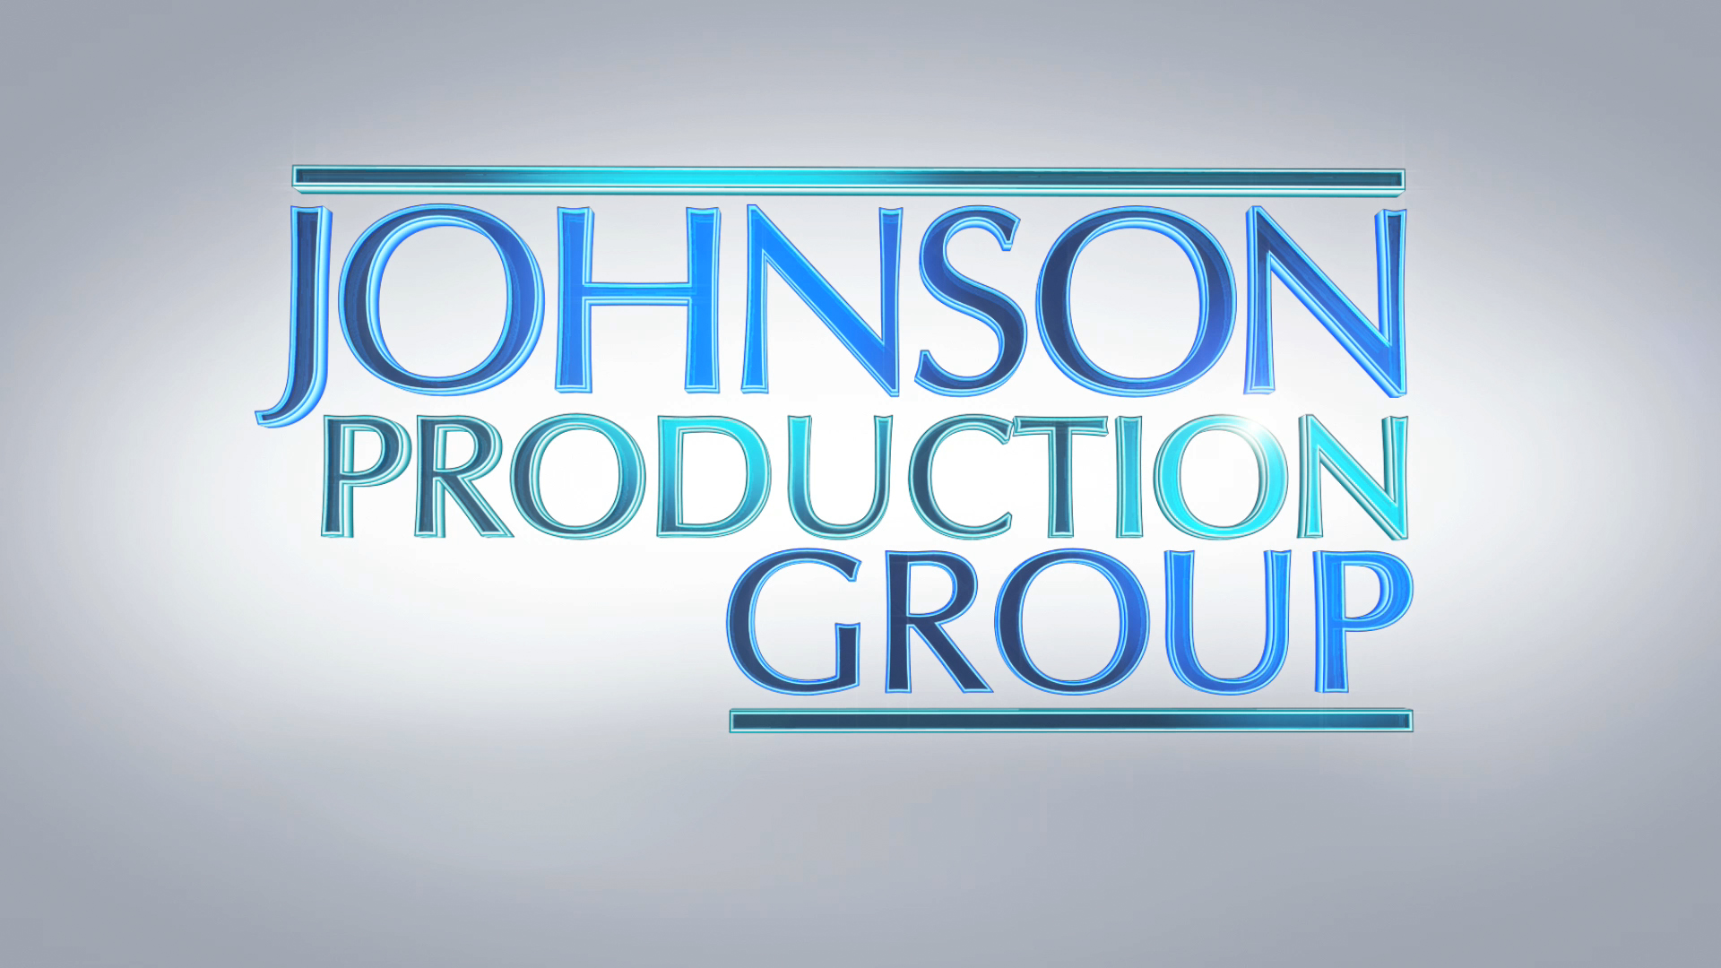
Meta Data

LONG (max 3000 characters) synopsis
When his ten-year-old daughter refuses to go swimming due to fear, Parker hires swim instructor Sabrina. Unbeknownst to all, Sabrina forms an unsinkable obsession for Parker and plans to drown everyone in her wake.
(215)

MEDIUM (max 500) synopsis
When his ten-year-old daughter refuses to go swimming due to fear, Parker hires swim instructor Sabrina. Unbeknownst to all, Sabrina forms an unsinkable obsession for Parker and plans to drown everyone in her wake.
(215)
SHORT (max 100 characters) synopsis
A swim instructor forms an obsession for her student’s father and plans to drown anyone in her way.
(99)

5 KEY WORDS
Instructor, drowning, pool, lifeguard, parent

