TAKEN IN MONTANA

Johnson Production Group

Press Kit

One-Liner
When her parents go missing on their family vacation, teen Reagan must put the clues together to find them -- but she may be trusting the wrong people to help, putting herself in danger.

Synopsis
Craig, Sarah, and Reagan Gerard have come to beautiful Big Sky, Montana for a much needed family vacation. Lucky enough Craig's old college roommate, Jackson Green, owns a very successful lodge. Before the family can get settled in Craig and Sarah are on a run for their life. They find out that Jackson has been running an illegal poaching ring, and will stop at nothing to get rid of all who know. Meanwhile their daughter, Reagan enlists the help of local Park Ranger, Jude, with the plan of bringing down Jackson and finding her parents.

Producers
Executive Producer
TIMOTHY O. JOHNSON
JOSEPH WILKA
Co-Executive Producer
LISA ALFORD
Producer
A.J. KELLY
Co-Producer
JACOB HORN
Line Producer
AMANDA SEARS

Key Cast
CHARACTER  Reagan Gerard  Craig Gerard  Jackson Green  Sarah Gerard |  | ACTOR  VERONICA RAMIREZ  JUSTIN BERTI  MATTHEW POHLKAMP  LAURIE FORTIER

Key Cast Biographies

VERONICA RAMIREZ
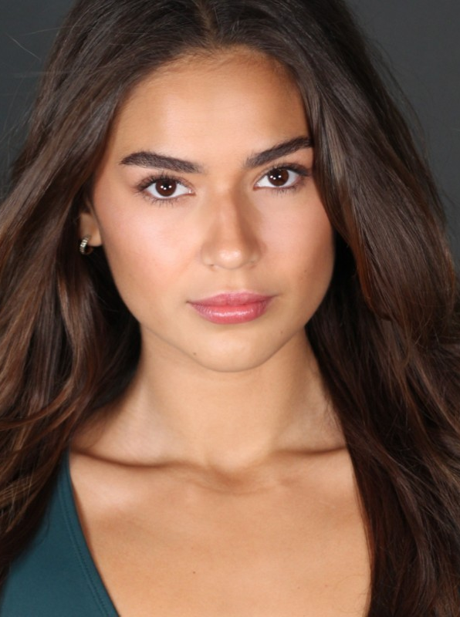
Actress Veronica Ramirez is originally from Toronto, Canada and now living in Los Angeles pursuing her career. She attended the New York Film Academy and has a Bachelor of Fine Arts In Acting for Film. Veronica has studied in trained in multiple dance styles such as jazz, hip hop, tap and ballet various styles and techniques; trained in fighting and stunts; and is also professionally. She starred in Road Trip Hostage.

JUSTIN BERTI
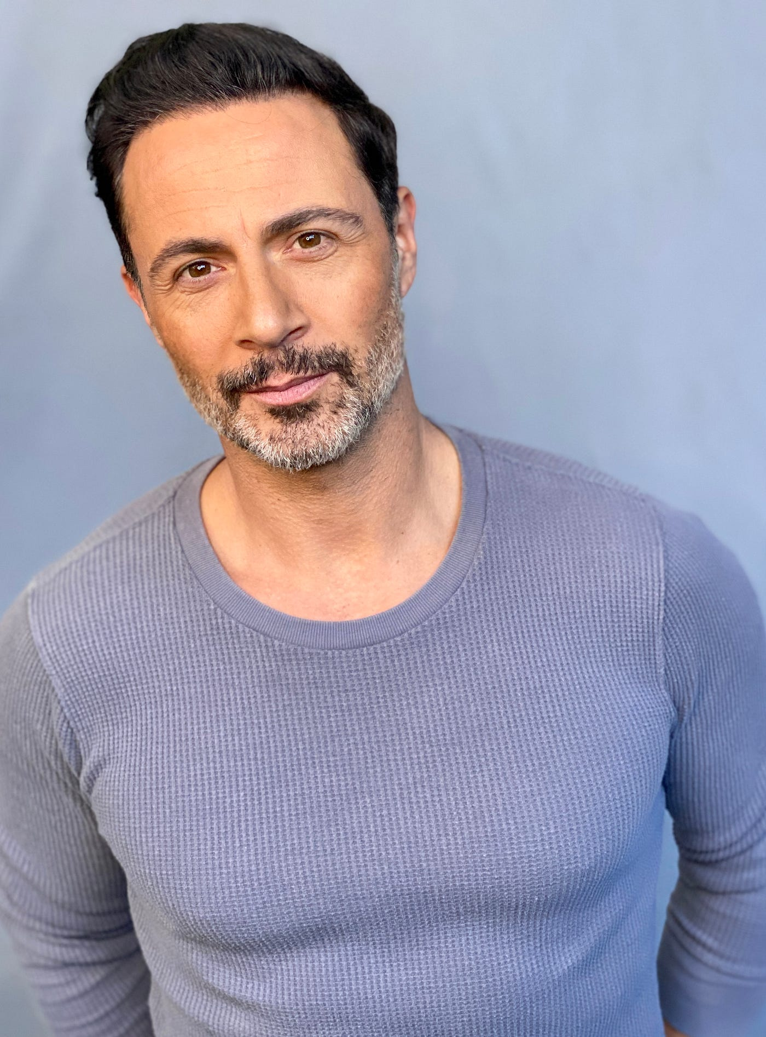
Justin Berti is meant to entertain and inspire. Well traveled, he was born in Connecticut, spent time in Texas and New York City, with his last major stint of 12 years being in Tokyo, Japan. Creating a name for himself, Justin was acting, dancing, and modeling in almost all major entertainment genres you can think of in the Land of the Rising Sun. He even played semi-pro baseball and was a Major League Baseball announcer for all preseason and regular season games featured in Japan. He also had a guest star role in Ramen Girl starring Brittany Murphy. Leaving Japan and moving to L.A. in 2015, he has been on stage, TV, and film making the most of his ambitions. The role of Elliot in the Showtime series Submission was the highlight of his first year back in the States and is what most of his fans know him from. Starring in the popular Billie Eilish's famous "Bad Guy" music video and getting to play the villain in Lifetime's Deadly Cheers and playing the vibrant Mario Bargellini in another Lifetime movie, Driven to Kill, are three memorable experiences for Justin as well. However, the lead role in his first romantic comedy, Divorce Bait, coming out the winter of 2021, will surely add to the top of his list. Tapping into his comedic skills and diving into this character, has been such a breath of fresh air given the difficult climate of 2020. Justin also starred in the independent film Frontera, which won over 9 film festival awards, 4 of them for Best Picture, since its release in 2018. As a Columbia University graduate and instructor of Yogic Arts (a powerful mix of Ashtanga, Martial Arts, and Modern dance), Justin's acting technique and "can do" attitude derive from his physical body mastery, prompting his nickname The Yoganator.

MATTHEW POHLKAMP
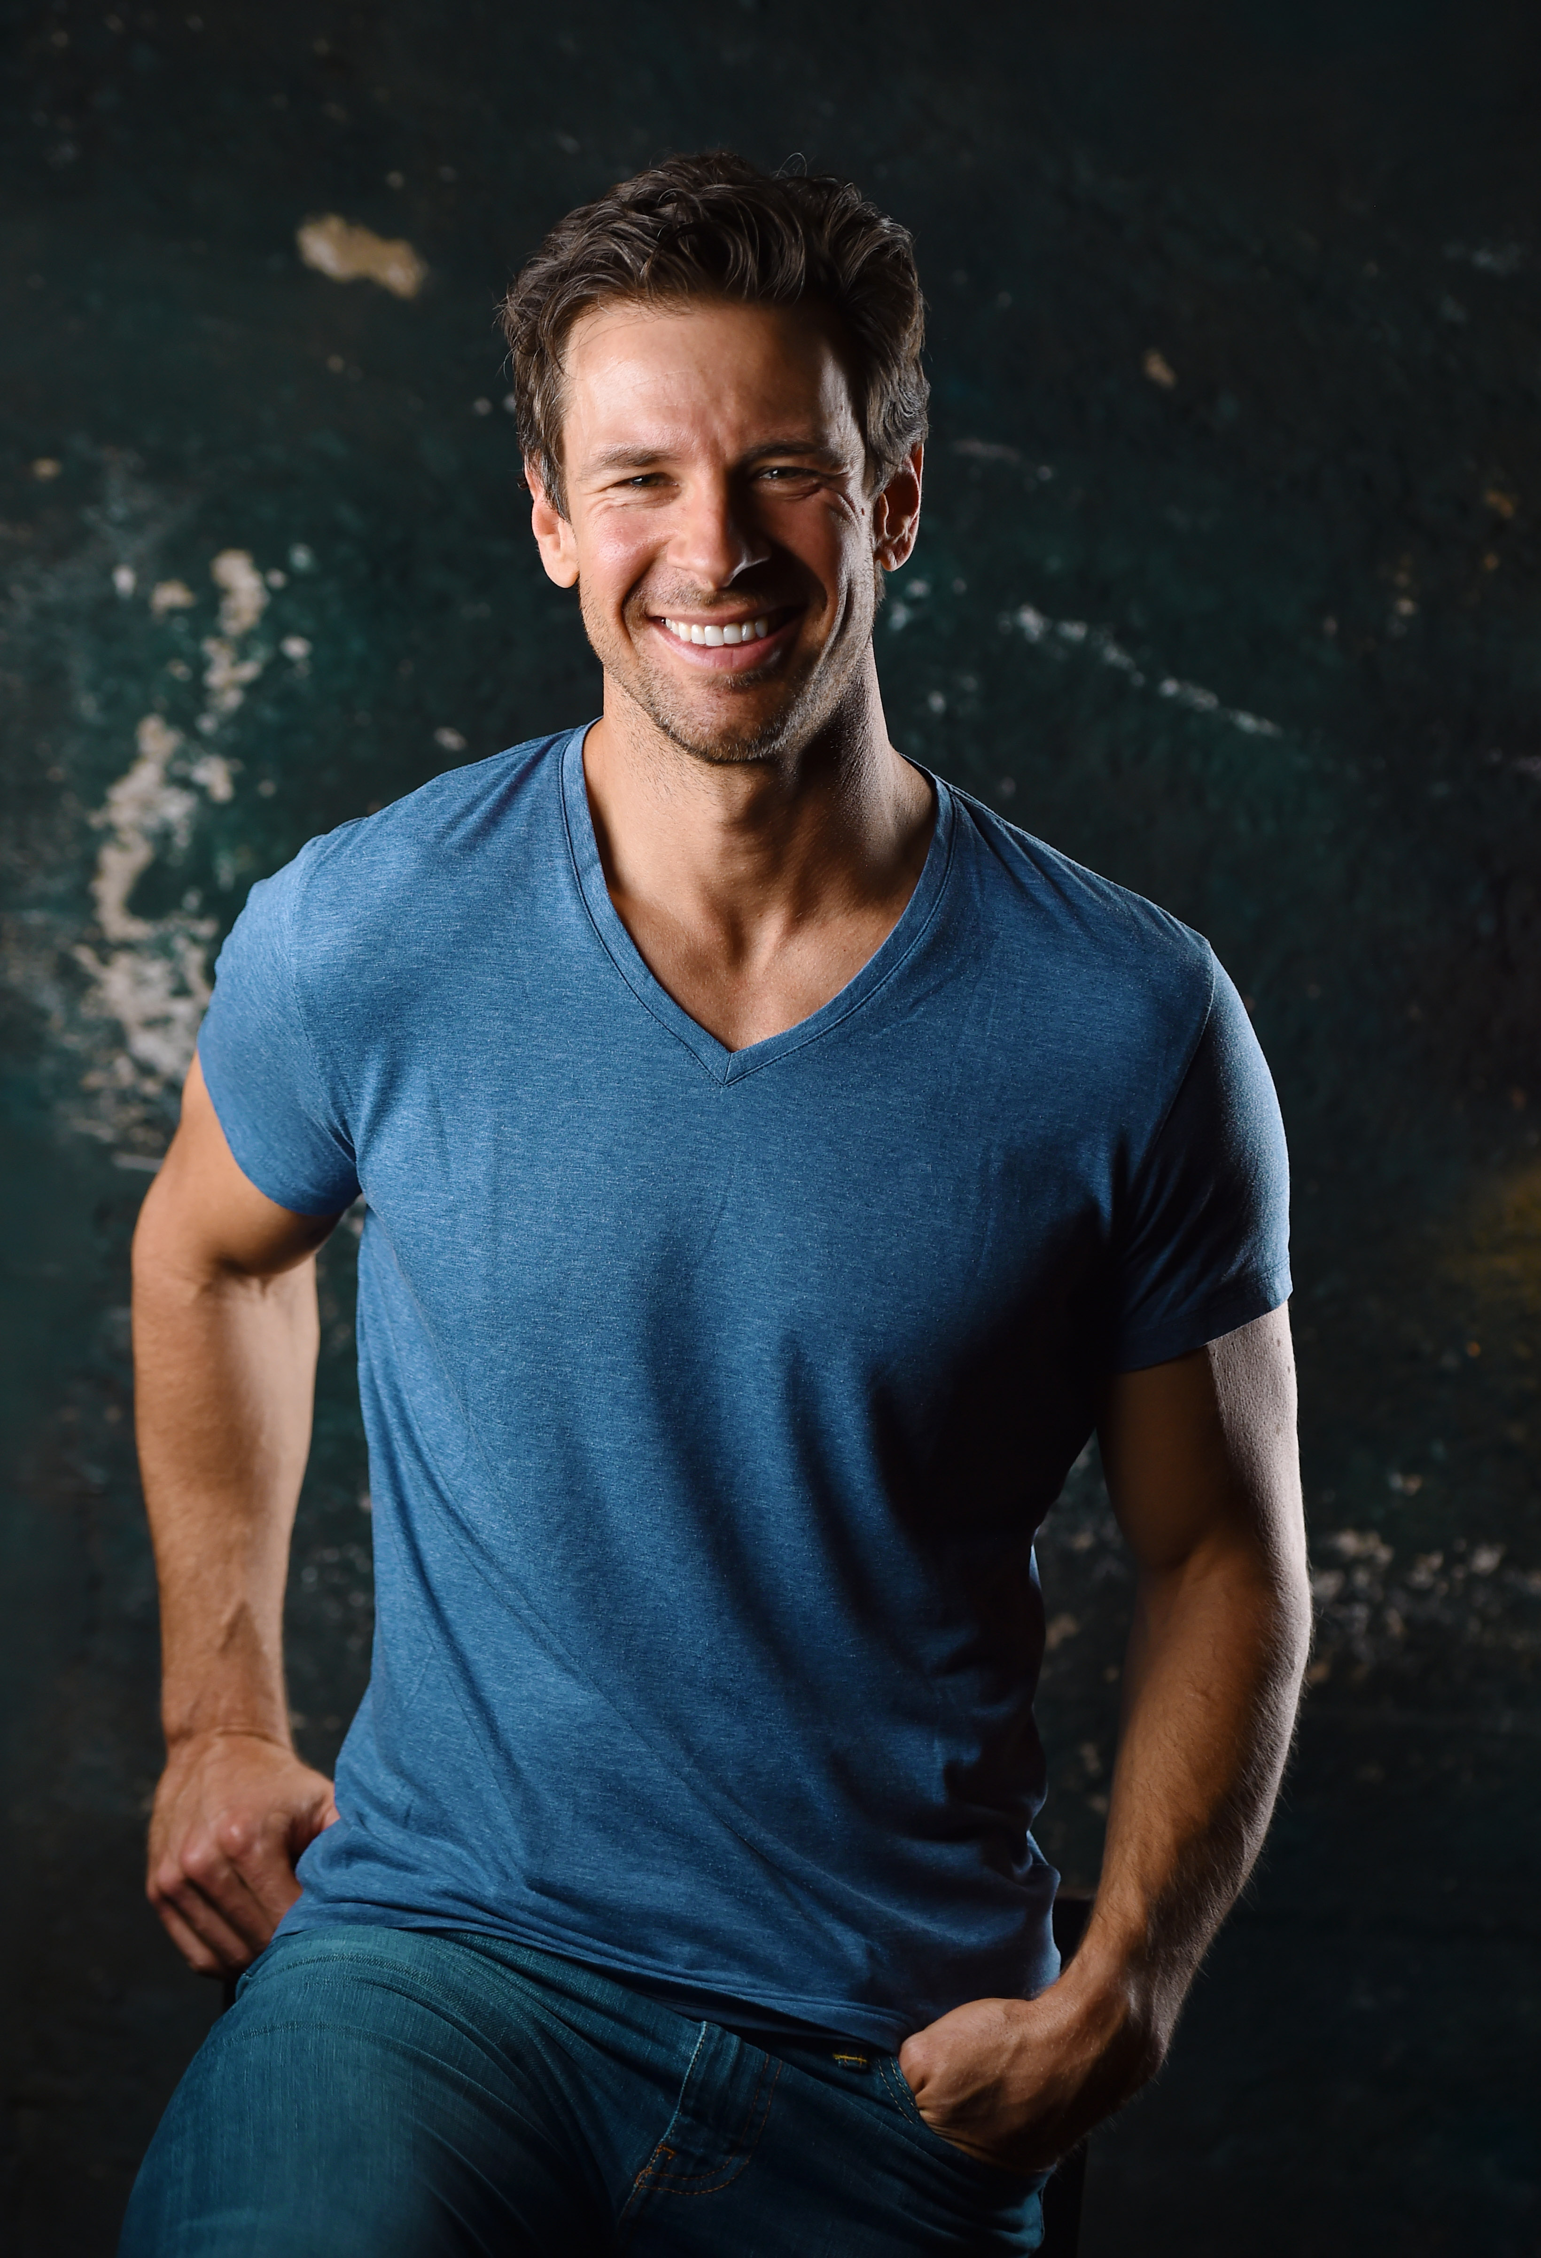
Originally from the west side of Cincinnati, OH, Matt at age 10 found passion in BMX bicycle racing and quickly climbed his way to the top of the sport turning professional at age 20. With numerous national and a world title to his credit, he still competes in the Masters Professional division at the international level. Matt found acting as a way to mentally get away from the demanding grind of professional athletics and has now become his new passion.
His many successes have included Sinister Stepsister, Student Seduction, If Walls Could Talk, The Wrong Blind Date, Dancer in Danger, Deadly Garage Sale, Dangerous Snow Day, Party from Hell, Designed for Death, Her Deadly Boyfriend, Behind Closed Doors, and Dangerous Medicine, amongst others. Look for his upcoming appearance in the TV Series Fantasy Island.
LAURIE FORTIER
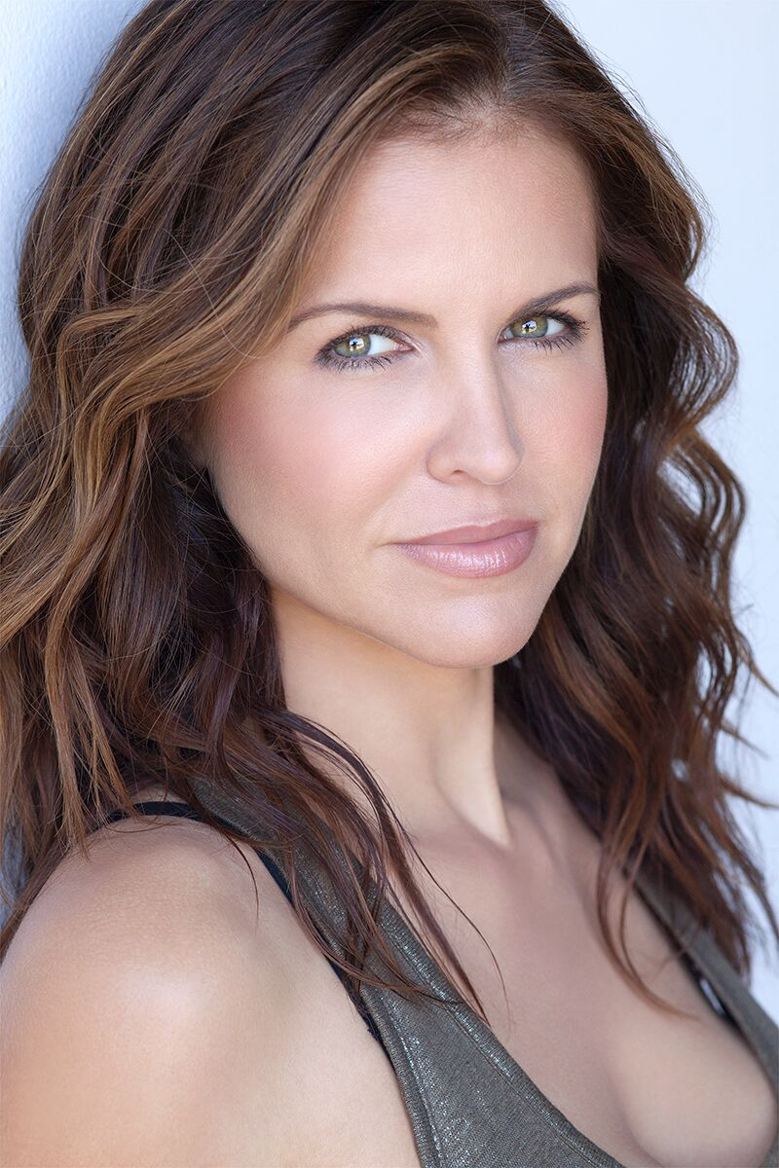
Laurie has been working professionally for over 20 years and has worked with legends including Michelle Pfeiffer, James Gandolfini, James Caan, Dennis Hopper, Martin Landau, Danny Aiello and Hugh Laurie to name only a few. Laurie played real life cop Donna Kading, opposite Josh Duhamel in the USA Network series, Unsoloved: a true crime story about the murder of Biggie Smalls and Tupac Shakur and was thrilled to work with Emmy award winning director, Anthony Hemmingway. She has also starred in numerous movies made for Lifetime including, "Into the Arms of Danger" alongside Cathy Moriarty, "In Bed with a Killer", "Erasing His Dark Past" and "My Mom's Darkest Secrets". With a wide breadth of success in TV & Film, Laurie was most recently seen in DC's Swamp Thing for CW. She has been in: every version of CSI (multiple times), Hawaii Five-O, Castle, Rush, Stalker, and 2 seasons of the Netflix original series Hemlock Grove opposite Dougray Scott and Famke Jansen. She starred in the Warner Brothers film The InCrowd and got her start acting in "To Gillian on Her 37th Birthday", opposite Michelle Pffiefer, Peter Gallagher and Claire Danes, where she was cast by legendary casting director Lynn Stalmaster (Tootsie, The Graduate).
She is thrilled that in her career she has been offered numerous prime time roles as mothers, male (yes male) con artists, maniacs, the girl next door, high powered attorneys, cops, victims, perps, athletes and devilish villains. From "kindhearted heroines" to the "evil monster", Laurie Fortier has been blessed with the gift of true versatility.

Production Credits

Full Cast
Actors  VERONICA RAMIREZ  JUSTIN BERTI  MATHEW POHLKAMP  LAURIE FORTIER  CAMERON RICHTER  ABNER LOZANO  CARL BAILEY  JACOB HORN  HUNTLY PLANTZ  MIKEY GRAY  SAVANNAH WILLIAMS | Role  Reagan Gerard  Craig Gerard  Jackson Green  Sarah Gerard  Tyler  Ranger Jude Rodriguez  Rick  Ranger Ward  Tween Boy  Rental Car Worker  Lodge Concierge

Casting By
THOMAS SULLIVAN CSA

Production Designer
COREY SORRELL

Director of Photography
NICHOLAS ALBERT

Edited By
QUINN ELSE

Music By
RYAN GARRISON

Written By
BRANDI SPERRY

Directed By
KAILA YORK

Full Crew
ANDREW JUKES | First Assistant Director
LUKAS STONE | Second Assistant Director
MEAGHAN HENLEY | Art Director
NOAH HENSE | Art PA
SOPHIA HOLM | Key Make-up Artist + SFX
ALEXA GROUEFF | Key Hair Stylist
CAT CRAWFORD | Additional HMU Artist
MADISON BLANK-PLAUTZ | 1st Assistant Camera
IZZAC NIXON | 2nd Assistant Camera
SATYA GOMEZ | Media Manager
EZRA OLSON | Stills Photographer
ERIC MOSLEY | Gaffer
MICHAEL JEZAK | Key Grip
MICHAEL GUNDERSON | Best Boy Electric
CHAD MARSHALL | Best Boy Grip
SONIA ANTAR | Costume Designer
RYAN BAUER | Onset Costumer
RYAN GRAHAM-LAUGHLIN | Production Sound Mixer
KYLE WEINGART | Script Supervisor
JERI RAFTER | Production Manager
COOPER TAYLOR | Safety Coordinator
JARED KAPLAN | Additional Safety Coordinator
GREG SABA | Key Production Assistant
JAKE AMES | Production Assistants
JULIA SPARR
MALLORY REGAN
PETER TREPKE | Dialogue Editor
CHRISTOPHER PENTECOST | Sound Effects Editor
JOHNNY LE | Studio Assistant
PATRICK EVANS | Post Production Supervisor
CHANGING FRAMES | Post Production Services
DAN EDWARDS | Supervising Colorist
JEFF SPOTT | Colorist
ANTHONY CAMPAGNA | Finishing Artist
LUKE BUTLER | Digital Intermediate Producer
HOLLYWOOD SCRIPT CLEARANCE | Script Clearance
PRIVATE ISLAND AUDIO | ADR Facilities
GOODFORM | Visual Effects
ABHIMANYU TANWAR
PETER TIMBERLAKE
ABACUS INSURANCE BROKERS, INC | Insurance
SWEET BUNS LLC | Catering
APPLES + ANGLERS
406 BISTRO
THE REAL YELLOWSTONE
RARE BREEDS | Cameras
ALL CAPS | production managers

Producer Biographies

TIMOTHY O. JOHNSON – Executive Producer
Timothy O. Johnson is among the most active and reliable producers in the business thanks to top rate productions and global distribution appeal. He is the managing partner of Johnson Production Group, a Canadian based operation that produces over 100 hours of dramatic television annually with hundreds of programs running internationally. The company is the leader supplier to Lifetime, Hallmark and other international outlets.
A graduate of the Marshall School of Business at the University of Southern California, he served as President of the USC Entertainment Management Association and a member of the Advisory Committee of the Center for Entrepreneurial Studies.
Johnson is also responsible for producing the international hit series, DR. QUINN, MEDICINE WOMAN for CBS for over 5 seasons. During his 100-episode tenure, he also developed and produced the original docu-drama COLD CASE for CBS network, which was the very first program to integrate television with the Internet.
Most recently, Johnson has produced the THE NOEL DIARY, being the #1 Film on Netflix’s Top 10 list in December of 2022. He was also at the helm of the successful GIRL IN THE SHED: THE KIDNAPPING OF ABBY HERNANDEZ, as well as the V.C. Andrews series of films, to date including TWILIGHT’S CHILD, MIDNIGHT WHISPERS, and DAWN, all produced for Lifetime..
Johnson has produced over 400 movies and 15 globally released series for every major US network - including Netflix, Lifetime, Hallmark, ABC, Disney, CBS, NBC, Netfly, FOX and Sony.

JOHNSON PRODUCTION GROUP
The Johnson Production Group contracts globally to produce television content for international networks, studios and distributors. Based in Los Angeles and Vancouver, British Columbia, the company manages production, facilitates development and financing, procures distribution and guarantees quality and timely execution of its programs. While costs have gone up, so has the demand for quality. No longer is good enough, good enough. Johnson Production Group serves that segment when a show needs to be "A" quality, but produced efficiently enough to meet a locked budget. JPG specializes in value, protection of creative elements, and delivery of a quality finished product.

JOSEPH WILKA – Executive Producer
Joseph Wilka is the Head of Production for Johnson Production Group. Los Angeles-based, Joseph had already produced and directed several feature films before serving as the senior marketing executive for Gravitas Ventures. While at Gravitas, Wilka helped pioneer new distribution models for independent films including day-and-date theatrical releases. It was also at Gravitas where Joseph first worked with Johnson Production Group to facilitate the release of their films to the worldwide Video On Demand audience. After serving as the Director of Distribution and Production for Viva Pictures, where he produced English-language versions of foreign animated titles for DirecTV, Wilka officially joined Johnson Production Group. As Head of Production, he oversees the development, production, and distribution of films from multiple production units for release on broadcast and streaming platforms.

LISA ALFORD – Co-Executive Producer
Lisa Alford is a development executive at Johnson Production Group. A Massachusetts native, Lisa has lived and worked in Los Angeles for over a decade, always in support of excellent storytelling. Prior to joining Johnson Production Group, Lisa worked as an executive at TriStar television where she specialized in identifying IP that supported TriStar’s mission to feature diverse, authentic characters and champion underrepresented voices. Lisa came up at Sony Pictures Television where she worked as a production coordinator in the Television Movies and Miniseries department and in the writers room on the WGN hit series OUTSIDERS. In her current role, Lisa shepherds projects from the concept phase through story development, production, and post.

A.J. KELLY – Producer
Producer and co-founder of the creative production company, Goodform, A.J. Kelly has spent the past decade creating film, television, documentary, experiential and branded content. His work has won awards at top festivals including Cannes & SXSW, aired on premium networks and received multi-cultural acclaim.
Based in Los Angeles, A.J. believes in elevating content from diverse creative voices and providing an outlet for filmmakers to bring their stories to life.

JACOB HORN – Co-Producer
Jacob Horn began his career in the entertainment industry by working his way up through Elijah Wood’s production company, Spectrevision. With them, he was able to gain producing experience with directors such as Nacho Vigalondo and Josh Waller. After leaving Spectrevision, Jacob went out on his own to produce and direct his own content including several short films, a Christmas feature for Hallmark , and also becoming the Stunt Dept Manager on Once Upon A Time In Hollywood. At present, Jacob is the Head of Production for GoodFlix, a feature film production company where he oversees an annual slate of films.

AMANDA SEARS – Line Producer
Born in Denmark, Amanda has been interested in movies since she was a young kid. At age 15 she joined a 3-year film program, where she worked on multiple internationally award-winning short films, before eventually making her way to Los Angeles to pursue her dreams as a producer. She has been working as a coordinator with GoodFlix since the winter of 2021 before getting the chance to Line Produce her first feature film in the fall of 2022.
In her free time, she enjoys skydiving and martial arts.

Billing Block
Inspired By True Events Lifetime Presents In Association with Johnson Production Group TAKEN IN MONTANA starring VERONICA RAMIREZ JUSTIN BERTI MATT POHLKAMP and LAURIE FORTIER Casting By THOMAS SULLIVAN CSA Production Designer COREY SORRELL Director of Photography NICHOLAS ALBERT Edited By QUINN ELSE Music By RYAN GARRISON Line Producer AMANDA SEARS Co-Producer JACOB HORN Co-Executive Producer LISA ALFORD Executive Producers JOSEPH WILKA TIMOTHY O. JOHNSON Produced By A.J. KELLY Written By BRANDI SPERRY Directed By KAILA YORK
© MMXX Johnson Production Group Inc. All Rights Reserved

Meta Data
LONG (max 3000 characters) synopsis
Craig, Sarah, and Reagan Gerard have come to beautiful Big Sky, Montana for a much needed family vacation. Luckily enough Craig's old college roommate, Jackson Green, owns a very successful lodge there. Before the family can even get settled in, Craig and Sarah are on a run for their life. They find out that Jackson has been running an illegal poaching ring and will stop at nothing to get rid of all who know. Meanwhile their daughter, Reagan, enlists the help of local Park Ranger, Jude, with the plan of bringing down Jackson and finding her parents. (557)
MEDIUM (max 500) synopsis
When her parents go missing on their family vacation in beautiful Big Sky, Montana, teen Reagan must put the clues together to find them -- but she may be trusting the wrong people to help, putting herself in danger. (215)
SHORT (max 100 characters) synopsis
A teen’s parents go missing on a family vacation but she may be trusting the wrong people to help.
(98)
5 KEY WORDS
Montana, lodge, poaching, family, ranger

