Johnson Production Group

Press Kit

One-Liner

Sam babysits his niece and nephew before the holidays, and when he recruits help from their handsome neighbour, Jason, he finds himself in an unexpected romance.

Synopsis

Sam is a workaholic living his best bachelor life in New York City. Just as he’s ready to head to the airport to spend Christmas in Hawaii, his sister calls him into active uncle duty when she and her husband have to leave town early when they learn the baby they’re adopting is being born two weeks ahead of schedule. After some brilliant sisterly guilting, Sam agrees to head upstate to watch his teen nephew and young niece while they’re away. When Sam gets to their suburban home he meets Jason, a friend and next-door neighbor who steps in to help until Sam arrives. Even though his sister left a detailed schedule to follow – along with takeout menus to avoid the kitchen fire he caused the last time he babysat – Sam realizes he’s ill-equipped for the job, at best. He enlists the help of Jason, who is also the contractor putting the finishing touches on the nursery and is planning to adopt since he’s tired of waiting to find the right guy and start a family of his own. Sam is so desperate for help he offers to hire Jason as a “consultant” of sorts to help him survive the next two days without major mishaps. But when the new baby’s arrival takes longer than expected, Sam has to adjust his vacation plans once again. As he spends more time there with his niece and nephew – and Jason – he begins to rethink his commitment to the bachelor life and realizes he may have found something he wasn’t looking for, including love.

Producers
Executive Producers
TIMOTHY O. JOHNSON
JONATHAN BENNETT
MAURA DUNBAR
Producer
NAVID SOOFI
Supervising Producer
OLIVER DE CAIGNY
Associate Producers
THOMAS STANFORD
PARALEE COOK
TIM SPENCE
CELESTE CROWE

Key Cast
CHARACTER  Sam  Jason  Kathleen  Miles  Dania |  | ACTOR  JONATHAN BENNETT  GEORGE KRISSA  CHELSEA HOBBS  EVERETT ANDRES  MILA MORGAN

Key Cast Biographies

JONATHAN BENNETT
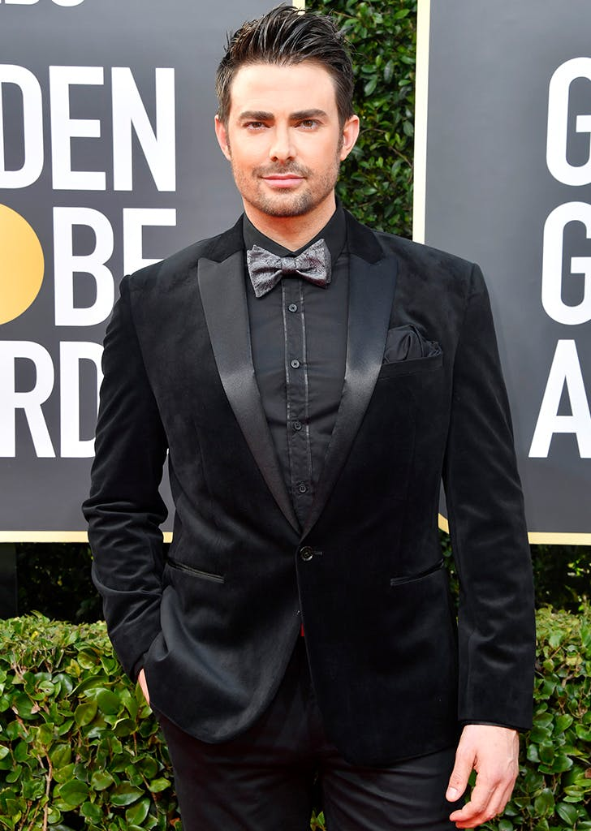
Though his striking good looks may have made Jonathan Bennett an object of affection for the “plastics” in Mean Girls, his talent and commitment are what have led them to his becoming one of the most sought-after actors in Hollywood. Diversifying his talent, he released a best-selling Mean Girls parody Burn Cookbook, became a fan favorite on “Dancing with the Stars,” “Celebrity Big Brother,” and also demonstrated his hosting skills on MTV’s competition series “Copycat.” This helped pave the way to Bennett’s turn as host of Food Network’s assortment of “Cake Wars” specials including ratings powerhouse “Halloween Wars” and “Holiday Wars,” official host of Times Square’s New Year’s Eve Countdown, as well as his role with NBC for their Winter Olympics coverage. Additionally, he remained a part of the Viacom family with recurring arcs on VH1’s “Hit the Floor” and MTV’s “Awkward.” More recently, he enjoyed an arc on Shondaland’s “Station 19;” filmed the original telefilm “Harvest of the Heart” which was one of the first vehicles to film amidst the pandemic; starred in the indie feature, Potato Dreams of America, which premiered at SXSW; as well as in the Hallmark Channel original telefilm, “The Christmas House,” for which he reprised his role in the GLAAD MEDIA Award nominated sequel, “The Christmas House 2: Deck Those Halls.” Bennett is also host of iHeart’s PrideCast podcast.
He’s parlayed the success of “The Christmas House” franchise into a two-picture deal with Hallmark Media for which most recently starred in and produced “Wedding of a Lifetime” as well as “The Holiday Sitter.”
Bennett’s first foray into a studio film was, in fact, Paramount’s smash hit Mean Girls from producer Lorne Michaels and writer Tina Fey in which he starred opposite Lindsay Lohan. In the romantic comedy Lovewrecked for Weinstein Co., Bennett transitioned into the love interest of Amanda Bynes. He has since starred as Bo Duke in Warner Bros. prequel to The Dukes of Hazzard; the comedy romp Bachelor Party Vegas; in the title role of National Lampoon’s Van Wilder: Freshman Year; in Cheaper by the Dozen 2, FOX’s sequel to the hit comedy, as Steve Martin’s antagonistic son-in-law; and reunited with Cheaper co-star Hilary Duff for The Haunting of Sharon Tate.
Bennett executive produced and starred in the film Authors Anonymous opposite Kaley Cuoco. Continued to wear his producing hat as well as carry a supporting role in feature Pawn with Ray Liotta and Academy Award-winner Forest Whitaker, starred in IFC Films’ dramatic thriller Submerged, the comedy Do Over, the crime thriller Paid In Full, the Lifetime telefilm “Romantically Speaking” opposite “Glee” star Heather Morris, the indie drama Do You Take This Man opposite Anthony Rapp, and the Hallmark original telefilm “Love At First Glance” opposite Amy Smart and Adrian Grenier.
He previously reunited with Mean Girls co-star Lacey Chabert in the Hallmark telefilm “Elevator Girl,” starred in the indie comedy The Assistants, Slightly Single In L.A, the drama Memorial Day with James Cromwell, the thriller Cats Dancing on Jupiter, the romantic comedy Divorce Invitation opposite Jamie-Lynn Sigler, and lead role in Lifetime’s “Holiday High School Reunion.”
Outside of the occasional guest star role on the likes of “Supergirl,” “Deception,” “Cane,” Dick Wolf’s “Law & Order: SVU,” David E. Kelley’s “Boston Public,” “Smallville” and “Veronica Mars,” Bennett’s first and only foray into series television was on the Emmy Award-winning “All My Children” after less than a month of having moved from his native Ohio to New York City.
No stranger to winning awards, Bennett took Best Actor honors at the 2003 Palm Beach International Film Festival for his lead role in the independent feature Season of Youth.
Originally from Ohio, Bennett currently resides outside of Los Angeles with his husband, Jaymes Vaughan, and their beloved pup, Bradley. The two recently made history by being the first gay couple to grace the cover of The Knot and beyond will host an LBTGQ+ OUTbound travel adventure.

GEORGE KRISSA

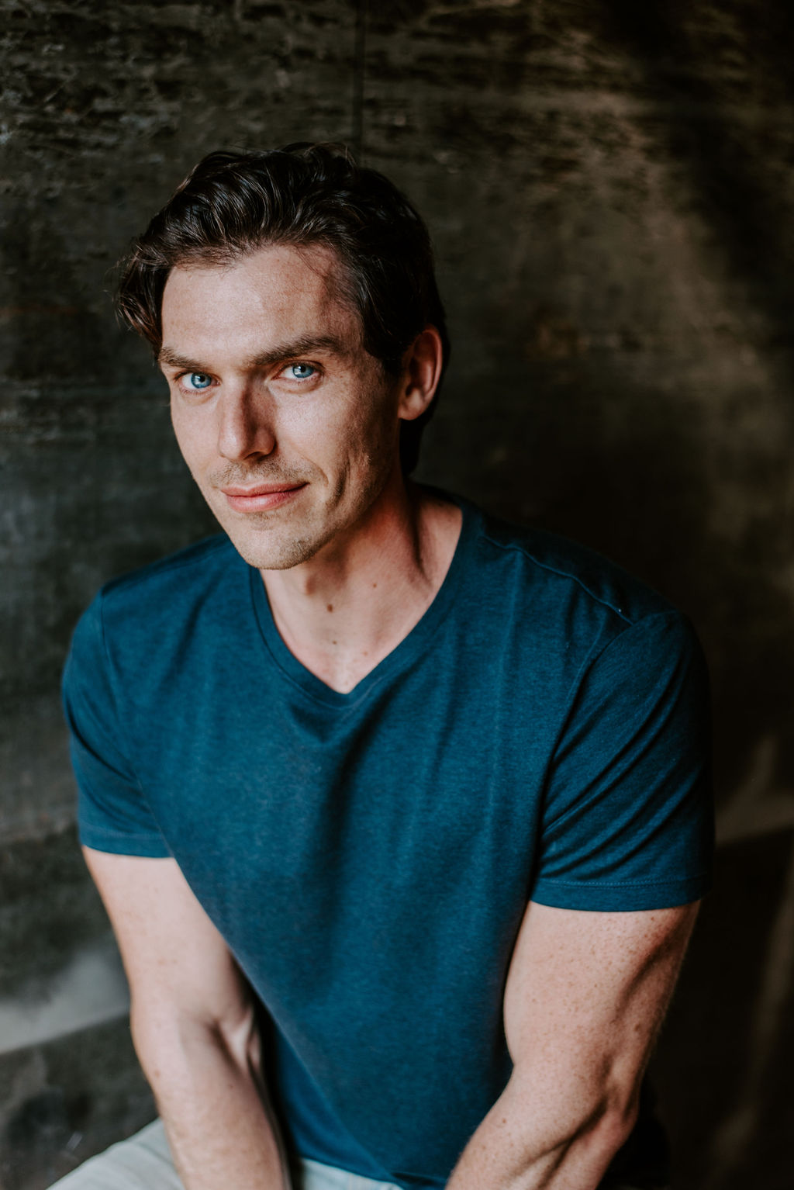
George Krissa is an actor and musician originally from Lashburn, Saskatchewan, Canada, a small town of just 700 people. Krissa is a classically trained singer and studied voice at Grant MacEwan University in Alberta, Canada. In addition to television and film work, Krissa has been seen in starring roles on renowned stages across Canada, including the Stratford Festival and the Shaw Festival. His film work includes roles on The CW’s “Coroner,” CBC’s “Murdoch Mysteries,” the Lifetime television movie “Trapped with My Husband” and the feature film The Dwelling from Breakthrough Entertainment, among others. He made his Hallmark Channel debut earlier this year in “Road Trip Romance.”

When not working in front of the camera or on stage, Krissa spends his time renovating and restoring his house, a Century Home built in 1907. Krissa lives in Toronto with his partner, Brian, and their dog Bixby.

CHELSEA HOBBS
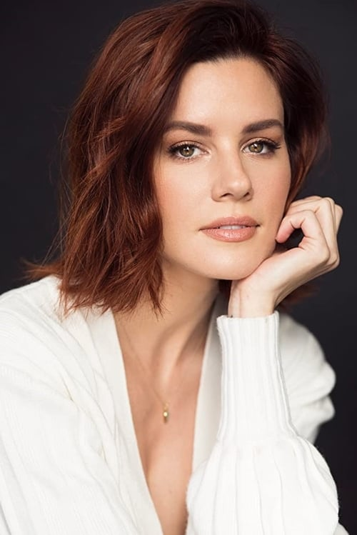
Chelsea was born in Vancouver, Canada and entered the world of film and television at just 8 years old. As a child, Chelsea filmed over 80 commercials. Her first big break came when she starred alongside Bridget Fonda in Hallmark's timeless mini-series Snow Queen, earning her a best actress Leo award nomination. It wasn't long after that she booked her own pilot, starring in FOX's Save the Last Dance. Chelsea then graduated high school early through home schooling and moved to Los Angeles alone at the tender age of 17.
Over the next several years she made a name for herself in Hollywood starring in various TV films and guest starring on hit shows such as CSI, The L Word, CSI: Miami, Cold Case and HBO's Transporter. Chelsea was also fortunate to work alongside the late Heath Ledger in Sony picture's feature film Lords of Dogtown, which has since become a cult classic.
It was her lead role as underdog Emily Kmetko in Freeforms hit gymnastics drama, Make It Or Break It that solidified Chelsea's presence on the small screen. Following this success Chelsea had her second child, and moved back to Vancouver to raise her two children as a single mother.
Most recently Chelsea has had a recurring role on season 3 of the Emmy nominated Lifetime/Hulu series UnReal, guest starred on Girlfriends Guide to Divorce, Rogue, Lucifer, Motive, Supernatural, and Take Two, as well as several upcoming films including Tosca Musk's adaptation of Ruth Clampett's best selling novel Mr. 365. Chelsea is continuing to have a solid career excelling as an actress, and was excited to bring her own material to big and small screens with Jovanna in 2019.

EVERETT ANDRES
Everett is 14 years old and has spent much of his young life in the pursuit of athletic excellence with a particular focus on the six events in Men's gymnastics. He is a carded athlete and most recently placed eighth all round at the Canadian National Championships (Junior). He has been studying piano seriously since the age of four and has also developed a passion for the craft of acting, quickly establishing himself as a quietly intense and accomplished young actor. Notably, he has had the privilege of working with Oscar-winning director Peter Ramsey as a Supporting Lead in Netflix's Lost Ollie and the iconic director Helen Shaver as Guest Star on the pilot for the reboot of Quantum Leap, which has been picked up for prime time on NBC.
Everett is a kind soul, an animal lover, and has a well-earned reputation for being fearless , congenial, and collaborative. Along with the rest of his family, he enjoys volunteering his time at BC Children's hospital

MILA MORGAN
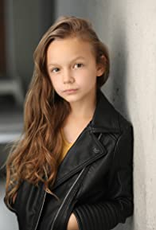
For someone of this age, Mila Morgan has quite an extensive acting resume. From roles in Sacred Lies and the Baby-Sitters Club, to a recurring role as Ginny Lisko in the popular series Home Before Dark, to a TV Movie role in North to Home, this young lady will be one to watch.
Production Credits

Full Cast
Actor  JONATHAN BENNETT  GEORGE KRISSA  CHELSEA HOBBS  EVERETT ANDRES  MILA MORGAN  MATTHEW JAMES DOWDEN  GABRIELLE ROSE  MATTY FINOCHIO  AMY GOODMURPHY  ROBERT WISDEN  BELLA LEONARDO  TODD MATTHEWS  RICK DOBRAN  ANDY RUKES  NATHAN PARROTT | Role  Sam  Jason  Kathleen  Miles  Dania  ate  Marilyn  Peter  Ellie  Frank  Arabella  Vance  Eddie  Tomme  Decklan

Casting by
JUDY LEE

Production Designers
JORDAN NINKOVICH

Director of Photography
MIKE KAM

Edited by
JASON NIELSEN

Composer
RUSS HOWARD III

Teleplay by
GREG BALDWIN
TRACY ANDREEN

Story by
GREG BALDWIN
JONATHAN BENNETT

Directed by
ALI LIEBERT

Other Crew
CELESTE CROWE |  | Production Manager
JASON RODY  CLAUDE PAVEL |  | First Assistant Directors
ALEXANDER DURIE |  | Second Assistant Director
JADEN DEVINE |  | Costume Designer
ERROL RICHARDSON |  | Set Decorator
CHRISTOPHER STIPE |  | Props Master
ELIZABETH MCLEOD |  | Make-Up Artist
NICOLE LAPOINTE |  | Hair Stylist
ROBERT BRICKER  JESSICA OLSEN |  | Location Managers
JULIE ZHU |  | Script Supervisor
JEFF DESMARAIS |  | Production Coordinator
CONNOR LYONS |  | Production Sound Mixer
LA HILTS |  | Extras Casting
NOVUS ORDO SECLORUM  SHOOTING GROUP INC. |  | Picture Post Production  Provided By
MAVERICK POST GROUP |  | Sound Facilities Provided By
PROMOTIONAL CONSIDERATION PROVIDED BY NINTENDO OF AMERICA INC.
PENNY PERRY |  | U.S. Casting
TATIANA ERASME
MIGUEL FIERRO
 | FOR HALLMARK CHANNEL
 | SAMANTHA DIPIPPO |  | Executives in Charge of Production
 | DEVIKA BOODHOO

Producer Biographies

TIM JOHNSON – Executive Producer
Tim Johnson is among the most active and reliable producers in the business thanks to top rate productions and global distribution appeal.
Johnson is also responsible for producing the international hit series, DR. QUINN, MEDICINE WOMAN for CBS for over 5 seasons. During his 100-episode tenure, he also developed and produced the original docu-drama COLD CASE for CBS network, which was the very first program to integrate television with the Internet.
Johnson has produced over 150 movies, 15 globally released series for every major US network - including ABC, Disney, CBS, NBC, Netfly, FOX and Sony.

JOHNSON PRODUCTION GROUP
The Johnson Production Group contracts globally to produce television content for international networks, studios and distributors. Based in Los Angeles and Vancouver, British Columbia, the company manages production, facilitates development and financing, procures distribution and guarantees quality and timely execution of its programs. While costs have gone up, so has the demand for quality. No longer is good enough, good enough. Johnson Production Group serves that segment when a show needs to be "A" quality, but produced efficiently enough to meet a locked budget. JPG specializes in value, protection of creative elements, and delivery of a quality finished product.

MAURA DUNBAR - Producer
Maura Dunbar is the President & CEO of Engage Entertainment(TM). She has over 25 years of extensive television programming experience as a senior level broadcast/cable executive, a creator and producer of original programming, and a highly successful media consultant. Her rich and diverse experience has made her a recognized expert in programming strategies, development, packaging, and production of original programming with a proven track record of identifying, buying, developing and overseeing production of over 250 television movies and mini-series, as well as an expertise in building a community around programming using new media and marketing platforms.
Previously, she was Senior Vice President of Original Programming and Development for the Hallmark Channel, where she launched the channel's franchise of original two-hour movies. Prior to that, Maura worked for 16 years as a creative executive in the program development department of ABC Entertainment. During her tenure at the network, she developed more than 300 hours of original made-for two-hour movies and minis. As Vice President of mini-series and special projects, Maura distinguished herself for her ability to develop and produce content that achieved both ratings and critical success as well as garnering numerous Emmy nominations and awards, such as Stephen King's The Stand, The Shining, Me and My Shadow: The Judy Garland Story (with Judy Davis), and Rear Window (starring Christopher Reeves).
Maura is a member of the Producer's Guild of America.
NAVID SOOFI – Producer
Navid is the primary producer for Novus Ordo Seclorum. Navid’s passion for filmmaking along with his business and engineering background plays an important role in creating a successful and transparent business model. Navid has been in the entertainment industry for more than 13 years and has produced over 50 feature films, TV shows and commercials that have been featured on national television, international theatres, and new media platforms. His credits include Over the Moon in Love, The Mistletoe Secret, Random Acts of Christmas, Love Unleashed, Identity Theft of a Cheerleader, and A Mother on the Edge.
OLIVER DE CAIGNY – Supervising Producer
Oliver De Caigny is a Canadian producer originally from Belgium, his background in financing, production, and post production makes him a well-rounded producer for any type of production. His experience in financing and production agreements (film and TV series and movies-of-the week), distribution agreements (both domestic and foreign) as well as international co-productions, Canadian tax credit, Telefilm Canada and Canada Media Fund incentives provides him with a well-rounded background in development, production and distribution for motion pictures, television series and productions.

Billing Block
Johnson Production Group with Hallmark Channel Presents “THE HOLIDAY SITTER” starring JONATHAN BENNETT GEORGE KRISSA CHELSEA HOBBS EVERETT ANDRES MILA MORGAN MATTHEW JAMES DOWDEN GABRIELLE ROSE MATTY FINOCHIO Casting by JUDY LEE Production Designer JORDAN NINKOVICH Director of Photography MIKE KAM Edited by JASON NIELSEN Composer RUSS HOWARD III Associate Producers THOMAS STANFORD PARALEE COOK TIM SPENCE CELESTE CROWE
Supervising Producer OLIVER DE CAIGNY Executive Producers TIMOTHY O. JOHNSON JONATHAN BENNETT MAURA DUNBAR Produced by NAVID SOOFI
Teleplay by GREG BALDWIN TRACY ANDREEN
Story by GREG BALDWIN JONATHAN BENNETT Directed by ALI LIEBERT
With the participation of the Province of British Columbia
Film Incentive BC
The Canadian Film or Video Production Tax Credit
© MMXXII Manmaid Productions Inc. All Rights Reserved

Meta Data
LONG (max 3000 characters) synopsis
Sam is a workaholic living his best bachelor life in New York City. Just as he’s ready to head to the airport to spend Christmas in Hawaii, his sister calls him into active uncle duty when she and her husband have to leave town early when they learn the baby they’re adopting is being born two weeks ahead of schedule. After some brilliant sisterly guilting, Sam agrees to head upstate to watch his teen nephew and young niece while they’re away. When Sam gets to their suburban home he meets Jason, a friend and next-door neighbor who steps in to help until Sam arrives. Even though his sister left a detailed schedule to follow – along with takeout menus to avoid the kitchen fire he caused the last time he babysat – Sam realizes he’s ill-equipped for the job, at best. He enlists the help of Jason, who is also the contractor putting the finishing touches on the nursery and is planning to adopt since he’s tired of waiting to find the right guy and start a family of his own. Sam is so desperate for help he offers to hire Jason as a “consultant” of sorts to help him survive the next two days without major mishaps. But when the new baby’s arrival takes longer than expected, Sam has to adjust his vacation plans once again. As he spends more time there with his niece and nephew – and Jason – he begins to rethink his commitment to the bachelor life and realizes he may have found something he wasn’t looking for, including love. (1436)
MEDIUM (max 500) synopsis
Confirmed bachelor Sam delays his Hawaiian holiday getaway to watch his niece and nephew when his sister and brother-in-law have to leave town suddenly to be there for the birth of the baby they’re adopting. Their next door neighbor Jason agrees to help him navigate this new world and in the process, he begins to rethink what he truly wants from life. (354)
SHORT (max 100 characters) synopsis
Sam lands in an unexpected romance with a handsome neighbor when he babysits his niece & nephew. (97)
5 KEY WORDS
Romance, family, Christmas, parenthood, Same-sex

