UNWRAPPING CHRISTMAS: LILY'S DESTINY

Johnson Production Group

Press Kit

One-Liner
Lily is excited to go on a date with realtor Owen Mansfield…he ticks all the boxes…but then she meets journalist Sean Whitlock and their chemistry is undeniable. Is she misreading the signs?

Synopsis

Lily, chief marketing guru and vibrant face of ALL WRAPPED UP, believes the universe sends signs guiding us to our destiny. With holiday responsibilities piling up, she eagerly accepts a date with local celebrity realtor Owen Mansfield. However, during an interview with journalist Sean Whitlock, who is doing a profile on her store, she feels an unexpected spark. Rumors of Sean's marital status initially dampen her hopes, but their growing chemistry makes her question everything. As her interest in Owen fades, Lily wonders if she's misreading the signs and if Sean might be the true match her heart has been seeking all along.

Producers
Executive Producers
TIMOTHY O. JOHNSON
ANDREW C. ERIN
OLIVER DE CAIGNY
MICHAEL VICKERMAN
CARLEY SMALE
LISA ALFORD
Producers
LEX EMANUEL

Key Cast
CHARACTER  Lily  Sean  Kenzie Reid  Whitney Boyd  Frank Parker  Owen  Olivia  Benjamin  Mia Parker  Beau Cavannagh  Tina  Michael |  | ACTOR  ASHLEY NEWBROUGH  TORRANCE COOMBS  MARTINA ORTIZ LUIS  JENNIFER BAKER  BRIAN FROUD  FRANCO LO PRESTI  Guest Starring:  CINDY BUSBY  JAKE EPSTEIN  KATHRYN DAVIS  NATHAN WITTE  NATALIE HALL  ALEC SANTOS

Key Cast Biographies

ASHLEY NEWBROUGH
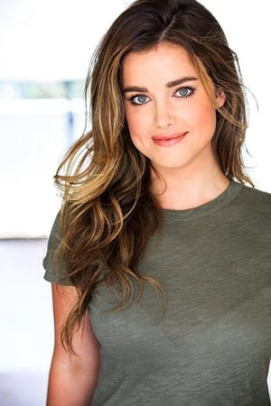
Beloved American child actress, Ashley Newbrough, started her entertainment career at the tender age of 14. Newbrough began her career with roles in Get a Clue for Disney and Missing for Lifetime. She went on to act in Radio Free Roscoe. She is known for starring as Sage Baker in The CW drama series Privileged, as well as for the ABC series Mistresses, and for starring in a number of predominantly Christmas-themed television films since 2015, such as Small Town Christmas, A Merry Christmas Match, Flowers and Honey, Blue Moon Ball, Christmas for Keeps, Saving Christmas Spirit, Love In Glacier National: A National Park Romance and Operation Nutcracker.

TORRANCE COOMBS
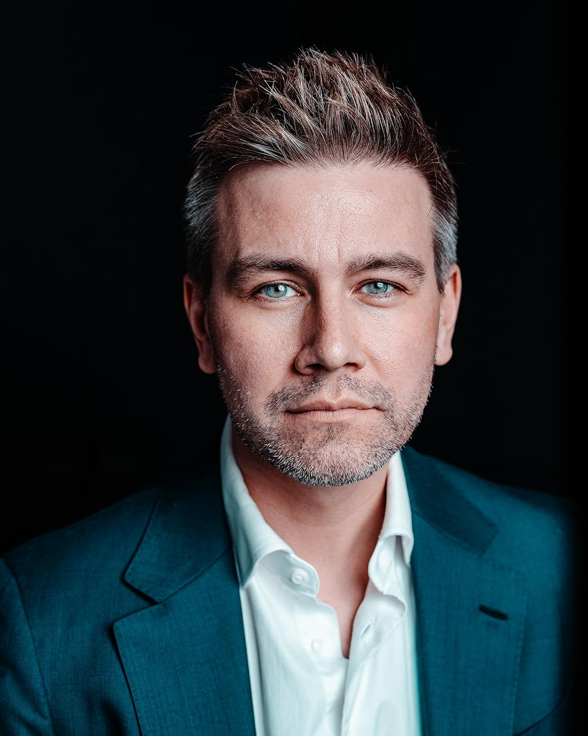
Born and raised in Vancouver, Canada, Torrance Coombs attended the acting program at the University of British Columbia. Coombs has appeared in productions at Bard on the Beach, an annual professional Shakespeare festival held in Vancouver; he has also appeared in the musical A Little Night Music.
His first starring role on television was as John Doe in the 2008 CBC comedy series jPod, based on the novel of the same name by Douglas Coupland. Coombs also appeared as Lance Corporal C. Sellers in a 2009 episode of the television series Battlestar Galactica.
In 2010, Coombs appeared in a recurring role as Thomas Culpeper in the television series The Tudors, and in CBC's Heartland as Chase Powers. In 2011, he co-starred as Sam Besht as in the Hulu drama series Endgame.
On March 11, 2013, it was announced that Coombs had been cast in a lead role as Sebastian in the CW period drama series Reign. He was nominated for Outstanding Actor in a Drama TV Series at the 2014 Monte-Carlo Television Festival for his role in Reign. In early 2016, Coombs chose to depart from Reign as a series regular at the end of the third season after appearing in 62 episodes, with the possibility to return as a guest star in future episodes.
In March 2016, it was announced that Coombs would star as a series regular for Shonda Rimes' new series Still Star-Crossed on ABC, and then in 2017, it was announced that Coombs would star in a recurring role in the final season of The Originals for 6 episodes.
In 2009 he starred as Sam Matheson in the short film The Familiar, and appeared as PJ in the short film Good Image Media. In 2012, he starred in the psychological thriller Liars All. Most recently he has starred in the TV movies Royally Ever After, Romance in the Air and Much Ado About Christmas.

MARTINA ORTIZ LUIS
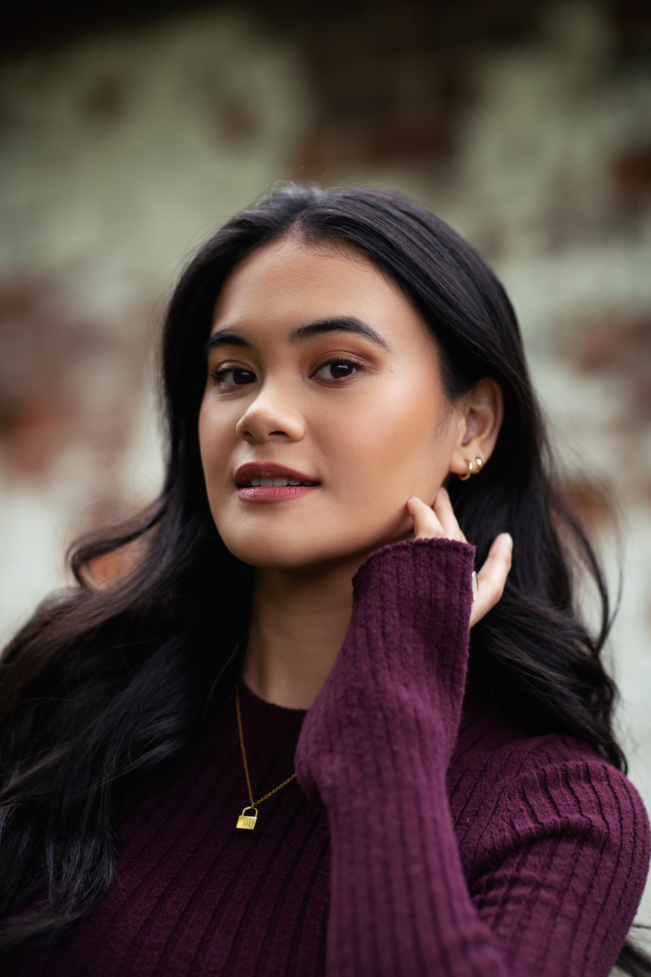
Martina Ortiz Luis is a Toronto-based, singer and actor best-known for her work as Rachel Valdez in the People's Choice Award-winning series "Wynonna Earp" and as Josie Suero in Roku's "Most Dangerous Game: New York" starring alongside David Castañeda, Christoph Waltz, and Anna Gunn.
She attended the acclaimed arts school, Cardinal Carter Academy for the Arts from grades 7 through 12. Upon graduating, she began an undergraduate program at the University of Toronto for classical vocal performance in 2019 before withdrawing to join "Wynonna Earp" as a series-regular in its fourth season and pursuing a full-time career in the arts.
Having built a reputation as a dynamic live performer, Martina has dazzled audiences across Canada from local live-music bars like El Mocambo to the beloved Scotiabank Arena, where she became the first official anthem singer in Toronto Maple Leafs history at 15 years old, holding the position for six seasons (2016-2022), and singing for hundreds of Leafs home games. Other nationally televised musical performances of hers include the 2019 Canada's Walk of Fame Awards Night, where she performed a tribute to Alessia Cara and later presented Cara with the Allan Slaight Award, the Toronto Santa Claus Parade, and Breakfast Television's Christmas Special live from the Distillery District's Winter Village.
Martina recently wrapped a 3-month shoot in Northern Italy, joining an exciting young cast as a supporting lead in, "Verona", a new musical feature-film based on Shakespeare's "Romeo and Juliet". More of her credits include series-regular Gabby in CBC Gem's musical series, "Topline", as well as an appearance in Netflix's "Grand Army".
When she isn't on set, performing, or making music, you might always find Martina with a book in hand or creating her own stories.

JENNIFER BAKER
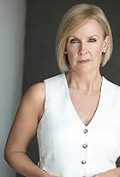
Jennifer Baker is an award-winning Canadian actor working in film, television and voiceover. Born in a small city outside of Toronto, she was always keen to sing, dance and act from a young age. She moved to Toronto and spent 15 years in the corporate world, but left all that behind to follow her passion and her hard work has paid off. Not just an actor, she made her writing, producing and directorial debut with the short film, Change. Change was released in September 2017, and won "Award of Commendation" at the Canada Shorts Film Festival (2017). Jennifer's acting credits include principal roles on these three acclaimed television series: Suits (2019), The Handmaid's Tale (2019) and Ginny & Georgia (2019), and her latest role as Mayor Brooks in Christmas in Big Sky Country.

BRIAN FROUD
Brian Froud is an award-winning actor, director, writer and educator. He is best known for his versatile voice acting in animation. His credits include fan-favorite roles in Detentionaire, Jimmy Two-Shoes, Monster Hunter Stories 2, ToonMarty, Total Drama Island and many others. Brian is also the voice director of Chop Chop Ninja, an animated series based on the popular video game series.

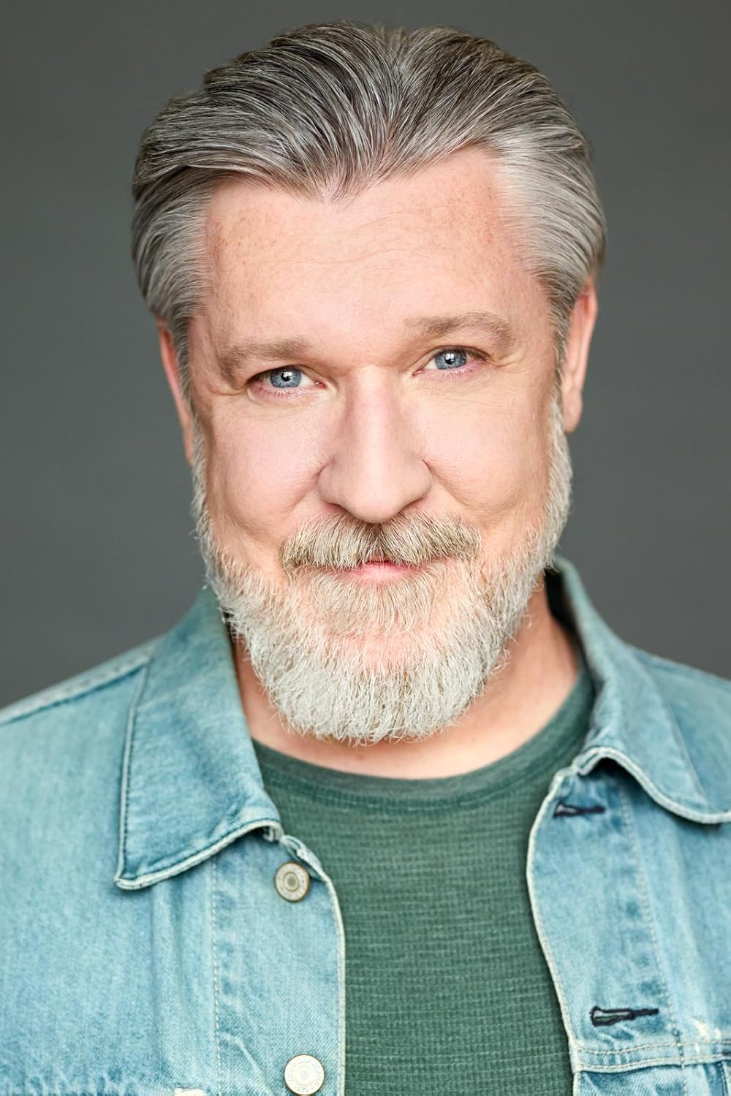

FRANCO LO PRESTI
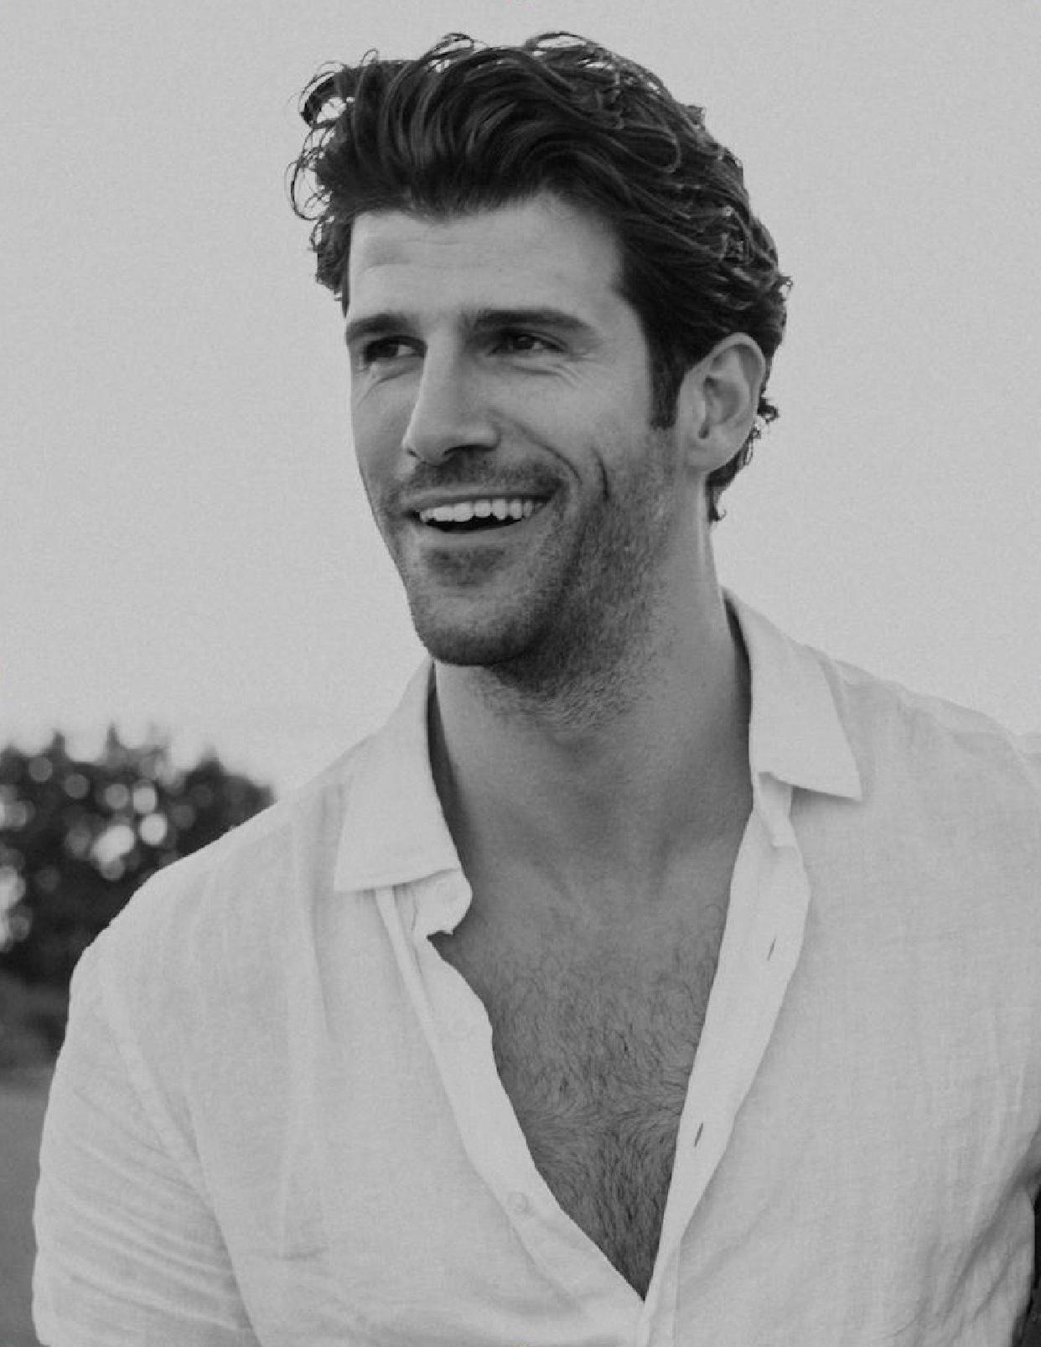
Franco Lo Presti was born and raised in Scarborough, Ontario. At a young age, he developed a passion for performance, especially playing guitar and soccer. This passion landed him a Division I scholarship at the University of Rhode Island, where he also developed a love of theatre.
After graduating, he played soccer in Italy for a team in Serie D, went on trial with Toronto FC and was eventually forced to call time on his soccer career, after succumbing to a hip injury.
At the age of 26, dream taken from the palm of his hands, Lo Presti was reminded of his past pursuits in the theatre and was encouraged by family and friends to partake in an acting class. It was in that class where Lo Presti found his peace and purpose.
His commitment and dedication to the performing arts have led to current and upcoming film and television roles on "Workin' Moms," "Hudson & Rex," "The Story of Love," and "Astrid and Lilly Save the World." He is eager to explore and grow as an artist and takes great pride in all his experiences in life, playing music, living abroad and especially, as an athlete.
When not acting, Lo Presti enjoys his time with family and friends, writing poetry and music, playing the guitar, traveling the world, and juggling a soccer ball from time to time.

CINDY BUSBY
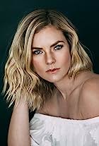
Cindy Busby is best known for her series regular role in Heartland, as “Ashley Stanton,” a rich, self-righteous, competitive horseback rider. The series took off quickly becoming one of the most popular Canadian television shows ever, and has become a fan favourite thanks to Netflix, while also being syndicated in over 81 countries around the world.
Throughout the following years, Cindy has continued having great success booking leading roles in over a dozen films, first landing the lead antagonist in the film Picture This alongside Ashley Tisdale and Kevin Pollack. She can also be seen in Royal Hearts, opposite James Brolin, which brought Cindy to Romania to film the movie. She can also be seen starring in Unleashing Mr. Darcy, alongside Frances Fisher, The Wrong Stepmother, opposite Vivica A Fox, and A Godwink Christmas, with Kathie Lee Gifford. Cindy was also nominated for a LEO Award for her portrayal of Jillian Tatterton in the Lifetime movie series event Web Of Dreams by V.C. Andrews. Most recently, Cindy starred in Netflix Australia’s Romance On The Menu.
Cindy’s resume continues to feature guest starring roles on top network television series, such as Supernatural, Vampire Diaries, La Complex, Psych, and The Secret Circle. She was also seen heavily recurring on Hallmark’s Cedar Cove working closely with Andie MacDowell, and on ABC’s Somewhere Between, as well as a series regular on UpTV’s Date My Dad starring Barry Watson.
Cindy Busby appeared in the Build-A-Bear Productions and Sony Pictures Worldwide feature Honey Girls, starring Grammy award winning singer Ashanti. She filmed alongside Chad Michael Murray in the Christmas movie The Holiday Train. Cindy has had starring roles in Joy For Christmas, Marry Me In Yosemite, Crown Prince Of Christmas, Love In Zion National: A National Park Romance and Everything Christmas.
JAKE EPSTEIN
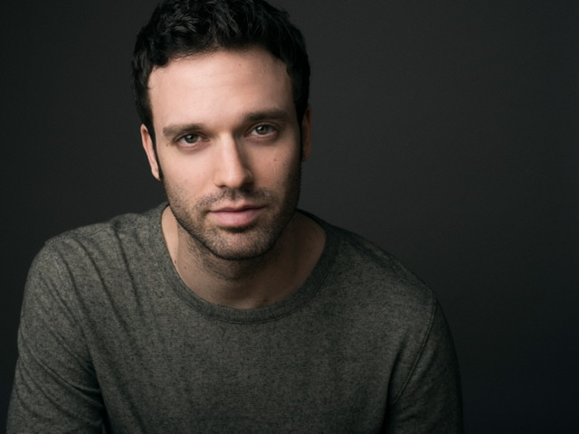
Jake Epstein is a Canadian actor, singer and writer. He is best known for playing Craig in 'Degrassi: The Next Generation' (Gemini Award), Chuck in 'Designated Survivor' and Brian in 'Suits,' along with many other leading roles. On stage, he appeared on Broadway as Peter Parker in 'Spider-Man: Turn Off the Dark,' Gerry Goffin in 'Beautiful: The Carole King Musical' (original Broadway cast), and starred in the US National Tours of Green Day's American Idiot and Spring Awakening. His film work has included roles in A Christmas Village Romance, Terror in the Country, Eight Gifts of Hanukkah, Candy Cane Candidate as well as recurring roles in The Hardy Boys and The Umbrella Academy.

KATHRYN DAVIS

Born and raised in Bath, England. Kathryn was introduced to theatre at a young age and has always had a great appreciation of all of the arts.
Over the years, Kathryn has accumulated an extensive resume from amateur theatre to professional work in England and Canada in theatre, film, video-games and television. Kathryn is a graduate of Toronto Metropolitan University's prestigious Theatre School program in Toronto where she has earned her BFA in Performance Acting with Honours. Throughout her training she studied many different styles of theatrical training including Classical Shakespeare, Naturalism (Stella Adler/Uta Hagen), Period Study (Jacobean), Mask, Mime, Clown, Commedia dell'arte, Voice & Speech, Movement (Alexander technique/Laban), Dance (Period/Jazz/Tap) and Musical Theatre.
Kathryn is also trained in Ballet, Tap and Jazz as well as being a strong mezzo-soprano singer. Kathryn has a British RP accent and other accents are very familiar and come easily to her.

NATHAN WITTE
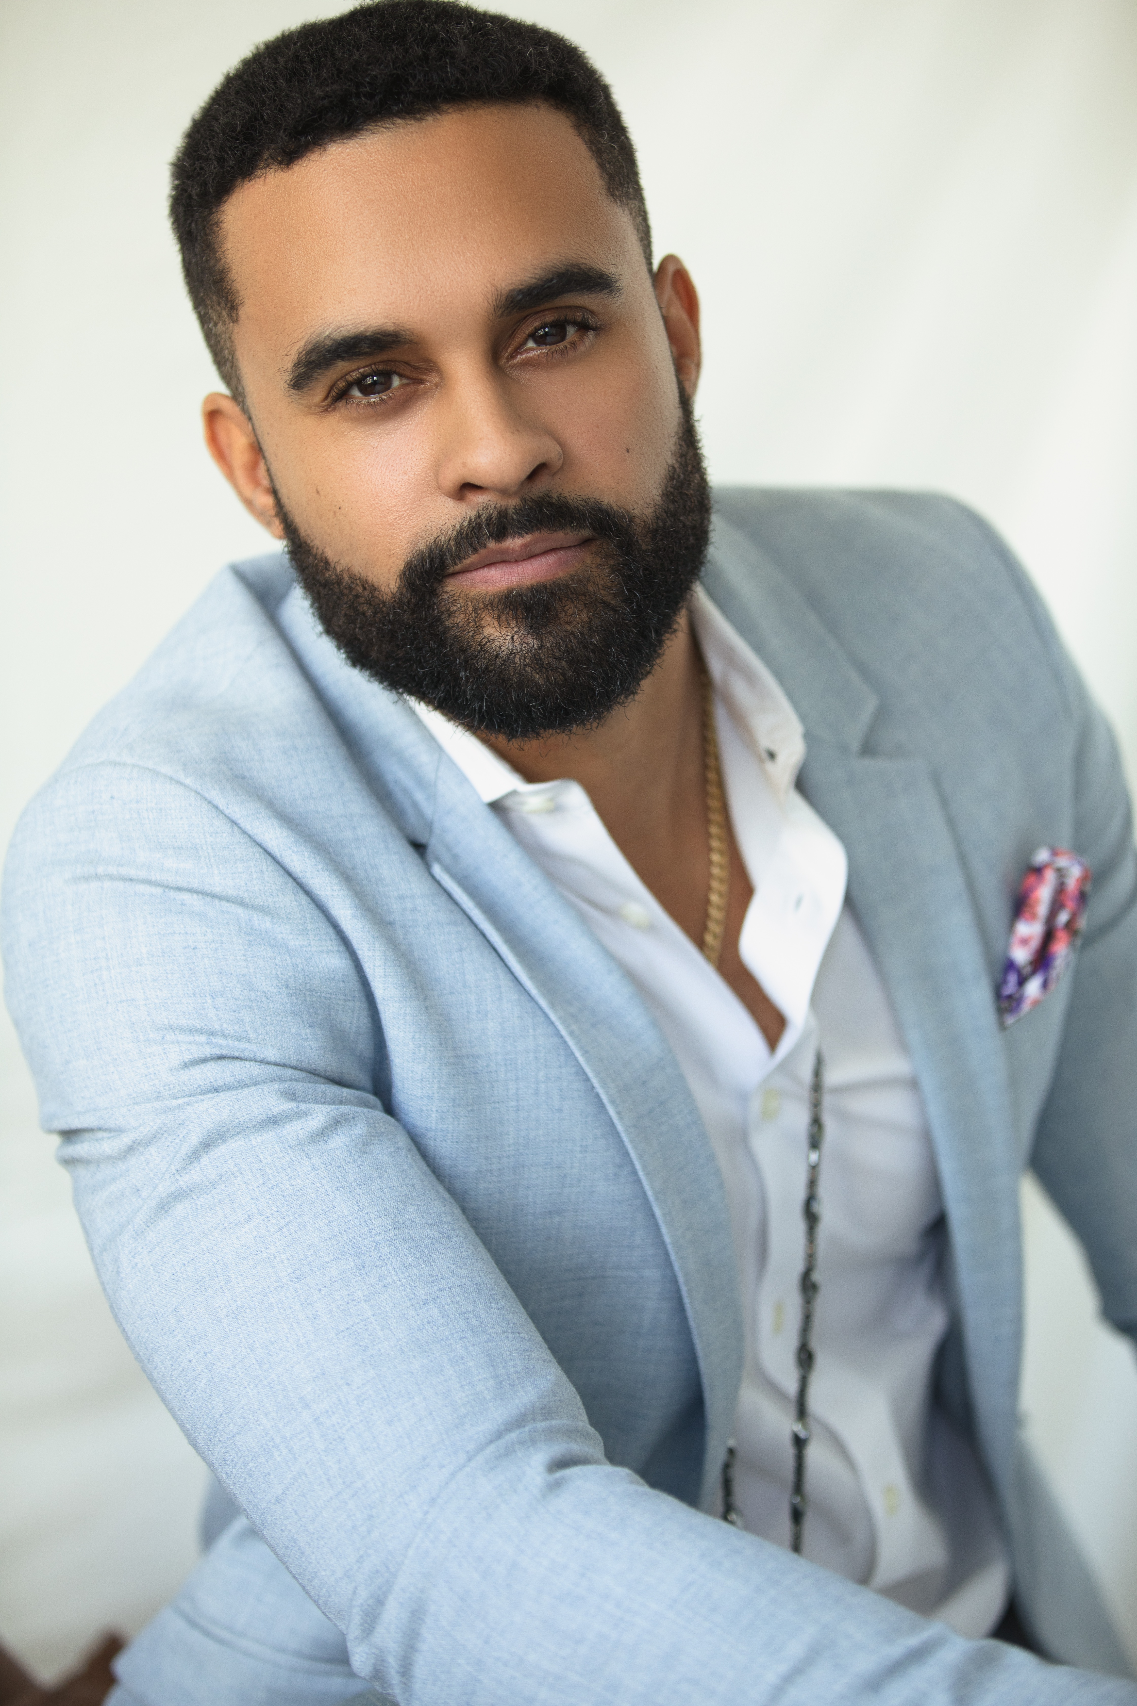
Nathan Witte, originally from Calgary, Alberta began his career in entertainment as a young boy in family home videos and hasn't looked back since. He has always enjoyed making people around him laugh so it came as no surprise to those who knew him that he would make a career of being in front of the camera. At 17, Nathan started working in whatever capacity he could in the industry, which like most, led him to background parts and stand-in work for local TV shows and films. Being a part of professional sets and watching A-list stars work was a great source of inspiration for him. In 2007 his talents and aspirations brought him to Vancouver where he immediately found success booking roles on films Finder of Lost Children (2009) and Gutterballs (2008), and a prominent Guest Star role on the TV show The Assistants (2009). Since then Nathan has continued to work regularly appearing on episodes of Smallville (2001), Supernatural (2005), Hellcats (2010), Arctic Air (2012), Arrow (2012), Rogue (2013), and Motive (2013). 2016 brought more momentum and challenges with bookings on Meet Cute (2016) (produced for Crazy 8s Film Festival), Wayward Pines (2015), Van Helsing (2016), and the feature film Ms. Matched (2016). Nathan and his business partner Chad Rook of CheckMate Films released their highly anticipated first feature film The Perfect Pickup (2020). Nathan will be played the lead role of Corey in this comedy, as well as serving as a producer on the project. Since then he has had recurring roles in the TV series Charmed and in Batwoman. He has been busy in the last couple of years with films including My Best Friend’s Bouquet, Sweet Carolina, The Nine Kittens of Christmas, Merry Liddle Christmas Baby, Greed: A Seven Deadly Sins Story, Romance to the Rescue and Must Love Christmas.

NATALIE HALL
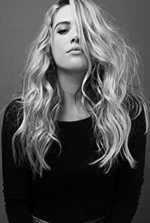
Natalie Hall is a talented and versatile actor and singer. Natalie starred in the Blumhouse anthology series Into The Dark for Hulu, as well as opposite Carla Gugino as in Sebastian Gutierrez Cinemax series Jett. She is well known to television audiences for playing the feisty stripper/mogul “Candi Coco” on the critically acclaimed comedy series Unreal and for her memorable arcs on HBO’s True Blood, USA’s Royal Pains and the CW series Charmed. In addition, Natalie was one of the leads of Star-Crossed for the CW and of the Unt. Marc Cherry Pilot for ABC and has appeared on hit shows like NCIS: New Orleans, Law And Order: SVU, The Good Wife, CSI and Pretty Little Liars. Also a very talented vocalist, Natalie has performed on stage in Cruel Intentions: The Musical and A Chorus Line, for which she received an Ovation Nomination for Best Supporting Actress in the latter. On the feature side, Natalie played opposite Miles Teller in the Sony/Lionsgate feature Only The Brave and starred in the independent films Summer Of 8, The Boy Downstairs, The Curse Of Sleeping Beauty, Plus One, Still Life, and Rising Stars. She has also been the lead of the highly rated Hallmark MOWs You’re Bacon Me Crazy, A Winter Princess, Fit For A Prince, Seven Year Hitch, Love’s Christmas Journey, Noel Next Door, and Fly Away With Me.

ALEC SANTOS
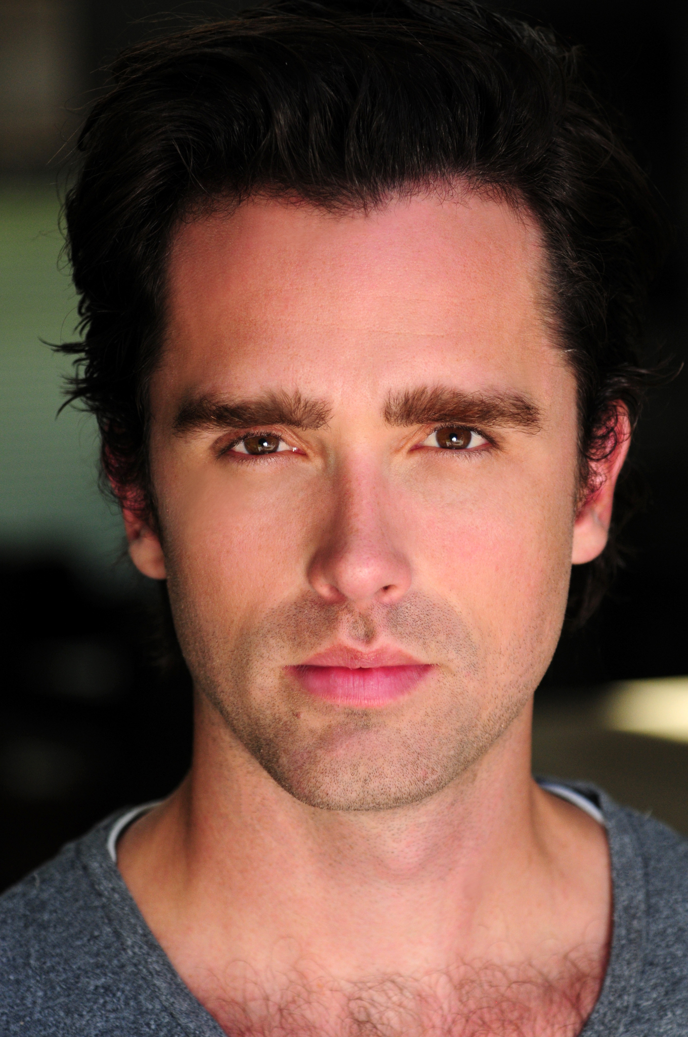
Born in Brasil, raised in America, Alec is the rare actor that can perform in three languages. Now a Vancouver mainstay, Alec has graced the screen as a lead on Hallmark and Lifetime Rom-Coms, has a recurring role in a much anticipated CTV-CW collaboration and has roles on multiple network shows. His recent credits include Virgin River (Netflix), Firefly Lane (Netflix) and Snowpiercer (TNT-Netflix). His comedic chops are on full display on over 2 dozen national commercials including, VISA, Coca-Cola, Nestle, Xfinity and Fitbit. His accolades extend to the stage as he was awarded a best Actor nomination for his performance on Lungs.

Production Credits

Full Cast
Actors  ASHLEY NEWBROUGH  TORRANCE COOMBS  MARTINA ORTIZ LUIS  JENNIFER BAKER  BRIAN FROUD  FRANCO LO PRESTI  JARROD MACLEAN  MOLLY LEWIS  DAVE CAMPBELL  RODRIGUES WILLIAMS  TRISTEN HUANG | Role  Lily Morgan  Sean Allen  Kenzie Reid  Whitney Boyd  Frank Parker  Owen Mansfield  David Morgan  Young Lily  CoWorker  Maitre D  Guest

Casting
BRIAN LEVY, c.s.a.
JASON STROUD, c.d.c.

Composers
RUSS HOWARD III
MASSIMO SAMMI

Costume Designer
MELONIE LAWRENCE

Editor
ALVIN CAMPANA

Production Designer
GREGORY PHILIP WILSON

Director of Photography
MICHAEL TIEN

Written by
KEITH HEMSTREET
W. STEWART

Directed by
AMY FORCE

Full Crew
ALEXANDRA WARING | Associate Producer
JOHNNY ROSS | First Assistant Director
CIMARRON LANGLOIS | Second Assistant Director
ELLA PEGAN | Third Assistant Directors
SANDERSON VINCIC
JULIAN BATE-VERGETTE | Fourth Assistant Director
SMYTH CASTING | Extras Casting
ILONA SMYTH
EKATERINA PAKHLAVUNI | Production Manager
EMELINE MACNAY | Production Coordinator
NATASHA TREPANIER PANETTA | Assistant Production Coordinator
LOGAN A. WAGNER | Production Accountant
MATTHEW CARVELL | Post Production Accountant
SARAH CHENIER | Assistant Accountants
JAKE EDWARDS
MARGARET LEGGE | Post Production Accounting Clerk
ALEXANDRA WARING | Post Production Supervisor
RICHARD FRAZIER | Post Production Coordinator
GREGORY PHILIP WILSON | Production Designer
TOMAS CHOVANEC | Art Director
GORAN POBRIĆ | Set Decorator
BRADLEY CASS | Set Dresser
MORGAN DUNBAR | Graphics Artist
ANTHONY RANKIN | Property Master
CAPITAL FILM WRANGLERS | Dog Wrangler
MATHIEU BISSONNETTE-BIGRAS | SFX Supervisor
MATTHEW SYNEK | SFX Assistant
MELONIE LAWRENCE | Costume Designer
JULIANNE HJARTARSON
MICHELE FEGGANS | Costume Truck Supervisors
RÉNALD JEAN-PIERRE
COELI MYX | Costume Set Supervisor
CAMILA BOUSQUET | Wardrobe Assistant
MICHAEL TIEN | Director of Photography
JOSH HENDERSON | A Camera Operator
ADAM TESTA | B Camera Operator
MATT CROSSE | A Camera - First Assistant Camera
MUNG HATLANG | A Camera - Second Assistant Camera
CHRISTOPHER BERTI | B Camera - First Assistant Camera
ABRAHAM ISSA
DANIEL COSTEA | B Camera - Second Assistant Camera
NIKKI TUBONGBANUA
BOYI TAN | Camera Trainee
RICHARD FRAZIER | Digital Imaging Technician
GEGHANI PANOSIAN | EPKBTS Camera Daily
RICHARD FRAZIER | Camera Technician
GEGHANI PANOSIAN | Camera Utility
DARCY RYAN | Stills Photographer
ORIGIN CAMERA RENTAL | Camera Equipment
STEVEN F.S. BRUNI | Gaffer
LIAM CASASOLA | Best Electric
NICHOLAS HERMIER | Key Grips
YAN SCHNELL
YAN SCHNELL | Best Grips
CONNOR DORZEK
CONNOR DORZEK | Grip / Electric Swings
MATHIEU NOLET
RACHEL VRECIC
ANDREW SUTHERLAND | Sound Mixer
KENNETH BOWMAN | Boom Operators
ADAM HINCHLIFFE
JESSIE EDWARDS | Script Supervisors
LORI HAREUTHER
NATALIE HONSHORST | Location Managers
NIKEEL WEIZMAN
ALEX ASANJARANI | Location Production Assistants
EMMA BOBROVSKIS
PABLO FRANCISCO GONZALES-CANALES
ALYSSA "ALY" MORDEN-HAYLEY | Key Makeup Artist
NATASHA TREPANIER PANETTA | Key Hairstylist
GISELE MATTE | Makeup & Hair Assistant
KEVIN CAROLL | Transport Coordinator
GREG LEWIS | Basecamp Generator Operators
JAY VISNESKIE
MICHAEL DICKSON | Drivers
ANGIE SHEA
CHRIS SURUJNARAIN
CHERYL LYNN LAVALLEE | Transport Production Assistants
TARA LEE LEBLANC LAVALLEE
KRISTEN MCNAULE
SANJAY MOHANTA
JAY VISNESKIE | Swamper
DAVID KIRK | Head Chef
CHANTAL EDWARDS | Chef
MATTHEW DUBUC | Caterer
RONDA MACKINNON | Craft Service
THE NO CONFLICT CLEARANCE COMPANY | Clearances
HALL WEBER LLP | Legal Services
DANNY WEBBER
ABOVE THE LINE MEDIA SERVICES | Business Affairs
BRENDAN MCNEILL
ARTHUR J. GALLAGHER CANADA LTD. | Insurance
URBAN POST PRODUCTION | Post Production Services
EHREN PFEIFER | ADR Recordist
CHRIS MATHESON | Dialogue Editor
KYRA CORBITT | Sound Effects Editor
TESS MOIR | Foley Artists
JESSICA SERVIER
DAVE MERCEL | Foley Recordist
EVAN GRAVES | VFX
KALI RAIGH | Online / Packaging Editor
ANDREW MANDZIUK | Colorist
COLIN MCLELLAN | Final Mixer
ASHLEY POUCHING | Project Manager
BRUCE REES | Picture Operations Manager
ROBERTA BRATTI | V.P. of Operations
ALEXANDRA WARING | Associate Producers
LOGAN A. WAGNER

Producer Biographies

TIMOTHY O. JOHNSON – Executive Producer
Timothy O. Johnson is among the most active and reliable producers in the business thanks to top rate productions and global distribution appeal. He is the managing partner of Johnson Production Group, a Canadian based operation that produces over 100 hours of dramatic television annually with hundreds of programs running internationally. The company is the leader supplier to Lifetime, Hallmark and other international outlets.
A graduate of the Marshall School of Business at the University of Southern California, he served as President of the USC Entertainment Management Association and a member of the Advisory Committee of the Center for Entrepreneurial Studies.
Johnson is also responsible for producing the international hit series, DR. QUINN, MEDICINE WOMAN for CBS for over 5 seasons. During his 100-episode tenure, he also developed and produced the original docu-drama COLD CASE for CBS network, which was the very first program to integrate television with the Internet.
Most recently, Johnson has produced the THE NOEL DIARY, being the #1 Film on Netflix’s Top 10 list in December of 2022. He was also at the helm of the successful GIRL IN THE SHED: THE KIDNAPPING OF ABBY HERNANDEZ, as well as the V.C. Andrews series of films, to date including TWILIGHT’S CHILD, MIDNIGHT WHISPERS, and DAWN, all produced for Lifetime..
Johnson has produced over 400 movies and 15 globally released series for every major US network - including Netflix, Lifetime, Hallmark, ABC, Disney, CBS, NBC, Netfly, FOX and Sony.

JOHNSON PRODUCTION GROUP
Johnson Production Group packages, finances, and distributes television content to networks, studios and streamers. The company specializes in various types of programming including romances, thrillers, holiday and true crime TV movies.
The company has been involved in the production of over 3000 hours of network television, with over $1 billion spent on production. JPG specializes in value, efficiency, protection of creative elements, and delivery of a quality finished product.

MICHAEL VICKERMAN – Executive Producer
Michael Vickerman is a native of Minneapolis, Minnesota and attended film school at the University of Wisconsin – Milwaukee before transferring to Columbia Film School. Michael began his career writing scenes with Sylvester Stallone for the feature film “Cliffhanger” while still attending film school and working as Mr. Stallone’s assistant. Over the next twenty-five years, Michael went on to write, direct and/or produce over forty feature and television films, including the event limited series “Tut” for Spike TV starring Sir Ben Kingsley. He is currently developing the historical drama “Taj Mahal” for Warner Brothers Television and the historical WWII series “The Doolittle Raiders.”

CARLEY SMALE – Executive Producer
Carley Smale is a screenwriter and rom-com connoisseur who received her first writing credit when she was twenty-four years old for the Lifetime made-for-tv movie entitled The Christmas Parade. She has since earned several more writing credits in the MOW space with titles such as, Snowed Inn Christmas, Christmas Pen Pals and Netflix's Midnight at the Magnolia. In February 2022, Midnight at the Magnolia was nominated for best made-for-tv movie at the Canadian Screen Awards. It spent over a month trending worldwide on the Netflix top 10 list. Carley also wrote and directed an indie feature entitled, “Cold Season” which won the Jury Award at the Toronto Independent Film Festival.

ANDREW C. ERIN – Executive Producer
Andrew Erin is a Canadian Writer/Director making a big splash in the US, and has produced, written and directed numerous commercially successful films.
His directorial debut, SAM’S LAKE, was an official selection at the Tribeca Film Festival and did an excellent theatrical run in select theaters around the country; distributed by Lionsgate Films. Andrew also wrote the script for the film.
Andrew’s directorial credits include, SIMPLE THINGS, produced for Screen Media Ventures and Universal Studios. Besides winning The Bob Clark Award for Best Director at the California Independent Film Festival, the film was commercially received.
Andrew has worked continuously as a writer/director, building a strong library of films in the Thriller/Horror genres with: Embrace of The Vampire, The Clinic, Final Sale, Confined and Toxic Skies.
His project, HAVENHURST was acquired by Lionsgate, and released in 2016. It was written, directed and produced under his own banner, along with Twisted Pictures.
OLIVER DE CAIGNY – Executive Producer
Oliver De Caigny is a Canadian producer originally from Belgium, his background in financing, production, and post production makes him a well-rounded producer for any type of production. His experience in financing and production agreements (film and TV series and movies-of-the week), distribution agreements (both domestic and foreign) as well as international co-productions, Canadian tax credit, Telefilm Canada and Canada Media Fund incentives provides him with a well-rounded background in development, production and distribution for motion pictures, television series and productions.

LISA ALFORD – Executive Producer
Lisa Alford is a development executive at Johnson Production Group. A Massachusetts native, Lisa has lived and worked in Los Angeles for over a decade, always in support of excellent storytelling. Prior to joining Johnson Production Group, Lisa worked as an executive at TriStar television where she specialized in identifying IP that supported TriStar’s mission to feature diverse, authentic characters and champion underrepresented voices. Lisa came up at Sony Pictures Television where she worked as a production coordinator in the Television Movies and Miniseries department and in the writers room on the WGN hit series OUTSIDERS. In her current role, Lisa shepherds projects from the concept phase through story development, production, and post.

LEX EMANUEL – Producer
After many years of production accounting, Lex Emanuel stepped up to produce films and television. He has a natural affinity for the creative process and, armed with an undergraduate degree in Economics and an MBA, he is intent on developing high concept films with high returns. In 2020 he produced the critically acclaimed Homewrecker and in 2022 he was responsible for the successful relaunch of the ID Discovery True Crime Doc series Who the Bleep Did I Marry?. In 2023 Lex produced the independent film Trapped and History Channel's The Unbelievable with Dan Aykroyd. This year Lex produced the independent film Lucky Star and Paramount's PD True.
Lex operates in Animation, Live Action and Documentary and has worked with all formats and is comfortable in all genres.

Billing Block
HALLMARK MEDIA PRESENTS IN ASSOCIATION WITH JOHNSON PRODUCTION GROUP UNWRAPPING CHRISTMAS: LILY'S DESTINY
starring ASHLEY NEWBROUGH TORRANCE COOMBS MARTINA ORTIZ LUIS JENNIFER BAKER BRIAN FROUD FRANCO LO PRESTI Guest Starring CINDY BUSBY JAKE EPSTEIN KATHRYN DAVIS NATHAN WITTE NATALIE HALL ALEC SANTOS Casting
BRIAN LEVY, c.s.a. JASON STROUD, c.d.c. Composers RUSS HOWARD III MASSIMO SAMMI Costume Designer MELONIE LAWRENCE Editor ALVIN CAMPANA Production Designer GREGORY PHILIP WILSON Director of Photography MICHAEL TIEN Executive Producers LISA ALFORD ANDREW C. ERIN OLIVER DE CAIGNY Executive Producers MICHAEL VICKERMAN CARLEY SMALE Executive Producer TIMOTHY O. JOHNSON Producer LEX EMANUEL Written by KEITH HEMSTREET W. STEWART
Directed by AMY FORCE

The Canadian Film or Video Production Tax Credit

© Fireside (1-4) Films Inc. All Rights Reserved


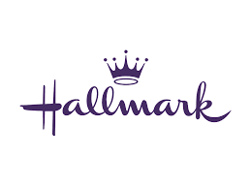
Meta Data
LONG (max 3000 characters) synopsis
Lily, chief marketing guru and vibrant face of ALL WRAPPED UP, believes the universe sends signs guiding us to our destiny. With holiday responsibilities piling up, she eagerly accepts a date with local celebrity realtor Owen Mansfield. However, during an interview with journalist Sean Whitlock, who is doing a profile on her store, she feels an unexpected spark. Rumors of Sean's marital status initially dampen her hopes, but their growing chemistry makes her question everything. As her interest in Owen fades, Lily wonders if she's misreading the signs and if Sean might be the true match her heart has been seeking all along. (632)
MEDIUM (max 500) synopsis
Lily, chief marketing guru of ALL WRAPPED UP, believes the universe sends signs guiding us to our destiny. With holiday responsibilities piling up, she eagerly accepts a date with local celebrity realtor Owen Mansfield. However, during an interview with journalist Sean Whitlock, who is doing a profile on her store, she feels an unexpected spark. As her interest in Owen fades, Lily wonders if she's misreading the signs and if Sean might be the true match her heart has been seeking all along. (496)
SHORT (max 100 characters) synopsis
Lily has met two very different men but feels chemistry with only one. Is she misreading the signs?
(99)
5 KEY WORDS
Realtor, Journalist, signs, Unwrapping Christmas

