Johnson Production Group

Press Kit

One-Liner

Is the charming head of the cleanup crew hiding his own crimes when a woman is attacked in a short-term vacation rental?

Synopsis

When a woman is attacked in a short-term vacation rental, the company’s shady Clean-Up Team steps in to help her pick up the pieces. But she soon finds that the charming head of the team might only be cleaning up his own crimes and will go to any measures to silence her. Inspired by a True Story.

Producers
Executive Producers
TIMOTHY O. JOHNSON
JOSEPH WILKA
Producer
A.J. KELLY
Line Producer
AMANDA SEARS

Key Cast
CHARACTER  Danielle Banks  Anton King  Alesha  Hannah  Mike |  | ACTOR  AUBREY REYNOLDS  JUSTIN BERTI  FELISHA COOPER  YOLANTHE CABAU  GRANT GUNDERSON

Key Cast Biographies

AUBREY REYNOLDS
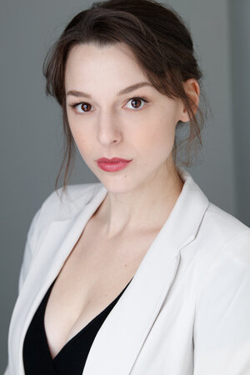
Aubrey Reynolds was born in Dallas, Texas and grew up in Grapevine, Texas, where she attended Colleyville Heritage High School. She received a BFA in Acting from Brigham Young University. She made her feature film debut in 2014 as the lead in the period drama 16 Stones and has proceeded to grace the screens with roles in DC’s Legends of Tomorrow, Snatchers & My Crazy Ex. She has had lead roles in several feature films including You May Now Kill The Bride, Escape: Puzzle of Fear, Frenzy, He’s Dead and So Am I, Hot Chocolate Holiday and most recently, Secrets in the Snow. She currently resides in Los Angeles, California.

JUSTIN BERTI
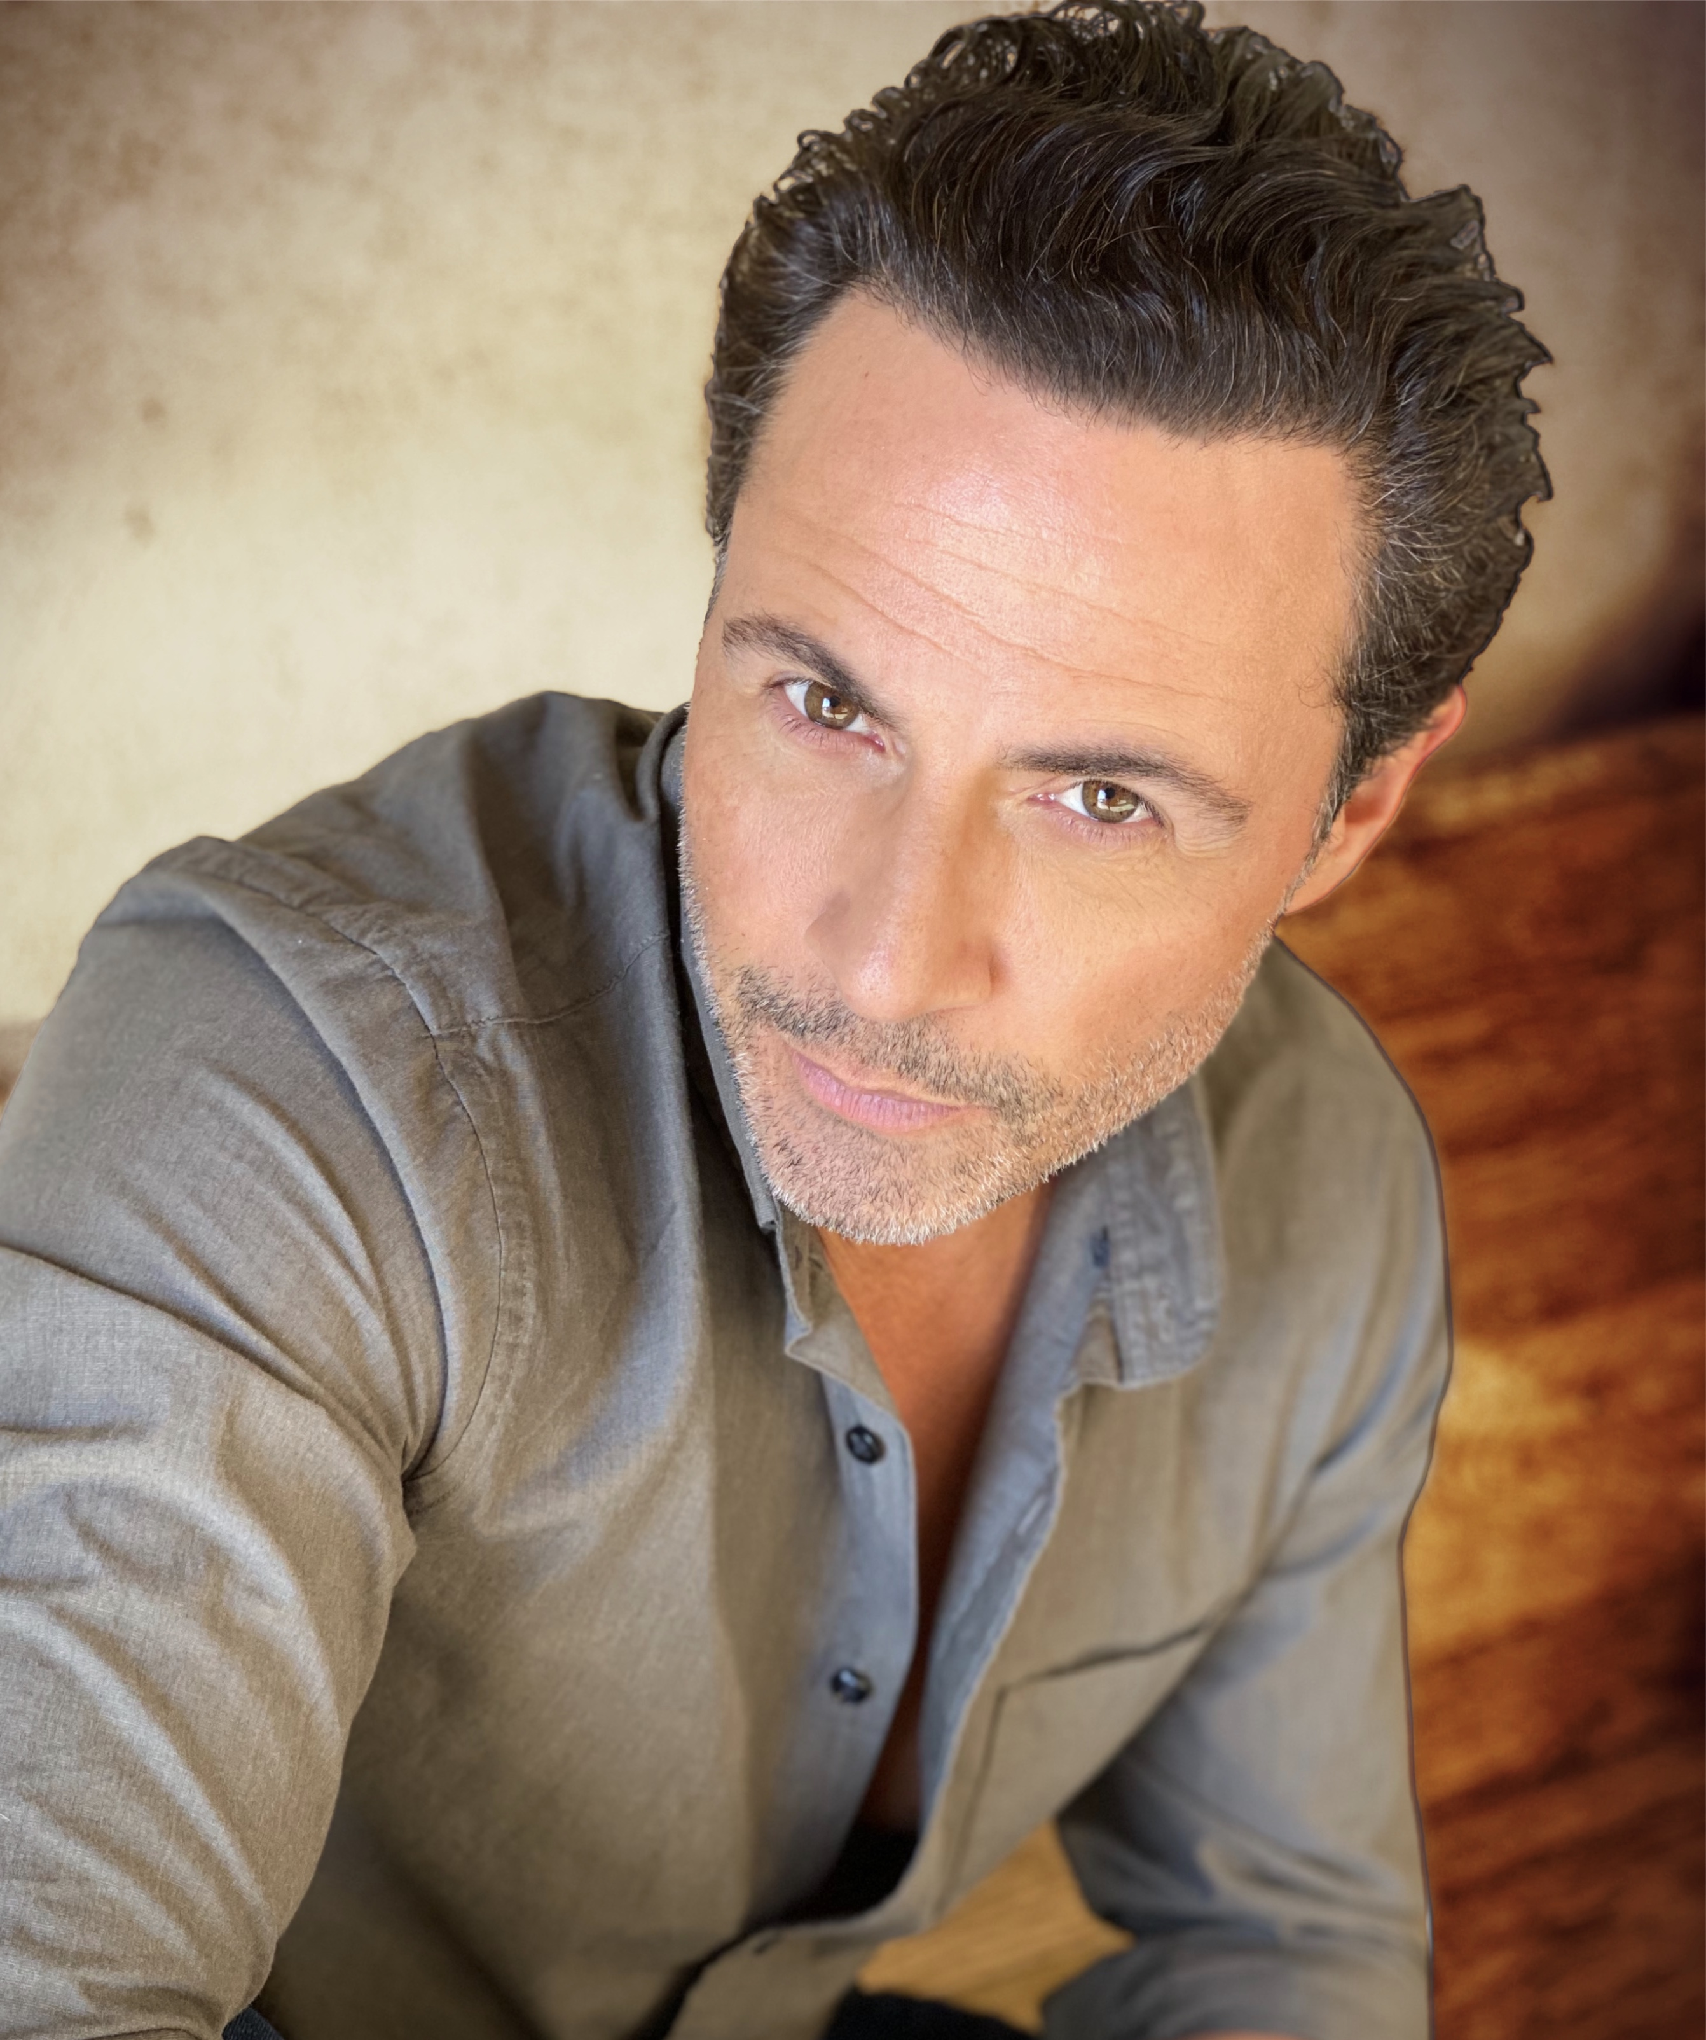
Justin Berti is meant to entertain and inspire. Well traveled, he was born in Connecticut, spent time in Texas and New York City, with his last major stint of 12 years being in Tokyo, Japan. Creating a name for himself, Justin was acting, dancing, and modeling in almost all major entertainment genres you can think of in the Land of the Rising Sun. He even played semi-pro baseball and was a Major League Baseball announcer for all preseason and regular season games featured in Japan. He also had a guest star role in Ramen Girl starring Brittany Murphy. Leaving Japan and moving to L.A. in 2015, he has been on stage, TV, and film making the most of his ambitions. The role of Elliot in the Showtime series Submission was the highlight of his first year back in the States and is what most of his fans know him from. Starring in the popular Billie Eilish's famous "Bad Guy" music video and getting to play the villain in Lifetime's Deadly Cheers and playing the vibrant Mario Bargellini in another Lifetime movie, Driven to Kill, are three memorable experiences for Justin as well. However, the lead role in his first romantic comedy, Divorce Bait, coming out the winter of 2021, will surely add to the top of his list. Tapping into his comedic skills and diving into this character, has been such a breath of fresh air given the difficult climate of 2020. Justin also starred in the independent film Frontera, which won over 9 film festival awards, 4 of them for Best Picture, since its release in 2018. As a Columbia University graduate and instructor of Yogic Arts (a powerful mix of Ashtanga, Martial Arts, and Modern dance), Justin's acting technique and "can do" attitude derive from his physical body mastery, prompting his nickname The Yoganator.

FELISHA COOPER
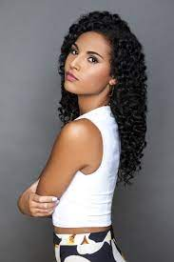
Actress Felisha Cooper found fame as both a bona fide bad girl on the daytime soap opera "The Bold and the Beautiful", where she has appeared in over 80 episodes, and as the comic foil for an eccentric private investigator on the series "Swedish Dicks", created by actor Peter Stormare. Born into a military family in Fayetteville, North Carolina on September 8, 1992, Cooper was discovered by an agent three weeks after moving to Los Angeles, California to pursue an acting career, and made her television debut with a walk-on role on a 2012 episode of the Nickelodeon kids' series "Big Time Rush" (2008-2013). From there, Cooper worked steadily in supporting and guest roles on television, including the biopic "Whitney" (Lifetime 2012), about singer Whitney Houston, and in features like the slasher All Cheerleaders Die, Fiancé Killer, Keys to the City, King Knight, as well as recurring roles in Date of Honor & Dhar Mann.

YOLANTHE CABAU
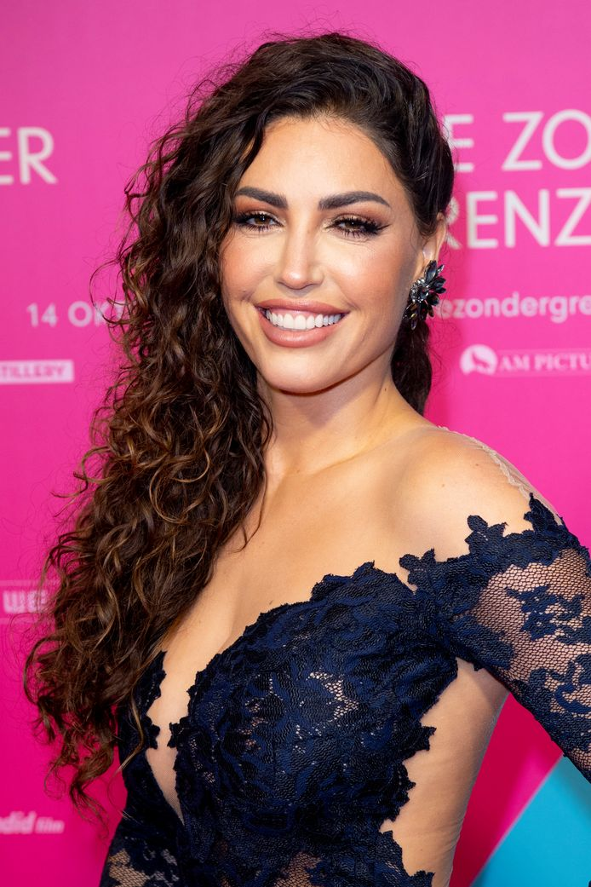
Yolanthe was born on March 19, 1985 on the Balearic Islands of Ibiza to a Spanish father and a Dutch mother. She moved to the Netherlands when she was 5 years old and at the age of 16 started her acting career.
She starred in the "School TV" series "Chromosomen" in which she played the young 14 year old Julia. After that she starred in the Dutch series named "Costa". Then Yolanthe went to Austria, where she acted in the movie "Snow Fever". Until October 2008, Yolanthe played the role of Julia Branca on the Dutch series "Onderweg Naar Morgen". In 2006 and 2007 she did "URBNN" for BNN, in 2007 "Try before you die", and after that "Crazy 88". At the end of September 2006 the film "Turkish Chick" was released by film director Lodewijk Crijns, a nominee at the Dutch 'Gouden Kalf' Film Festival. In this film Yolanthe played the role of Dilara, who stole the heart of a young skateboarder. At the end of 2008 Yolanthe started to work for the broadcasting association "TROS" and won the first 'Televizier Talent Award'. She starred in several TV shows, including: "Twinzz", "Buma Gouden Harpen Gala", "Te leuk om waar te zijn", and "Ei van Columbus". Additionally Yolanthe was one of the permanent jury members for AVRO's live shows of the Junior European Song Festival. Yolanthe played one of the leading roles as 'Kate Witte' in the successful RTL4 series "Voetbalvrouwen" during season 2009-2010. In 2009 Yolanthe played the role of the thoroughly evil 'Miss Volta' in the first ever "Mega Mindy" film for Belgian and Dutch cinemas, followed by "Het Stedenspel". In 2010 she filmed the National Song Festival and "Mijn vader is de beste". She played 'Mila Sol' in the series "Flikken Maastricht". In 2010 Giro d'Italia chose Yolanthe as 'Madrina'. In 2012 Yolanthe was starring in the main role as 'Mariken van Dalen' in one of the episodes of the tv hit series "Van God Los'. In 2013 Yolanthe played the role of 'Nienke Loos' in the movie "Valentino". In that same year she starred in the Hollywood movie "Pain & Gain" as 'Analee Calvera' the love interest of Mark Wahlberg. In 2014 she filmed the Dutch cinema movie: "Stuk", where she played the role of detective 'Saar Beerman'. That same year she played a part in the serie: "Rechercheur Ria". In 2015 she filmed 2 seasons of the tv hit "Bluf" where she had a leading role as sophisticated manager 'Shira Goudsmit'. In 2016 Yolanthe played in a Turkish blockbuster hit "Police Academy Alaturka". She followed up with her role as fierce 'Sacha Sano' in "Popoz". In 2017 / 2018 Yolanthe filmed "Reunited" , "Temptation Island" and "Jongens tegen de meisjes". In 2018 Yolanthe did a sketch in the "TV kantine" as 'Morticia Addams', and in theater she played the role of 'Bobbie' in "The Christmas show, a Christmas Carol". Yolanthe was busy shooting the detective series: "DNA", where she has the leading role of a tough and uncompromising detective 'Lara Noord', that aired January 2019.
GRANT GUNDERSON
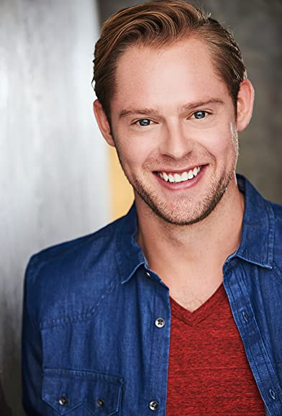
A relative newcomer to the acting world, Grant Gunderson has appeared in several TV Series including The Rita Guida Show, Dark Future, People Magazine Investigates and Tita Guida the Original Story, as well as the film The Departure. He has had roles in multiple shorts, one of which, InTime, won him a European Cinematography award for Best Supporting Actor.

Production Credits

Full Cast
Actors  AUBREY REYNOLDS  JUSTIN BERTI  FELISHA COOPER  YOLANTHECABAU  GRANT GUNDERSON  ANASTACIA MCPHERSON  CHRISTOPHER SKY  NICK CHECKET  MARIA BREESE  MONIQUE SYPKENS  LINDSAY HARTLEY  ROBIN MAZER | Role  Danielle Banks  Anton King  Alesha  Hannah  Mike  Detective Greer  Jack  Craig  Cassandra  Jill  Lindsay  Anton’s Wife

Casting By
JEFF HARDWICK CSA

Production Designer
DAVID VENABLE

Director of Photography
JOSH MAAS

Edited By
JEREMY BRUNSON

Music By
ANDREW SKRABUTENAS
BRYAN WINSLOW

Written By
JOHN HAYES

Directed By
LINDSAY HARTLEY

Other Crew
ANDREW JUKES | First Assistant Director
NATHAN DE LORIMIER | Second Assistant Director
LESLIE GLADNEY | Art Director
GRAHAM HART | Set Dressers
CRIS HERNANDEZ
KESHIA SMITH | Key Make-up Artist
CORTNEY WATSON | Key Hair Stylist
DESHON GREY | Additional Stylist
DANIELLE LOUISE
JUSTIN WILSON | Steadicam Operator
ETHAN TSCHIDA | 1st Assistant Camera
ALEXIS CASTILLO | 2nd Assistant Camera
PETE AGUIRRE | Media Managers
GERARDO AGUIRRE
KEN SAX | Stills Photographer
JEFF MARLOWE | Gaffer
DAN PROSTAK | Best Boy Electric
DAVID KINCHEN
DEVIN CONNER
JOHN CHIGAS
PETER G HOWELL | Key Grip
JOSHUA TOLON | Best Boy Grip
DAVID HUGHES
CHRISTOPHER GRAJALES | Dolly Grip
KINGSLEY COSTIN
JAYNE SEWARD | Costume Designer
JACLYN BRITZ | Wardrobe Assistant
ERIC ENROTH | Production Sound Mixer
ADAM BROOKS | Boom Operator
CALLIOPE WEISMAN | Script Supervisor
PATRICK GREER | Production Coordinator
KARIM PHELPS | Safety Coordinator
GREG SABA | Production Assistants
ARIES LOUIZIA
DARLENE PEREZ
KETAYMA STEWART
ANDREW SILAGY | Sound Designer / Supervising Sound Editor
MATIAS EMMANUEL BELTRANDO | Dialogue Editor
LUIS MURGUIA
LUIS MURGUIA | Sound Editors
JERRY DEATON | Re-Recording Mixer
CHANGING FRAMES | Post Production Services
DAN EDWARDS | Colorists
JEFF SPOTT
HOLLYWOOD SCRIPT CLEARANCE | Script Clearance
PRIVATE ISLAND AUDIO | ADR Facilities
TARANTULA VFX | Visual Effects
ABACUS INSURANCE BROKERS, INC | Insurance
TOO TASTY CATERING | Catering
RARE BREEDS | Cameras

Producer Biographies
TIM JOHNSON – Executive Producer
Tim Johnson is among the most active and reliable producers in the business thanks to top rate productions and global distribution appeal.
Johnson is also responsible for producing the international hit series, DR. QUINN, MEDICINE WOMAN for CBS for over 5 seasons. During his 100-episode tenure, he also developed and produced the original docu-drama COLD CASE for CBS network, which was the very first program to integrate television with the Internet.
Johnson has produced over 150 movies, 15 globally released series for every major US network - including ABC, Disney, CBS, NBC, Netfly, FOX and Sony.

JOHNSON PRODUCTION GROUP
The Johnson Production Group contracts globally to produce television content for international networks, studios and distributors. Based in Los Angeles and Vancouver, British Columbia, the company manages production, facilitates development and financing, procures distribution and guarantees quality and timely execution of its programs. While costs have gone up, so has the demand for quality. No longer is good enough, good enough. Johnson Production Group serves that segment when a show needs to be "A" quality, but produced efficiently enough to meet a locked budget. JPG specializes in value, protection of creative elements, and delivery of a quality finished product.

JOSEPH WILKA – Co-Executive Producer
Joseph Wilka is the Head of Production for Johnson Production Group. Los Angeles-based, Joseph had already produced and directed several feature films before serving as the senior marketing executive for Gravitas Ventures. While at Gravitas, Wilka helped pioneer new distribution models for independent films including day-and-date theatrical releases. It was also at Gravitas where Joseph first worked with Johnson Production Group to facilitate the release of their films to the worldwide Video On Demand audience. After serving as the Director of Distribution and Production for Viva Pictures, where he produced English-language versions of foreign animated titles for DirecTV, Wilka officially joined Johnson Production Group. As Head of Production, he oversees the development, production, and distribution of films from multiple production units for release on broadcast and streaming platforms.

A.J. KELLY – Producer
Producer and co-founder of the creative production company, Goodform, A.J. Kelly has spent the past decade creating film, television, documentary, experiential and branded content. His work has won awards at top festivals including Cannes & SXSW, aired on premium networks and received multi-cultural acclaim.
Based in Los Angeles, A.J. believes in elevating content from diverse creative voices and providing an outlet for filmmakers to bring their stories to life.

AMANDA SEARS – Line Producer
Born in Denmark, Amanda has been interested in movies since she was a young kid. At age 15 she joined a 3-year film program, where she worked on multiple internationally award-winning short films, before eventually making her way to Los Angeles to pursue her dreams as a producer. She has been working as a coordinator with GoodFlix since the winter of 2021 before getting the chance to Line Produce her first feature film in the fall of 2022.
In her free time, she enjoys skydiving and martial arts.

Billing Block
Lifetime Presents In Association with Johnson Production Group “VACATION HOME NIGHTMARE” starring AUBREY REYNOLDS JUSTIN BERTI FELISHA COOPER YOLANTHE CABAU GRANT GUNDERSON Casting By JEFF HARDWICK CSA Production Designer DAVID VENABLE Director of Photography JOSH MAAS Edited By JEREMY BRUNSON Music By ANDREW SKRABUTENAS BRYAN WINSLOW Line Producer AMANDA SEARS Executive Producers TIMOTHY O. JOHNSON JOSEPH WILKA Produced By A.J. KELLY Written By JOHN HAYES Directed By LINDSAY HARTLEY
© MMXXII Johnson Production Group Inc. All Rights Reserved

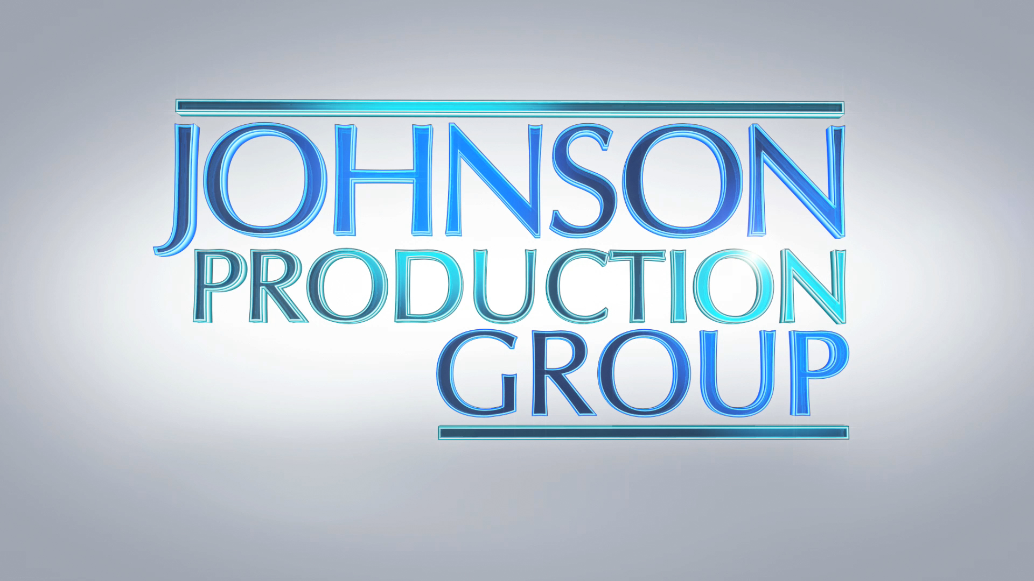

Meta Data

LONG (max 3000 characters) synopsis

MEDIUM (max 500) synopsis
When a woman is attacked in a short-term vacation rental, the rental company’s shady Clean-Up Team steps in to help her pick up the pieces. But she soon finds that the charming head of the team might only be cleaning up his own crimes and will go to any measures to silence her. Inspired by a True Story. (298)
SHORT (max 100 characters) synopsis
Is a cleanup crew hiding their own crimes when a woman is attacked in a short-term vacation rental? (100)
5 KEY WORDS
Vacation rental, criminals, attack, house

