VANISHED IN YOSEMITE
Inspired by True Events

Johnson Production Group

Press Kit

One-Liner
Certain she has met “Mr. Right”, a woman goes missing in the Yosemite wilderness and her sister sets out to find her.

Synopsis

While vacationing in Yosemite, sisters Katrina and Jennifer meet the perfect guy: handsome Rick. Smitten, Katrina is certain she has met "Mr. Right"; however when Katrina goes missing deep in the Yosemite wilderness, Jennifer suspects kidnapping and sets out to rescue her sister. Worried her sister's life is in danger, and knowing she can't go it alone, Jennifer requests help from her ex-boyfriend Wally, who begrudgingly comes to Yosemite to help. But can the two of them get past their issues and work together to find Katrina before it's too late?

Producers
Executive Producers
TIMOTHY O. JOHNSON
JOSEPH WILKA
Co-Executive Producer
LISA ALFORD
Producer
ROBERT BALLO
Co-Producer
ROBIN CONLY

Key Cast
CHARACTER  Jennifer  Katrina  Wally  Rick |  | ACTOR  SKYE COYNE  KELCIE STRANAHAN  JASON TOBIAS  ROB LACOLLA

Key Cast Biographies

SKYE COYNE
Skye Coyne is an American actress known for her infectious energy and emotional availability on-screen. She has captivated audiences across various platforms such as Paramount+, Lifetime, UPtv, and Amazon Prime. Born and raised in Florida, Skye's passion for acting blossomed at a young age. Her boundless enthusiasm and natural flair for storytelling propelled her towards a career in the performing arts. After earning her BFA and honing her craft through stage performances, Skye ventured into the world of film and television. Whether she's portraying vivacious and spirited characters or delving into complex emotional depths, Skye's on-screen presence is characterized by her ability to convey a wide range of emotions authentically. From heartwarming romantic comedies to emotionally complex dramas, she fearlessly dives into her roles. She has garnered a reputation for being a true joy to work with. Some of her work includes Deadly Radio Romance, Love Under the Lemon Tree, Love's Playlist, The Search for Secret Santa, The Devil in the Room and Feeling Sexual.

KELCIE STRANAHAN
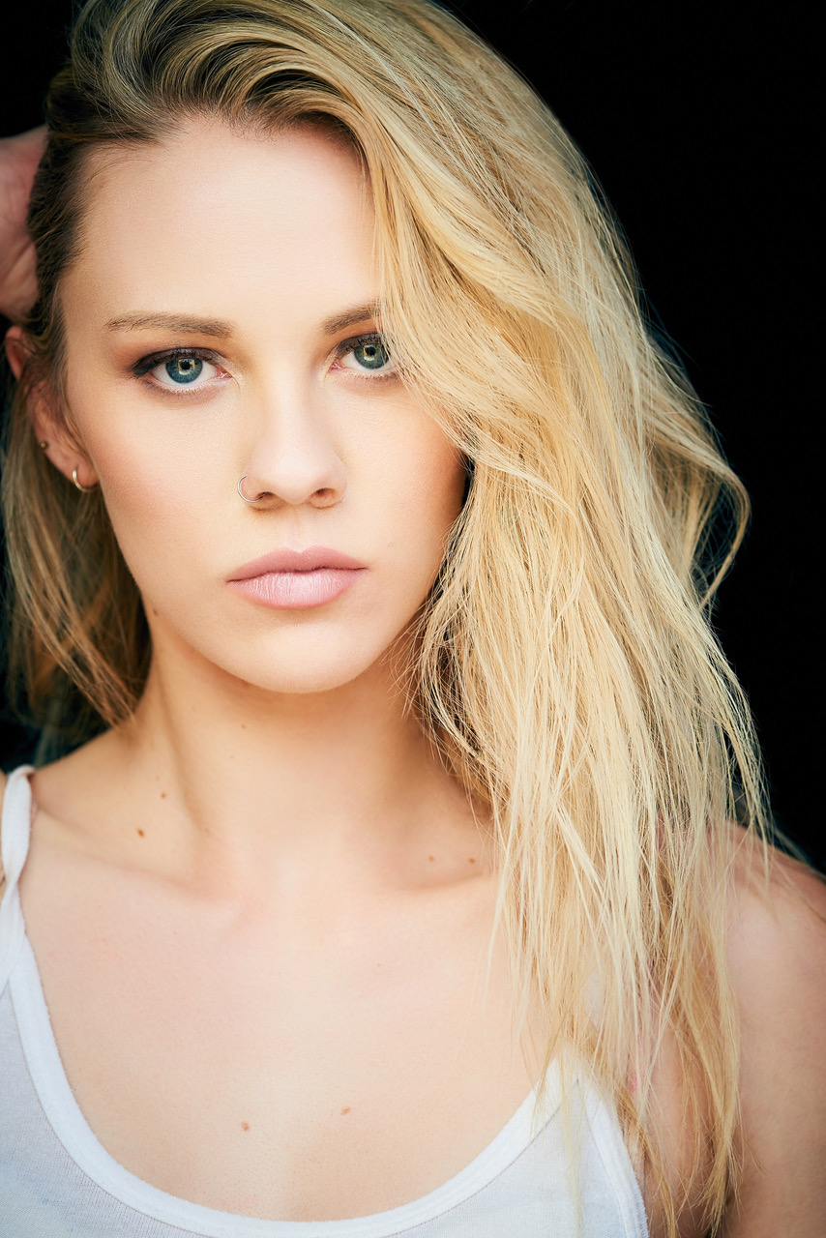
American born actress, Kelcie Stranahan trained as a ballet, jazz and lyrical dancer from a young age. Her film roles include starring in Without A Trace, Last Hours In Suburbia, Dirty Teacher, Stalked By My Neighbor, Designed for Death and Spinning Out of Control.

JASON TOBIAS
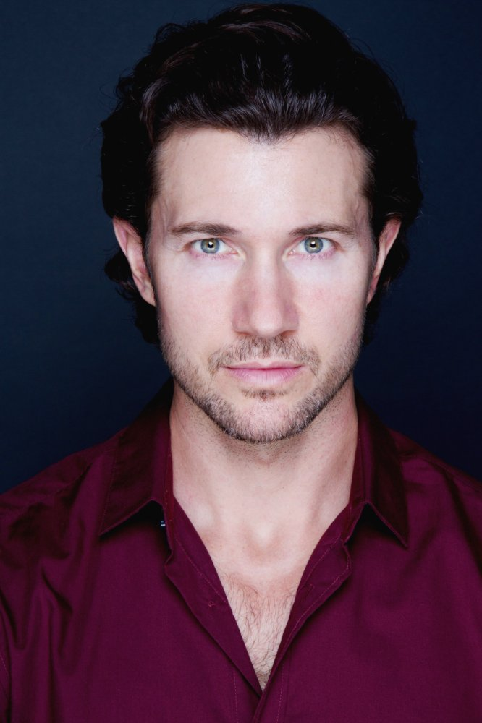
Jason Tobias is an Actor, Writer, Director, that grew up between the Bay Area and the east coast, throughout the late 80's and 90's. Since he was a child, he has loved storytelling. His strongest influences include; Classic Literature, Comics, Cartoons, Video Games, the Summer Blockbuster and Family.
He moved to Los Angeles in the spring of '09. In pursuing his acting career, he has built credits on popular shows like; "BETTER THINGS" (FX), "DEAD TO ME" (Netflix), "JUSTIFIED" (FX), "The Fosters" (ABC Family), "NASHVILLE" (CMT), and Independent feature films, "DOWNRANGE" (Ryuhei Kitamura), "CAN'T HAVE YOU" (Mark A. Altman).
In 2016, Jason wrote, produced and starred in, his first award winning short film: "Star Wars: GENERATIONS". It won with Disney/Lucasfilm at Star Wars Celebration, at London that year.
In 2017, Jason created the production company; 'Action Figure Entertainment' with long time friend and collaborator Lucas Solomon. Together partnered with Blair Pennington, they develop, produce and deliver, high concept, scripted series and feature films.
In 2021, Action Figure Entertainment released "F.E.A.R." (Geoff Reisner & Jason Tobias) their first feature film from their production banner. Jason Co-Directed, Wrote, Produced and Stars in the picture.

ROB LACOLLA
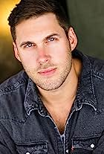
American actor, Rob LaColla, Jr. was very involved in sports, music and theatre at a young age within his community. He began drumming at the age of 3 by playing percussion in the church choir, and broadened his interest in the arts when he starred as Prof. Harold Hill in his elementary school's rendition of "The Music Man" at the age of 13. Graduating high school during the recession in 2008, he realized getting a job in the arts wouldn’t be as easy as he thought, so he decided to use his athletic background to get into a good college with a promising degree. He played division 1 baseball at Manhattan College where he graduated with a Civil Engineering degree in 2012. But acting was in his blood and he switched from a promising engineering career to pursue a career in acting. He has had recurring roles in several TV Series including The Murder Tapes, Indemnity and A Grunt’s Life. His film roles include A Grunt’s Life, The Rebels of PT-218, Diamond in the Rough and Secrets in the Building.

Production Credits

Full Cast
Actors  SKYE COYNE  KELCIE STRANAHAN  JASON TOBIAS  ROB LACOLLA  MACKENZIE POSSAGE  DEVANTE WINFREY  SHEMEKA WRIGHT  JON BRIDDELL  JANET CARTER  CHRISTIAN VILINA  EDDIE CALDWELL  RYAN CUAN  VILION FOK  STACEY DREDGE  LOFTON ETHERIDGE  MARISA DESA  NICHOLAS LAMBERT  JOHANNA MATTOX  FRANCHESCA PARKS  JILLIAN SUSSKIND  CHRISTOPHER BOGUSH  OSHYN CANNON  TIMOTHY CASH  MONIKA CHAN  EDWARD COVARRUBIAS  KYLE DONNELLY  CARLTON GILREATH  REINA GUTIERREZ | Role  Jennifer  Katrina  Wally  Rick  Melissa  Deputy James  Teresa  Mayor Dan  Abby  Zack  Hotel Patrons  Bar Patrons

Casting by
ROBIN DE LANO
NICOLE DIONNE

Makeup by
ASHLEY ALDRIDGE

Sound Design by
ANDRES BOULTON

Music by
RANDY MILLER

Edited by
JASON ROSE

Costume Designer
CLEY KIM

Production Designer
NICOLA WAKE

Director of Photography
CHRISTOPHER JORDAN

Line Producer
NICOLE LAYSON

Story by
ANDREA SHAWCROSS
DOUG CAMPBELL

Written & Directed by
DOUG CAMPBELL

Full Crew
DENZEL JOHN | First Assistant Director
ALEX TETZNER | B Camera Operator
REID COLLINS | First Assistant Camera
WARREN MCELROY
EMMA DONAHUE | Second Assistant Camera/DIT
MATTHEW GIBSON
STEVE CURLY | Still Photographer
KEEGAN CRAWFORD | Prop Master
QUINLAN DONOVAN-SCHAGER | Chief Lighting Technician
JOSH DIERCKS | Best Boy Electric
BENJI PAYNE
ALEXANDER TOBIAS | Key Grip
ASHLEY ALDRIDGE | Makeup Artist
NICK OSORIO | Production Sound Mixer
JOSE GALLO
DREW RUBADO | Weapons Master
OLIVIA PHILLIPS | Production Office Coordinator
JOAQUIN PARADA | Assistant Production Office Coordinator
FRANK INGLIS | Production Assistants
ERICK NUNEZ
WRAPBOOK | Payroll
TONY MONTANA CATERING | Catering
GLOW CAFE
BOOKED TALENT | Background Casting
POST PRODUCTION
SOUNDASART | Post Sound
ANDRES BOULTON | Supervising Sound Editor
NICK HURTADO | Foley Editors
JONATHAN MORGAN
SCOTT CASILLAS | Foley Artist
BRIAN O'HARA | Sound Effects Editor
ANDRES BOULTON | Re-recording Mixer
BLUELINE FINISHING | Conform and Delivery
RANDY COONFIELD | Color Grading
PETER LALIC | VFX Artist
GOAL PRODUCTIONS | Stock Footage
CLEARANCE UNLIMITED | Script Clearance
SUZY VAUGHAN
BLACKSTONE ENTERTAINMENT | Grip and Lighting Equipment
GOAL PRODUCTIONS | Camera Equipment
MEDIA BOX CAMERA
LEWIS MEYER | Additional Music and guitars

Producer Biographies

TIMOTHY O. JOHNSON – Executive Producer
Timothy O. Johnson is among the most active and reliable producers in the business thanks to top rate productions and global distribution appeal. He is the managing partner of Johnson Production Group, a Canadian based operation that produces over 100 hours of dramatic television annually with hundreds of programs running internationally. The company is the leader supplier to Lifetime, Hallmark and other international outlets.
A graduate of the Marshall School of Business at the University of Southern California, he served as President of the USC Entertainment Management Association and a member of the Advisory Committee of the Center for Entrepreneurial Studies.
Johnson is also responsible for producing the international hit series, DR. QUINN, MEDICINE WOMAN for CBS for over 5 seasons. During his 100-episode tenure, he also developed and produced the original docu-drama COLD CASE for CBS network, which was the very first program to integrate television with the Internet.
Most recently, Johnson has produced the THE NOEL DIARY, being the #1 Film on Netflix’s Top 10 list in December of 2022. He was also at the helm of the successful GIRL IN THE SHED: THE KIDNAPPING OF ABBY HERNANDEZ, as well as the V.C. Andrews series of films, to date including TWILIGHT’S CHILD, MIDNIGHT WHISPERS, and DAWN, all produced for Lifetime..
Johnson has produced over 400 movies and 15 globally released series for every major US network - including Netflix, Lifetime, Hallmark, ABC, Disney, CBS, NBC, Netfly, FOX and Sony.
JOHNSON PRODUCTION GROUP
The Johnson Production Group contracts globally to produce television content for international networks, studios and distributors. Based in Los Angeles and Vancouver, British Columbia, the company manages production, facilitates development and financing, procures distribution and guarantees quality and timely execution of its programs. While costs have gone up, so has the demand for quality. No longer is good enough, good enough. Johnson Production Group serves that segment when a show needs to be "A" quality, but produced efficiently enough to meet a locked budget. JPG specializes in value, protection of creative elements, and delivery of a quality finished product.

JOSEPH WILKA – Executive Producer
Joseph Wilka is the Head of Production for Johnson Production Group. Los Angeles-based, Joseph had already produced and directed several feature films before serving as the senior marketing executive for Gravitas Ventures. While at Gravitas, Wilka helped pioneer new distribution models for independent films including day-and-date theatrical releases. It was also at Gravitas where Joseph first worked with Johnson Production Group to facilitate the release of their films to the worldwide Video On Demand audience. After serving as the Director of Distribution and Production for Viva Pictures, where he produced English-language versions of foreign animated titles for DirecTV, Wilka officially joined Johnson Production Group. As Head of Production, he oversees the development, production, and distribution of films from multiple production units for release on broadcast and streaming platforms.

LISA ALFORD – Co-Executive Producer
Lisa Alford is a development executive at Johnson Production Group. A Massachusetts native, Lisa has lived and worked in Los Angeles for over a decade, always in support of excellent storytelling. Prior to joining Johnson Production Group, Lisa worked as an executive at TriStar television where she specialized in identifying IP that supported TriStar’s mission to feature diverse, authentic characters and champion underrepresented voices. Lisa came up at Sony Pictures Television where she worked as a production coordinator in the Television Movies and Miniseries department and in the writers room on the WGN hit series OUTSIDERS. In her current role, Lisa shepherds projects from the concept phase through story development, production, and post.
ROBERT BALLO – Producer
With over 34 years of industry experience, Robert Ballo has created award-winning productions for clients that include ABC, TBS, PBS, Discovery Channel, and Lifetime, and that have aired on national network television, cable networks, and internationally in Asia and Europe. As Director of Photography and Producer at Shadowland, Ballo has created over a dozen feature films seen on the Lifetime Network and distributed internationally. As Director of Photography, his Shadowland films include MISSING AT 17, THE SURROGATE, STALKED AT 17, TEENAGE BANK HEIST, WALKING THE HALLS, BETRAYED AT 17, HOME INVASION, MATERNAL OBSESSION, ACCUSED AT 17 and SPECTRES. Other feature film credits include RUNNIN' AT MIDNITE, THE AFFAIR and STARVING ARTISTS. Ballo has also traveled the world on many documentary productions.
His television credits for national broadcast and cable networks include COLLEGE SPORTS IN AMERICA, GREAT EUROPEAN BALLOON ADVENTURE, DIRTY HARRY THE ORIGINAL, THE GREAT YEAR, and THE ROSE PARADE - PAGEANT FOR THE AGES. Through his other digital motion picture company, GOAL Productions, Ballo works with Fortune 500 companies, non-profit organizations and government agencies to produce sales and marketing videos as promotional communications. After a twenty-year tenure teaching film and video imaging, Ballo recently retired from his position as an Associate Professor of Practice at USC’s School of Cinematic Arts. A graduate of the USC film production program himself, Ballo is a member of the Academy of Television Arts and Sciences.

ROBIN CONLY – Co-Producer
Robin is a boots-on-the-ground producer who can take any project from development thru deliverables; always aware of the artistic vision of the movies she makes. She is a PGA and DGA member who produced and directed a variety of successful, award-winning projects before joining Shadowboxer. Films. Most notable are her family films that can be seen on networks including HBO, Hallmark, Showtime, Hulu, Tubi and Netflix. At Shadowboxer Films, she has produced and overseen post-production on over a dozen features since 2021.
Her BA is in Radio / TV and Film production from the University of Louisiana.

Billing Block
JOHNSON PRODUCTION GROUP PRESENTS IN ASSOCIATION WITH SHADOWBOXER FILMS "VANISHED IN YOSEMITE” starring SKYE COYNE KELCIE STRANAHAN JASON TOBIAS ROB LACOLLA AND MACKENZIE POSSAGE CASTING BY NICOLE DIONNE AND ROBIN DE LANO SOUND DESIGN BY ANDRES BOULTON MUSIC BY RANDY MILLER EDITED BY JASON ROSE COSTUME DESIGNER CLEY KIM PRODUCTION DESIGNER NICOLA WAKE DIRECTOR OF PHOTOGRAPHY CHRISTOPHER JORDAN LINE PRODUCER NICOLE LAYSON EXECUTIVE PRODUCERS TIMOTHY O. JOHNSON & JOSEPH WILKA CO-EXECUTIVE PRODUCER LISA ALFORD CO-PRODUCED BY ROBIN CONLY PRODUCED BY ROBERT BALLO WRITTEN & DIRECTED BY DOUG CAMPBELL
With the participation of the Province of British Columbia
Film Incentive BC
The Canadian Film or Video Production Tax Credit
© MMXX Johnson Production Group Inc. All Rights Reserved
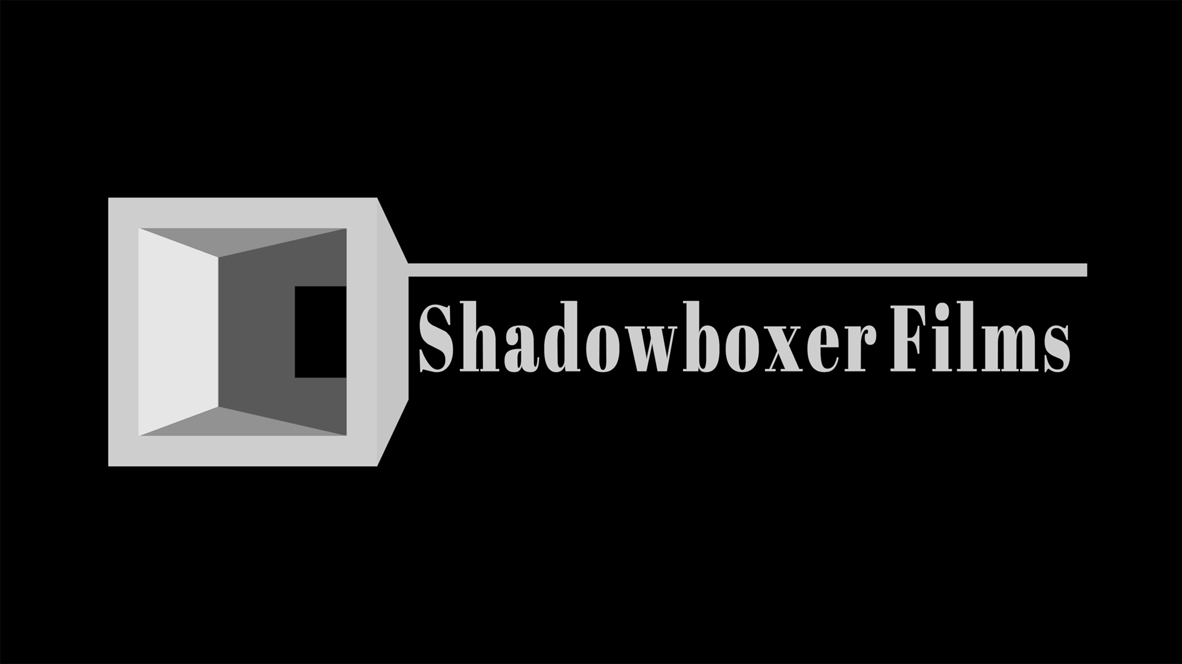
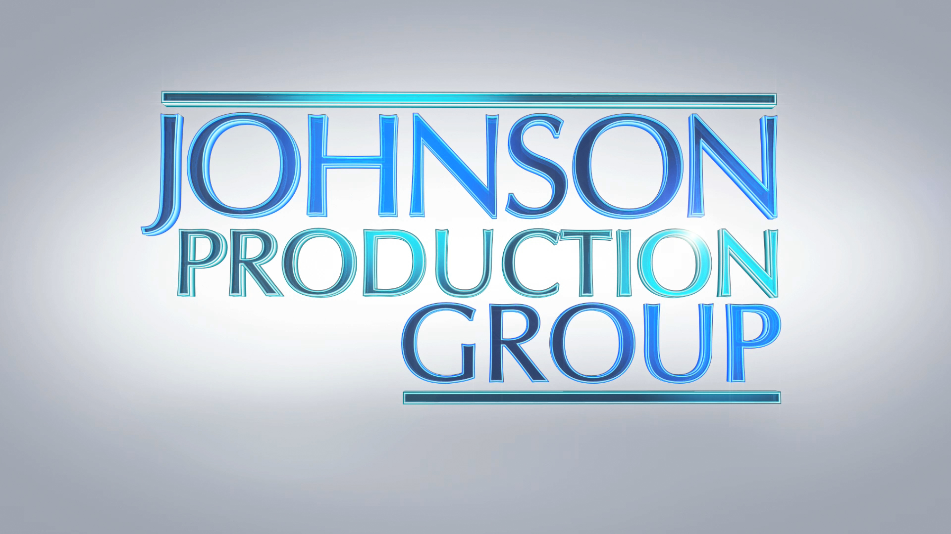

Meta Data
LONG (max 3000 characters) synopsis
While vacationing in Yosemite, sisters Katrina and Jennifer meet the perfect guy: handsome Rick. Smitten, Katrina is certain she has met "Mr. Right"; however when Katrina goes missing deep in the Yosemite wilderness, Jennifer suspects kidnapping and sets out to rescue her sister. Worried her sister's life is in danger, and knowing she can't go it alone, Jennifer requests help from her ex-boyfriend Wally, who begrudgingly comes to Yosemite to help. But can the two of them get past their issues and work together to find Katrina before it's too late? (553)
MEDIUM (max 500) synopsis
While vacationing in Yosemite, sisters Katrina and Jennifer meet the perfect guy: handsome Rick. Katrina is immediately smitten, however when she goes missing deep in the Yosemite wilderness, Jennifer suspects kidnapping and sets out to rescue her sister. Knowing she can't go it alone, Jennifer requests help from her ex-boyfriend Wally, who begrudgingly comes to Yosemite to help. But can the two of them get past their issues and work together to find Katrina before it's too late? (487)
SHORT (max 100 characters) synopsis
After meeting the perfect guy, a woman disappears in Yosemite and her sister sets out to find her. (98)
5 KEY WORDS
Kidnapping, wilderness, thriller, sisters, rescue

