Johnson Production Group

Press Kit

One-Liner
An outdoorsy fitness expert at a wellness retreat must whip a bad-boy movie star into shape before shooting begins on his next action film

Synopsis

Fitness instructor Kate Wolfe leaves Los Angeles to take a job at her best friend’s wellness retreat. To her surprise, A-lister Rick Steele is assigned by the studio to come and train with her to shed some pounds for his new feature film. Not only does the duo make a breakthrough athletically, but also they equally break through some personal walls and find an unexpected friendship that is put at risk when Rick’s gorgeous co-star is also sent to train with Kate.

Producers
Executive Producers
TIMOTHY O. JOHNSON
DAWN WOLFROM
Co-Executive Producer
JOSEPH WILKA
Producer
NAVID SOOFI
Supervising Producer
OLIVER DE CAIGNY
Key Cast
CHARACTER  Kate Wolfe  Rick Steele  Sasha Jones  Liza Calhoone |  | ACTOR  CINDY BUSBY  CHRISTOPHER RUSSELL  LATONYA WILLIAMS  CAITLIN STRYKER

Key Cast Biographies

CINDY BUSBY
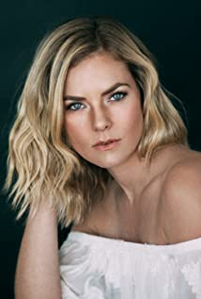
Cindy Busby has been making waves in the television and movie industry for almost 2 decades. Growing up in Montreal, Canada, Busby always dreamed of becoming an actress. To pursue these dreams, Busby attended the Professional Theater Program at Dawson College, a rigorous three-year training, allowing Busby to demonstrate her professionalism, hard work, and devotion to her craft.
After graduation, Busby hit the ground running and landed a leading role as Ashley Stanton in over 50 episodes of the hit series HEARTLAND. The series took off quickly becoming one of the most popular Canadian shows ever, as well as syndicated in 81 countries around the world and is a Netflix top pick. Busby continued having success booking roles as the antagonist in the film PICTURE THIS alongside Ashley Tisdale, and booking guest starring roles on the smash hit series THE VAMPIRE DIARIES, SUPERNATURAL, LA COMPLEX, RUSH, PROOF, THE TOMORROW PEOPLE, and THE SECRET CIRCLE. In 2010 and 2011, Busby appeared on the big screen in DIARY OF A WIMPY KID from 20th Century Fox, followed by the Fox 2000 film THE BIG YEAR, playing opposite Hollywood heavy hitter Steve Martin.
Cindy’s work ethic and reputation has earned her over a dozen lead roles in the last few years, making her a household name and fan favorite among the Hallmark Channel community. Starring in UNLEASHING MR DARCY and MARRYING MR DARCY, viewed by over 3 million viewers individually and breaking the network’s social media record. In 2017, Busby traveled to Romania when she booked the lead in ROYAL HEARTS, directed by James Brolin and most recently Busby starred in the audience acclaimed A GODWINK CHRISTMAS: MEANT FOR LOVE along side Kathie Lee Gifford.
Cindy also showed off her comedic chops as the leading lady in the series DATE MY DAD.
Time and time again, Cindy has won over audiences as a chameleon performer with her quick wit, comedic timing, and dramatic ability. With several movies slated to release in 2021, it’s safe to say that Cindy Busby is here to stay.

CHRISTOPHER RUSSELL
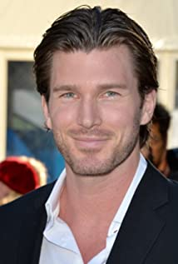
Christopher Russell is a first generation Canadian born to British parents. From a very young age, he was drawn to the arts and began performing. His first role as an actor was portraying Mary and Joseph's donkey in his pre-school production of “The Nativity Story,” for which he received rave reviews. In high school, Russell performed in many productions, most notably as Magnus Muldoon in a rendition of Tom Stoppard’s “The Real Inspector Hound,” which earned him the Sears Drama Festival Award of Excellence.
Russell recently filmed the lead role of Madison in ABC Family’s pilot “Gorgeous Morons.” His numerous television credits prior to that include guest star and recurring appearances on “Girlfriends’ Guide to Divorce,” “Men in Trees” with Anne Heche, “Flashpoint,” “The Listener,” “Murdoch Mysteries,” The CW’s “iZombie,” “Nikita,” “Supernatural” and “Beauty and the Beast,” as well as the TV movies “Love, Again,” “Midnight Masquerade,” “The Boy Next Door,” “Seduced By Lies” and “Catch A Christmas Star.”
Russell’s film credits include “Gone Tomorrow,” “Gangster Exchange,” George Romero’s “Land of the Dead,” “Center Stage: Turn It Up” and “The Right Kind Of Wrong,” which was an official selection for TIFF 2013, starring “True Blood’s” Ryan Kwanten and Catherine O'Hara.
Russell currently lives in Vancouver with his wife and his two children.

LATONYA WILLIAMS
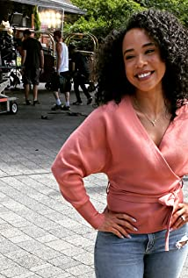
Latonya Williams is a well known American actress, known for her work in the series, Travelers. She played the character of Treena in the movie, Merry Liddle Christmas. Latonya gained fame from her work in the movie, Always Be My Maybe.

CAITLIN STRYKER
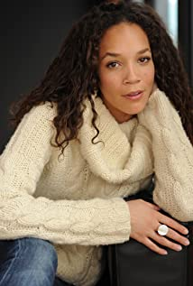
Caitlin Stryker grew up a railroad brat, never living in any city for longer than 2 years as her father's railroading career kept the family on the move. With her gypsy spirit firmly in place, she splits time between the three cities she calls home: NYC, LA, and Vancouver, BC. She started her career in the performing arts as a ballet dancer performing with the Royal Winnipeg Ballet's Young Performers Ensemble, where her love for emotional freedom was established. Caitlin was then scooped up by Elite modeling agency in Toronto, which fluidly led to her acting career in Film/TV. Her love of film has even put her behind the camera as she co-produced multiple shorts, and the 31x Award-Winning feature film, "Land of Smiles", with her husband Bradley Stryker.

Production Credits

Full Cast
Actors  CINDY BUSBY  CHRISTOPHER RUSSELL  LATONYA WILLIAMS  DOLORES DRAKE  DEVON ALEXANDER  AL MIRO  RICKY HE  CAITLIN STRYKER  DEVON FERGUSON  RHONDA DENT | Role  Kate Wolfe  Rick Steele  Sasha Jones  Minnie  Jared  Nigel  Matt  Liza Calhoone  Young Man  Photographer

Casting by
JUDY LEE

Production Designer
HEATHER COUTTS

Director of Photography
SEAN COX

Edited by
JASON NIELSEN

Music by
FREDERIK WIEDMANN

Story By
STEVEN KENT
PAMELA RICE

Written By
W. STEWART

Directed by
CHRISTIE WILL

Full Crew
CHAD SAYN | Stunt Coordinators
SHAUN MAGEE
RICHARD VAN LIEMPT | Water Safety
THOMAS STANFORD | Associate Producer
DARREN ROBSON
NAVID SOOFI | Production Managers
DARREN ROBSON
GRANT O’KANE | First Assistant Director
CLAUDE PAVEL | Second Assistant Director
RUSTY ROSS | Set Decorator
AMY KUYPER | Assistant Set Decorator
TRACEY TIFFANY LAU | On Set Dresser
MITCHELL RAUSCH | Dressers
CIMRAN JASSAL
MARIEL CALVO
LAURA STREET
MORGAN GREENWELL
AARON WILSON
KSENIIA LIEONTIEVA | Props Master
LETICIA LOUREIRO BRANDAO | Props
SELENA TAYLOR | Hair Stylist
KATHLEEN FOWLSTONE | Make-up
JADEN DEVINE | Costume Designer
SOPHIA NIEWERTH | Assistant Costume Designer
MATTHEW PASSARELLI | Set Supervisor
VALERIE SMITH | Truck Costumer
JORDAN EWAN | Camera Operators
AARON NATHANSON
RYAN PETEY
BAURZHAN DOSMAGAMBETOV | First Assistants Camera
BENJAMIN HOPPER
TITOUAN FOURNIER
CHARLES HADRIAN | Second Assistants Camera
BENJAMIN STENNER
PIERRE CRUZ | Gaffer
SEPEHR MAHBOB | Best Boy Gaffer
HANNA BOHMAN | Electrics
MARTYN VACHON
CORY TYMOSCHUK | Key Grip
DENNIS CHAPPELL | Best BoyGrip
CHRISTOPHER JENKINS | Dolly Grips
NILS KIMMEL
OLIVIA PEARSE | Grips
MATTHEW YURECHKO
PETER GIBSON | Transport Coordinator
COSTAS PAPADOPOULOS | Transport Captain
LARRY CARTER | Drivers
FRANCIS ROSS
JEFF J. CHARLTON
SAEED SODEYF
BARRY HUNT | Security Coordinator
RICHARD PLUHOWY | Security
ROBERT GUDLJEK
BRANDON RYAN
HARPREET KAULDHAR
CELESTE CROWE | Location Manager
ANA NUNES | Assistant Location Manager
CARTER VILLEMAGNE-GAMACHE | Key Location Assistants
JOSEPH HUNT
LIANA BABIN
JANA QUADRELLI | Location Assistants
SEAN REA
EMILIA SAINZ SOLER | Production Sound Mixer
ELSY DAGDUG CHAMELIS | Boom Operator
CHRISTOPHER DOERKSEN | Script Supervisor
PARALEE COOK | Production Accountant
ROBERT JAY DEACHMAN | Production Accountant Assistant
THOMAS STANFORD | Business Affairs
JEFF DESMARAIS | Production Coordinator
REINE WONG | Catering Coordinator
MICHAEL HOLSTEIN | Craft Service/First Aid
JULIA ANDERSON | Craft Service/First Aid Assistants
MELANIE MUNOZ
KAYLA BROWN | COVID Specialist
MARC GENEROSO | Third Assistant Directors
CHRIS BILLION
MAIA MICHAELS | Casting Assistant
LA HILTS | Extras Casting
KATRINA NEUHAUS | Stand-In
COASTAL CLEARANCES | Script Clearances
CHANDLER FOGDEN ALDOUS  LAW CORPORATION | Legal Services
FRONT ROW INSURANCE BROKERS  BROKERS | Insurance
LEAH MYERS | Post Production Supervisor
TIM SPENCE | Post Production Coordinator
RON PENCHALAIYA | Assistant Editor
NATHAN YOUNG | Second Assistant Editor
MARCEL VANDERWEKKEN | Visual Effects
SeÁN TRAVERS | Colourist
MAVERICK POST GROUP | Sound Facilities Provided by
GREGOR PHILLIPS | Supervising Sound Editor
GREGOR PHILLIPS | Re-Recording Mixer
ELAN GABRIEL | Dialogue Editor
CRAIG GEORGE | SFX Editor
ALEX MACIA | Foley Artists
DEVON QUELCH

Producer Biographies

TIM JOHNSON – Executive Producer
Tim Johnson is among the most active and reliable producers in the business thanks to top rate productions and global distribution appeal.
Johnson is also responsible for producing the international hit series, DR. QUINN, MEDICINE WOMAN for CBS for over 5 seasons. During his 100-episode tenure, he also developed and produced the original docu-drama COLD CASE for CBS network, which was the very first program to integrate television with the Internet.
Johnson has produced over 150 movies, 15 globally released series for every major US network - including ABC, Disney, CBS, NBC, Netfly, FOX and Sony.

JOHNSON PRODUCTION GROUP
The Johnson Production Group contracts globally to produce television content for international networks, studios and distributors. Based in Los Angeles and Vancouver, British Columbia, the company manages production, facilitates development and financing, procures distribution and guarantees quality and timely execution of its programs. While costs have gone up, so has the demand for quality. No longer is good enough, good enough. Johnson Production Group serves that segment when a show needs to be "A" quality, but produced efficiently enough to meet a locked budget. JPG specializes in value, protection of creative elements, and delivery of a quality finished product.
OLIVER DE CAIGNY – Supervising Producer
Oliver De Caigny is a Canadian producer originally from Belgium, his background in financing, production, and post production makes him a well-rounded producer for any type of production. His experience in financing and production agreements (film and TV series and movies-of-the week), distribution agreements (both domestic and foreign) as well as international co-productions, Canadian tax credit, Telefilm Canada and Canada Media Fund incentives provides him with a well-rounded background in development, production and distribution for motion pictures, television series and productions.
NAVID SOOFI – Producer
Navid is the primary producer for Novus Ordo Seclorum. Navid’s passion for filmmaking along with his business and engineering background plays an important role in creating a successful and transparent business model. Navid has been in the entertainment industry for more than 13 years and has produced over 50 feature films, TV shows and commercials that have been featured on national television, international theatres, and new media platforms. His credits include Over the Moon in Love, The Mistletoe Secret, Random Acts of Christmas, Love Unleashed, Identity Theft of a Cheerleader, and A Mother on the Edge.

CHRISTIE WILL - Director
Christie Will studied at Emerson College in Boston MA, and the College of Charleston in SC. She earned a BA in Business Arts Management, in addition to a BA in Theatre Performance (concentrating in Music Theatre and Film). Christie also earned a BFA in Art History, along with receiving a 'Leadership in the Arts' Distinction Award, upon graduation.
Following University, Christie graced stages across North America, before moving to Los Angeles where she worked as an actress, model, and emerging director and writer. During this time, she split the year by living between Vancouver Canada and Los Angeles California. In Vancouver, Christie founded the first avant-garde black box theatre; The Beaumont Playhouse (based on the teachings of Sanford Meisner; Christie was a long time student of Robert Carnegie's 'Playhouse West' in Los Angeles). It was during her time back in the theatre that Christie honed in on her writing and directing for the stage. After finding success and audiences within the theatre scene, Christie soon transposed her efforts into film.
Career: Her first short film 'Dysfunction' was received with critical acclaim, encouraging Christie to focus her creative aspirations to further writing and directing for the big and small screen. She worked as Peter Berg's director's assistant (Smokin Aces, Friday Night Lights, Hancock, The Rundown), before moving into Senior Executive in Business Development for singer/ entertainer Paula Abdul (responsible for the development of Paula's first reality show 'Hey Paula'). From this position, Christie focused her sights on directing electronic press kits for feature films, and learning the business of movie production. Her sharp storytelling, and creative approach to these electronic press kits, made for happy distributors and producers. She quickly moved into a producer’s seat, after earning the respect from her colleagues and peers.
After successfully producing (co-producing & associate producing) on various film and televised projects, Christie naturally segued into writing and directing feature films.
As a new female writer, director, producer on the Hollywood scene, Christie's work has been described as "fresh, often providing an uncontrived social commentary on Hollywood" (ref: TS 2006). Her writing and directing has also been described as "authentic, uncensored, and female centric; Christie Will is one of those emerging talents to keep your eye on" (The Sun)
Christie lives on the West Coast between Los Angeles, California, USA, and Vancouver, British Columbia, Canada.

Billing Block
Johnson Production Group Presents “WARMING UP TO YOU”
starring CINDY BUSBY CHRISTOPHER RUSSELL LATONYA WILLIAMS CAITLIN STRYKER Casting by JUDY LEE Production Designer HEATHER COUTTS Director of Photography SEAN COX Edited by JASON NIELSEN Music by FREDERIK WIEDMANN Supervising Producer OLIVER DE CAIGNY Co-Executive Producer JOSEPH WILKA Executive Producers TIMOTHY O. JOHNSON DAWN WOLFROM Produced By NAVID SOOFI Story by STEVEN KENT PAMELA RICE Written By W. STEWART Directed by CHRISTIE WILL
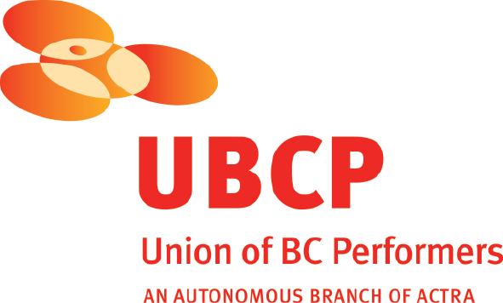
With the participation of the Province of British Columbia
Film Incentive BC
The Canadian Film or Video Production Tax Credit
© MMXXI Wings Productions Inc. All Rights Reserved
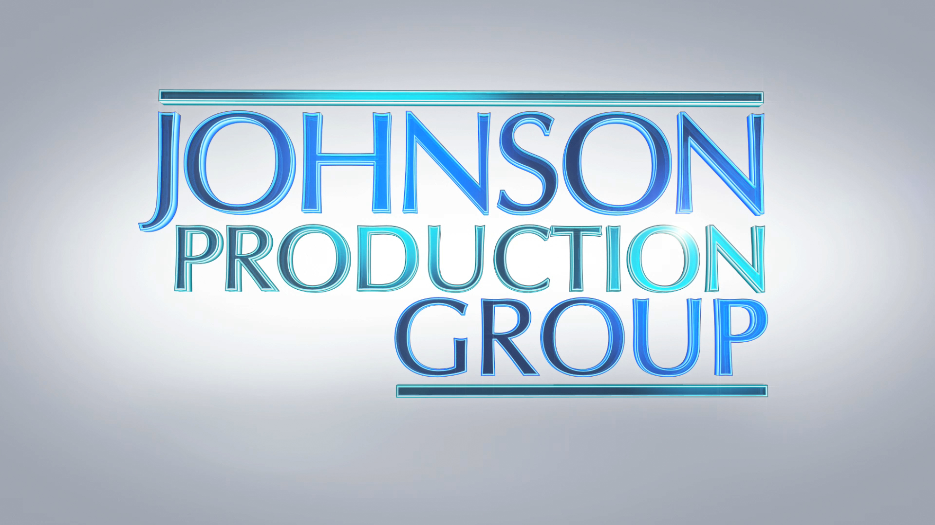

Meta Data

LONG (max 3000 characters) synopsis
Fitness instructor Kate Wolfe leaves Los Angeles to take a job at her best friend’s wellness retreat. To her surprise, A-lister Rick Steele is assigned by the studio to come and train with her to shed some pounds for his new feature film. Not only does the duo make a breakthrough athletically, but also they equally break through some personal walls and find an unexpected friendship that is put at risk when Rick’s gorgeous co-star is also sent to train with Kate. (465)

MEDIUM (max 500) synopsis
Fitness instructor Kate Wolfe leaves Los Angeles to take a job at her best friend’s wellness retreat. To her surprise, A-lister Rick Steele is assigned by the studio to come and train with her to shed some pounds for his new feature film. Not only does the duo make a breakthrough athletically, but also they equally break through some personal walls and find an unexpected friendship that is put at risk when Rick’s gorgeous co-star is also sent to train with Kate. (465)
SHORT (max 100 characters) synopsis
A wellness retreat fitness expert must whip a bad-boy movie star into shape before his next film (96)

5 KEY WORDS
Fitness trainer, movie star, retreat

